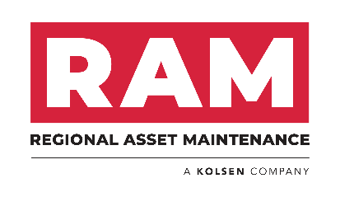
MEDIA RELEASE
Regional Asset Maintenance Services Pty Ltd announces strategic partnership with OSOS Alliance
Today Regional Asset Maintenance Services Pty Ltd, a leading critical asset maintenance company, head quartered in Darwin announced their strategic partnership with OSOS Alliance, a Perth based Aboriginal majority owned company providing electrical and industrial services. This partnership brings together Regional Asset Maintenance Services 35 years of the Northern Territory and regional QLD experience with OSOS Alliance’s industry and community experience nationally.
” We are excited to be involved with OSOS Alliance. Our combined client base will benefit from this strategic partnership, providing specialised industrial services to regional and offshore sites across Australia. It aligns our shared vision of contributing to enrichening lives for our people and our community through sustainable business. It also positions both companies for the long term, creating additional value to all stakeholders”. Said Martin Bottolfsen CEO of Kolsen Pty Ltd.
“This strategic partnership with Regional Asset Maintenance Services Pty Ltd allows both companies to collaborate and provide not only value to all stakeholders but increased opportunities in our communities. We are about Partnering Business with Community, and this partnership supports our commitment to our communities and people. Our shared values and vision made this a natural fit for our business “. Said Peter Harris Managing Director of OSOS Alliance Pty Ltd
Regional Asset Maintenance Services is part of the Kolsen group of companies, more details can be found at www.kolsen.com.au
For further information contact Daniel Lyall, General Manager – East Coast. daniell@kolsen.com.au

