UNDER EMBARGO UNTIL 01 April 2022

After COVID now 7-Day Leak Lockdown

Today, a 7-day lockdown for major leak and water loss offenders has been announced. Anyone who has not resolved a water leak issue in the past 28 days will undergo a mandatory 7-day lockdown. Any person needs to remain there until they either show a negative leak result or until they have installed a SMART testing kit.

Australian water efficiency services company WaterGroup has been a strong advocate for this. "We have seen how effective lockdowns have been in arresting the spread of COVID-19," says Guenter Hauber-Davidson, Managing Director of WaterGroup.

"We can do the same with leaks. We just need to have the political will to do it. It centres around a device that anyone, especially utilities, can install to see how much water is lost. The technology is there," Guenter adds.

However, not everyone is happy. Lauchlan "Locky" Leaky from Leakavilla complains from behind the fence: "Why now? With all the recent rain we've had, it's very hard to distinguish a pipe leak from a natural leak. I am so over all this water. When is the next drought?"

Regardless, the new rules are coming into force today. There are only three ways to escape the leak lockdown:
- Get a SMART kit (Smart Meter Agnostic Reading Test).
- An amnesty for anyone who self-reports a leak before 11am today
- Request your utility to install one.

To make it easy and keep you free from lock lockdown WaterGroup have set up a special website www.watergroup.com.au/leakfree.

"We deeply care about our customers, water and freedom", says Hauber-Davidson. WaterGroup has increased stock levels to meet anticipated surge in demand when leak offenders from all over Australia rush to get these devices. "Additionally, we are giving away the first 104 kits ordered this morning".

With utilities worldwide rapidly adopting digital metering technology, it is hoped that such measures will soon be a thing of the past. Locky Leaky says if the government had acted on these years ago, we would now not have to go through yet another round of lockdowns!

Meanwhile, head on over to www.watergroup.com.au/leakfree and select one of three options to avoid the leak lockdown.

Attached: One picture royalty free for use

Picture connotation: Lauchlan "Locky" Leaky from Leakavilla locked up in his garden due to a leak

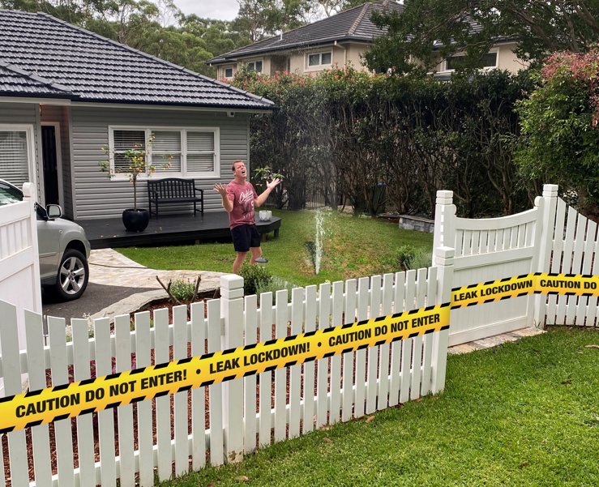

Ends.

About WaterGroup:
Established in 2006, WaterGroup is a water savings solutions provider widely recognised for helping water utilities, municipalities, hospitals, universities, large corporates, shopping centres, and large water users save water and money.
By leveraging the Internet of Things, innovation, and sustainable solutions, they offer the best smart water metering, leak detection and water efficiency products and services.
Watergroup consistently delivers measurable outcomes for their clients, including yearly water savings of almost 300 million litres (ML) with cost savings of over $1 million.
www.watergroup.com.au

Media Contact
Aimi Macready
aimim@watergroup.com.au
Head of Sales and Marketing
WaterGroup
02 9499 8795

