

Friday 4th, March, 2022

Signia’s Rechargeable Range Brings Hearing Aid Sustainability

- Signia, one of the World’s leading hearing aid brands, has proven that its rechargeable hearing aids have 65 per cent less environmental impact compared to traditional battery-powered systems
- Rechargeable hearing aid users save more than 100 batteries each year, which is particularly significant in Australia, as the country does not have a recycling scheme for these spent cells.
- Locally, one in five Australians will be impacted by hearing loss in their lifetime.

Signia’s leading hearing aid range continues to innovate, providing a wide range of sustainable and environmentally friendly solutions to the marketplace through its comprehensive range of rechargeable devices.

Featuring proven lithium-ion technology, the coverage of the Signia Rechargeable offering entails the full suite of instant fit in-the-ear, behind-the-ear, receiver in canal and custom solutions, available with a wide array of accessories in multiple specifications and at various price points.

The rechargeable technology is convenient for users, with multiple charging options available, while the elimination of battery changes is a significant advantage for people with dexterity issues.

From an environmental standpoint, Signia has proven that its rechargeable hearing aids have 65 per cent less environmental impact compared to traditional battery-powered systems, with key improvements found in areas such as climate change (57 per cent), fossil depletion (52 per cent), human toxicity non-cancer (76 per cent), land use (87 per cent), and marine eco-toxicity (78 per cent), amongst other factors.

In real terms, rechargeable hearing aid users save more than 100 batteries each year, which is particularly significant in Australia, as the country does not have a recycling scheme for these spent cells.

“In Australia, one in five Australians will be impacted by hearing loss, and via the Signia Rechargeable range, we bring to the market a sustainable and environmentally friendly solution that is reliable and cost-effective,” said Peter McKinnon, Signia Product Manager.

“Late last year, Signia published a study on the environmental benefits of rechargeable hearing aids, the first-ever comprehensive and scientific life cycle assessment of the options.

“Over 18 different environmental criteria, the advantages of recharging are apparent – it is clearly the way forward for the industry.

“Outside of the sustainability factors, rechargeable hearing aids are extremely practical and hassle-free, and there are zero compromises in quality or comfort.

“Signia have developed rechargeable options to cover the entire product range, from entry-level, affordable systems through to high-performance lines.

“Hearing loss does not need to limit your potential, and we are proud to continue to make a difference in people’s lives.”

For the purpose of the Signia study, total environmental impact throughout the life cycle of the hearing aids included considerations such as raw materials, production, transportation, usage, and disposal, with the battery itself contributing 80 per cent of the environmental impact of the non-rechargeable option.

Depending on the product, a range of different charging options are available within the rechargeable range, including pocket-sized charging cases, as well as Qi wireless charging technology, while the Dry&Clean charger also offers UVC cleaning and drying technology to maintain the hearing aids in peak condition.

Leading the Signia Rechargeable range are lines such as the Insio Charge&Go AX, the first custom hearing aids to feature lithium-ion contactless charging, Signia Active, the Signia Motion X, and the CROS AX.

Built on 140 years of industry experience, the Signia line of hearing aids was launched in 2016, with the brand quickly rising to be top-three in the market.

Further information on the complete Signia Rechargeable offering is available at signia.net/en-au/.

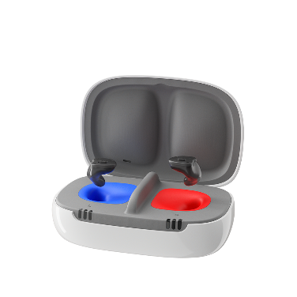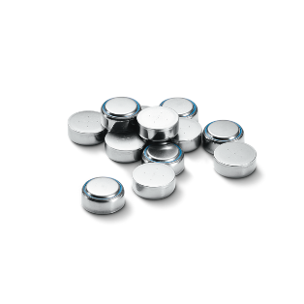

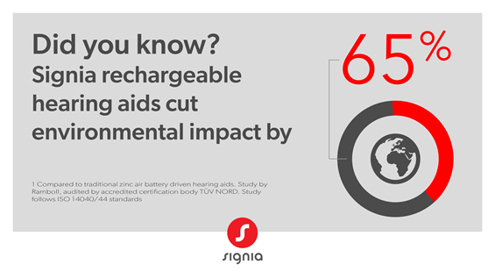

About Signia:

Signia is one of the world’s leading hearing aid brands. We aim to enhance human performance through iconic innovations that shape the prescription audio category. Since its launch in 2016, Signia has regularly brought world-first hearing solutions to the market. In addition to highly innovative hearing aids, Signia also delivers tools and apps to increase customer interaction and engagement at all levels of hearing aid management. Signia allows hearing care professionals and hearing aid wearers not just to correct a hearing loss but to gain an edge – to Be Brilliant.

To access images, brochures and video footage: https://bit.ly/36UKuSp

For all media enquiries or to arrange an interview:
Maree Mellett
0414 609 006
maree@mediacomservices.com.au

