

**Media release – for immediate release**

**Earthquake technology gives hope to those with hand tremors**

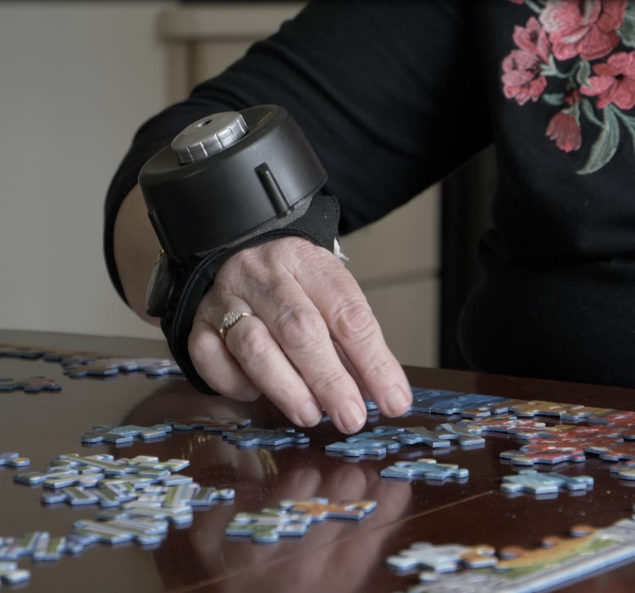

**This April, as we recognize Parkinson’s Awareness Month, earthquake technologies are proving revolutionary for Australians with shaky hands.**

For people living with hand tremors, the day-to-day impact can be devastating. Affecting not only a person’s independence and cutting short careers, but for some it is the cause of great humiliation and distress.

According to the ‘Shake it up Australia Foundation’, Parkinson’s Disease affects 100,000 Australians, with 38 new people being diagnosed every day. While these numbers are huge in themselves, Parkinson’s Disease is but one of the causes of tremor.

Research from the St. Vincent’s Hospital, estimates that in excess of 900,000 people in Australia live with some form of tremor on a daily basis.

While research continues to find a cure for Parkinson’s Disease and other forms of tremor, there are medicines and surgeries that can treat tremors in some people. Unfortunately, these treatments do not work for everyone and cost of certain treatments or the side effects of others means there are too many people still suffering.

Looking for an alternative, non-medical way to improve the daily lives of people with hand and wrist tremors, a Canadian team set about developing a hand stabilising glove designed to assist people with Parkinson’s and Essential Tremor.

“I’m a civil engineer by background,” said Mark Elias (developer of the Steadi-Two hand stabilising glove). “During my studies at the University of Toronto, I learned how to stabilise buildings against wind vibrations and earthquakes. So, I decided to apply the same principles to hand tremors.”

The technology that underlies the Steadi-Two is inspired by a design used to stabilise buildings against earthquakes, called magnetic tuned mass damping. The Steadi-Two device uses a magnet-based system designed to move in the opposite direction of a person’s tremor, to stabilise the wrist and forearm and minimise tremors.

One of the early adopters and people trialing the Steadi-Two during its development phase was Betty Faulkner. Betty declared that the Steadi-Two is “worth its weight in gold” as it finally resulted in some “serious non-chemical help” with Essential Tremor. Betty said the glove gave her the “freedom and independence to do the things I want to do.”

“I’ve had tremors for the last 50 years and finally we have some serious non-chemical help,” says Faulkner. “It’s worth its weight in gold.”

**Betty Faulkner| Steadi-Two early adoptor**

Betty’s husband, Howard, even made a video of Betty putting on make-up for the first time in decades – “Wow, I can do it….I’m getting some of my life back,” Betty proclaims excitedly.

The Steadi-Two is due onto Australian shores in June 2022 and is available from Healthport.

You can watch Betty’s testimonial here – [Betty’s testimonial](https://www.youtube.com/watch?v=ktlnhEbRO0M)

*Healthport is an Australian based medical wearable supplier that works alongside start-ups and established innovative technology companies that develop innovative wearable solutions to chronic health conditions that can be used at home| www.healthport.com.au*

END

**Media Contacts:**

Brett Doyle

Ph. 0423004043

brettd@healthport.com.au