Contact:
Ian Nankivell 23/05/2022
Cresstec Pty. Ltd.
info@cresstec.com
+61 2 9194 3400

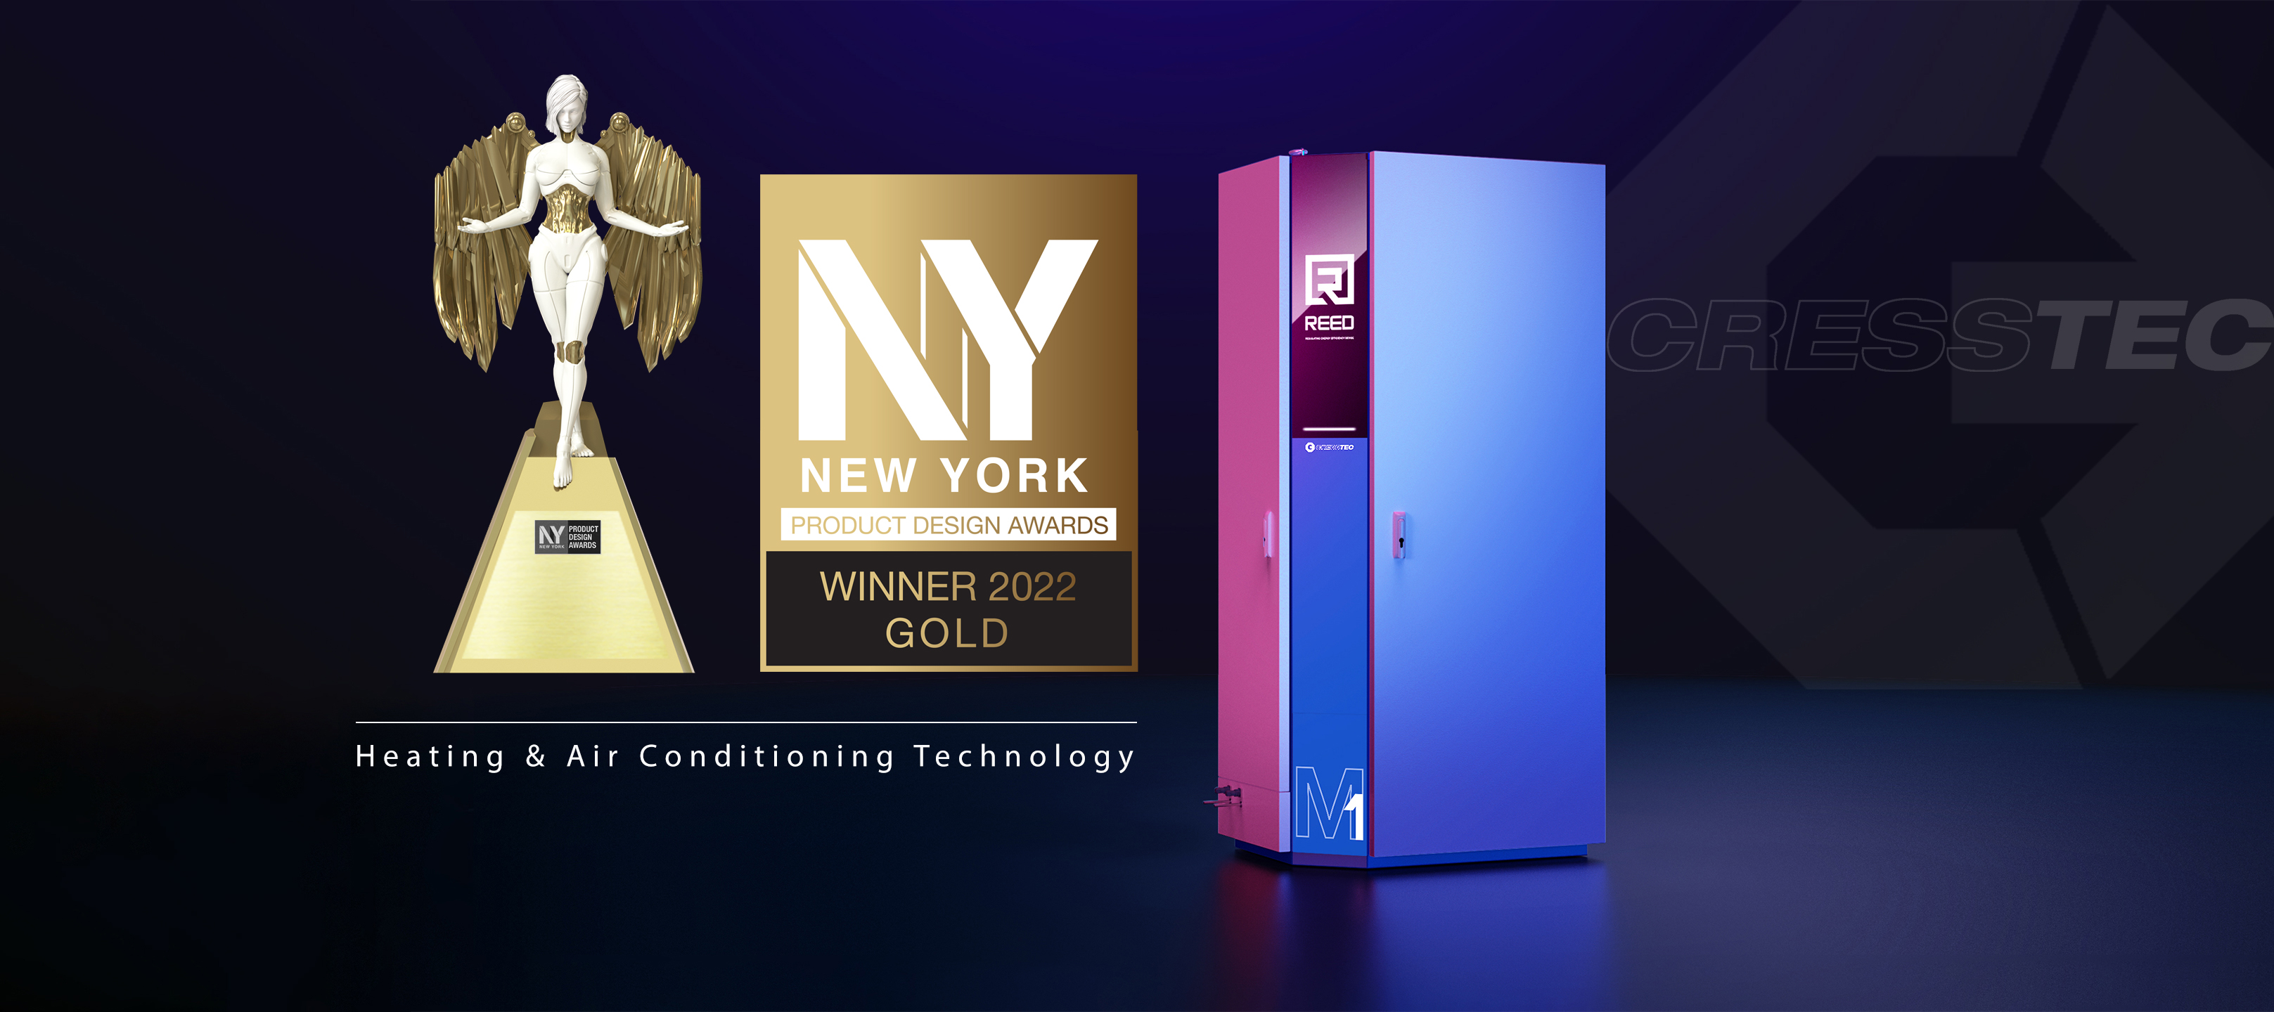

FOR IMMEDIATE RELEASE

Cresstec Seizes a Win in the 2022 NY Product Design Awards

Sydney NSW – 23rd of May 2022 - The NY Product Design Awards has just concluded its season of competition for 2022 and has released the official list of winners. From the over 500 entries submitted from all over the world, the competition narrowed down its winners by determining which designers’ works improved the people’s daily lives.

In the face of intense competition, Cresstec’s REED™ (Regulating Energy Efficiency Device) walked away victorious with the Gold Award for Heating & Air Conditioning Technology.The winning work was created by Cresstec & Design + Industry for Cresstec.
Ian Nankivell, CEO and Executive Director of Cresstec, commented: “It’s an honour be recognised for our accomplishments by the New York Product Design Awards, this prestigious international Gold Award for design and innovation is extremely humbling and is a credit to the achievements and work of our team.”
“Cresstec’s mission is to help our customers meet their global competitive challenges from rising energy prices and carbon reduction costs.”
“We do this through the development of novel carbon reducing and energy saving technologies, benefits that are embodied in our world first REED technology for the commercial HVAC-R market.”
“These key core design principles we believe, will add maximum value to our client’s bottom line, regulatory compliance capability and the overall environmental outcomes that business and government are working together to achieve.”
“REED is a game changer, its ability to mitigate refrigerant leaks and save energy, are unparalleled in the industry today.” Ian went on to say.
The NY Product Design Awards was organized with the intention to honor and promote product designers, whose works make the world a better place. The competition welcomes both professionals and enthusiasts, and spotlights the importance of product design, given how the world consumes goods differently as it becomes increasingly inter-connected.

“It is truly astounding to witness the number of details considered in a designer’s thought process. The submissions embody the very best that this ever-evolving industry has to offer,” Thomas Brandt, spokesperson of the International Awards Associate (IAA), remarked. “Take a moment to analyze their works, and that should give you a newfound appreciation for these designers’ insight.”

Grand Jury Panel & Evaluation Process

The 17 jurors from 14 countries, adhered to a blind judging method. With this, the jury could only assess individual entries in a vacuum, without them being compared to other submissions. This resulted in entries standing out purely on their own merits.

Amidst the sea of esteemed companies and named professionals, who participated with hopes to snatch the victory for themselves, Cresstec emerged victorious.

“While the world is itself adapting to the times that we are in, the unfaltering will and discipline shown by these professionals were truly awe-inspiring. Such excellence was certainly demonstrated by Cresstec’s REED technology,” Thomas said. “As we continue to move forward as a civilization, these talented individuals would certainly serve as guideposts and encouragement to those who come after.”

Website: NY Product Design Awards
Facebook: NY Product Design Awards

Twitter: NY Product Design Awards
Instagram: NY Product Design Awards
Media Partner: Muse.World

