MEDIA RELEASE

ReHomed Clothing Marketplace

Contact Rogan Or Kim Carroll

0447263913

[contact@rehomedclothing.com](mailto:contact@rehomedclothing.com)

FOR IMMEDIATE RELEASE

**New Clothing Marketplace Saves Users Money And Our Environment**

It’s interesting that the most environmentally conscious generation is also the most wasteful when it comes to discarding clothing.

The new generation of shoppers is craving lifestyle and fashion content on their ever-present digital devices. They are extremely influenced by the next fashion style and as a result, their wardrobes are bulging.

Research shows that the average person today buys 60 percent more items of clothing than they did 15 years ago. But consumers keep that clothing for only half as long as they used to. One in three young women consider clothes “old” after wearing them once or twice. One in seven consider it a fashion faux pas to be photographed in an outfit twice.

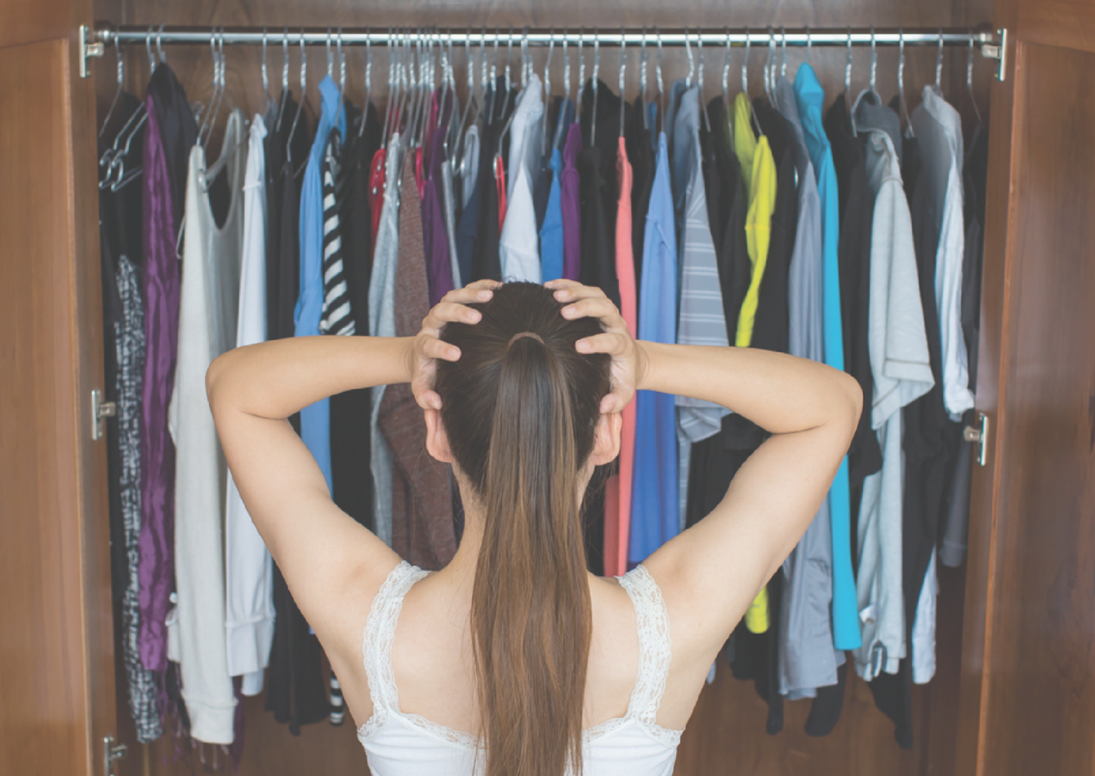

Simply put, the Instagram generation today crave newness, and are much more likely to embrace churn in their wardrobes. At the same time younger generations are more interested in sustainable clothing than older consumers. Clothing resale lengthens the clothing item lifecycle while offering the newness these digital consumers desire.1

Most people would admit to having clothes in their wardrobe that they never wear. What do they do with all those clothes when it’s time to clean out the wardrobe? Give them to a charity shop where only the best items make it onto the racks, and the rest end in landfill? Or do they just throw them out themselves?

There is no such thing as throwing them out. They must go somewhere, right?

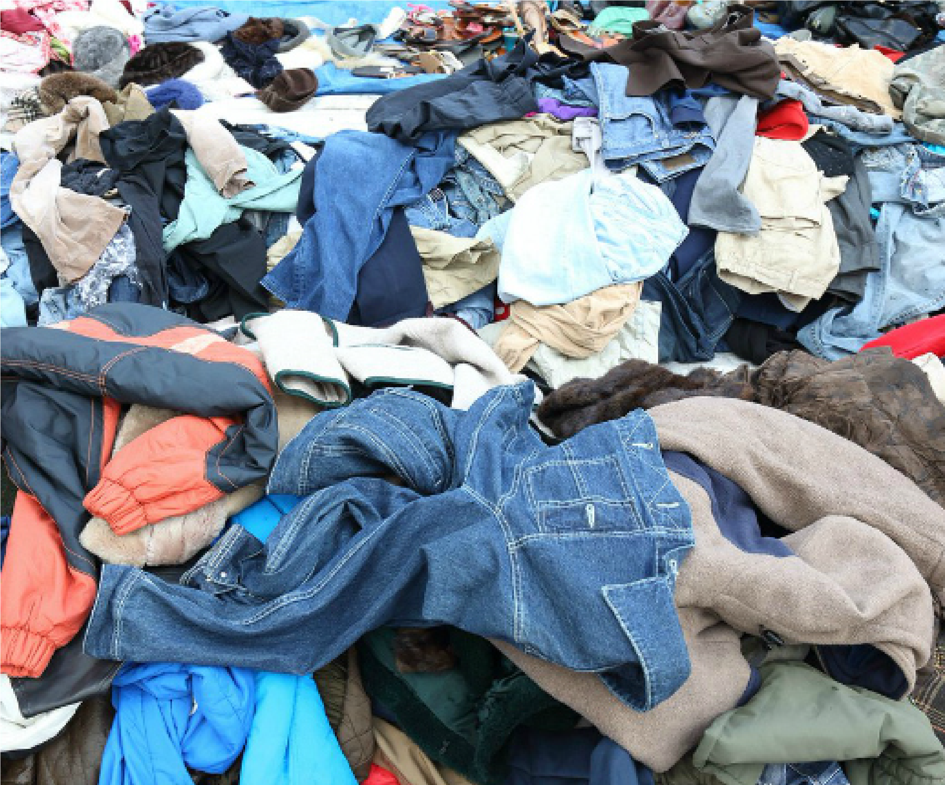

Every second, the equivalent of one garbage truck of textiles is landfilled or burned. Australian alone discard 23 kilograms of clothing per capita every year and this results in six tonnes of textiles and clothing contributed to landfills in Australia every 10 minutes. If nothing changes, by 2050 the fashion industry will use up a quarter of the world’s carbon budget.

Globally, the fashion industry is the second largest polluting industry after the oil and gas industry, producing 20 per cent of global wastewater and 10 per cent of global carbon emissions year. This is an amount larger than that of international flights and shipping combined.

If the average life of clothing was extended by just three months, it would reduce their carbon and water footprints, as well as waste generation, by five to 10 percent.

Just because we’re bored of the clothes in our wardrobe doesn’t mean someone else won’t wear them.

According to US consignment store group, ThredUp, the resale of second-hand clothing has grown 21 times faster than retail apparel over the past 3 years. This statistic demonstrates that the future of fashion definitely has a place for second-hand clothing.

Most of the distribution for resale clothing happens in retail consignment stores or websites. Not overly convenient, nor easy to use. There is now a clothing specific marketplace which gives users a simple to list and buy option for pre-loved clothing, and accessories.

The ReHomed Clothing Marketplace uses pre-populated filters to list products, which means buyers do not get inundated with cluttered search results as they do with most other marketplace searches. It’s really simple to use.

The clothing items being listed on ReHomed, whilst second-hand, are more than often used once or twice with many items not even worn, they are new with tags still attached. Created by Sydney based parents of a young adult daughter, Rogan and Kim Carroll see that clothing churn first-hand.

Whereas typical marketplaces tend to be ‘local’ with pickup as the default relying on a narrow geographic reach, raising many issues with face-to-face transactions, ReHomed has made it super simple for the buyer and seller to transact via tracked post-delivery. “Many a story has been recounted to me about getting scammed or forced to sell at a discount upon pickup using the likes of Gumtree or Facebook Marketplace. ReHomed doesn’t have that problem as the price is set, accepted, and not received by the Seller until the tracked item is received.” claims Rogan Carroll, co-founder of ReHomed Clothing.

The ReHomed Clothing Marketplace is available now for selling and buying pre-loved clothing. More information can be found at [www.ReHomedClothing.com](http://www.ReHomedClothing.com)

###

[www.rehomedmarketplace.com](http://www.rehomedmarketplace.com)

Instagram @rehomed_clothing

Facebook @ReHomedClothing

Statistics references:

<https://www.ragtrader.com.au/news/every-10-minutes-6-tonnes-of-clothing-goes-to-aussie-landfills>

1.<https://www.mckinsey.com/~/media/mckinsey/industries/retail/our%20insights/state%20of%20fashion/2022/the-state-of-fashion-2022>