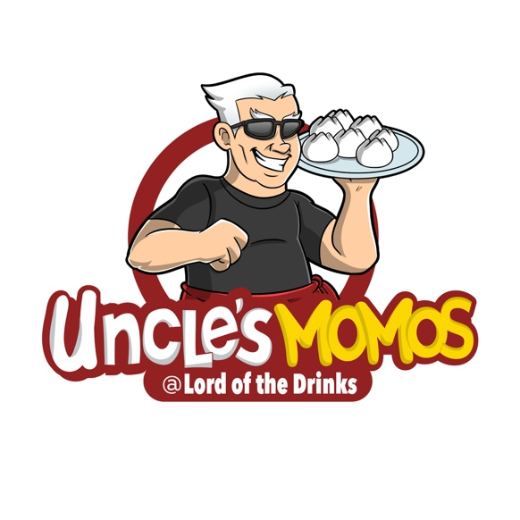
Media Release
For Immediate Release
20th July 2022

How Steep is Caxton St?

Luckily, it’s not so steep as to have much in common with Mt Everest…until recently. Now they share an exciting new similarity… you can find Himalayan Street Food in both locations.

A delicious new taste sensation has come to Petrie Terrace and, if you bear with us for a couple of more minutes, you will be in on the secret…think of it as being in the know on Himalayan Salt before the hippies (and “Entrepreneurs”) made all those pink lamps.

Uncle’s Momos has teamed up with Lord Of The Drinks to deliver Himalayan Street Food to Caxton St. Both brands are very well known and recognised in their cultural communities but working together in a premier Brisbane dining precinct is an exciting combination that you would be crazy to ignore.

In the foothills of the Himalayas, where the Newari Tribe sends out Food Venders into the streets of Kathmandu, the Himalayan Dumpling (or “Momo” to the locals) has held back the US Burger invasion entirely. The humble Momo has been the number one fast food on Mt Everest (and surrounds) for centuries.

With Crocodile from Rockhampton, Buffalo from Maleny, Kangaroo from Barcaldine, Chicken from Gympie and Veggies from local growers, this exotic food sensation has lower food miles than most of the stuff you buy at your local supermarket. Add to that the traditional Nepalese leaf plates it’s served on (called Tapari) which has a close to zero carbon footprint and delivers much needed economic benefit to remote Himalayan villagers without harming the source Sal trees. The fact that Momos are addictively delicious is only a little bonus, right?

Bipin Karki, owner of the Uncle’s Momos Group, said “Momos and Himalyan Street Food have been sold throughout Nepal, Tibet and in the shadow of Everest for centuries – bringing them to an iconic area within the Brisbane cuisine community is the culmination of a dream and a lot of hard work”

19 Caxton St is known, from a Brisbane heritage perspective, as “Berry’s Shop” and is estimated to have been built in 1880. Today it is the home of the next deliciousness to excite the Brisbane community.

Lord Of The Drinks offers a broad range of cocktails (and all of your favourite libations) while Uncle’s Momos delivers a whole new taste sensation that will quickly become your new addiction – you have been warned.

Initially opening for dining on Thursday, Friday and Saturday evenings from 5pm, Uncle’s Momos at Lord Of The Drinks will also open for Suncorp Stadium Event days and for Private Functions while additional regular hours are being planned. Bookings, particularly for larger groups and functions, are encouraged. Bookings can be made by email at kitchen@unclesmomos.com.au.

What’s a Momo?

The deliciousness known as the Himalayan Dumpling or Momo started in Nepal back in the 1300s – that makes them 700 years old! (Don’t worry, at Uncle’s Momos they believe in stock rotation). Momos were initially a Newari food in the Kathmandu valley. It was later introduced to Tibet, China and as far away as Japan by a Nepalese princess who was married to a Tibetan king in the late 1400s.

Today, Momos are the most popular food throughout Nepal – home of the peak of Mt Everest. It’s said that you can’t walk 100 metres in a Nepalese city or village without finding a place selling Momos. Buffalo Momos are the most popular type in Nepal.

Uncle’s Momos is very proud to provide you with the opportunity to eat Momos created using the authentic Himalayan recipe along with their fusion contribution to Australian cuisine in their Crocodile and Kangaroo dumplings.

About Crocodile Momos

Uncle’s Momos World’s First Crocodile Momos are created using meat that is ethically sourced directly from a Queensland farming operation. Be ready to try a completely different meat – perhaps you’ve had red meat like buffalo, or white meat like chicken or fish, this is reptile! We don’t want to freak you out too much….but …. if you have ever wanted to know what a dinosaur tasted like, here is your chance!

Crocodile meat looks like fish, cuts like chicken but cooks like fish and, when prepared properly, has a taste unlike either. Don’t believe the hype, it doesn’t taste like chicken at all!

Crocodile meat is low in fat and high in protein, so, if even if you’re not on a “cheat day”, you are good to go without any guilt.

Uncle’s Momos sources certified Halal meat wherever they can, but, if you really think about it, no one was keen to sign up to provide Halal crocodile meat so their crocodile meat IS NOT Halal.

About Uncle’s Momos Buffalo Meat

Water Buffalo have been present in Northern Australia since the 1820’s when 41 Asian Water Buffalo were imported. By the 1980s there were approximately 400,000 feral buffalos causing massive damage across the Top End. A cull program was set up and the feral population was reduced to under 100,000.

The international demand for Asian Water Buffalo meat and hides meant that some enterprising farmers around Australia have since developed carefully managed domesticated herds.

Buffalo meat is very low in fat (less than 2%) and comparatively low in cholesterol. This leanness makes buffalo meat very healthy. The fat composition in the lean meat has a higher proportion of polyunsaturated and omega 3 fatty acids than in chicken, lamb or beef. Buffalo meat has been found to be very high in protein, iron and zinc content.

Uncle’s Momos sources ethical best quality Australian Buffalo Meat from Maleny in the Sunshine Coast Hinterland.

