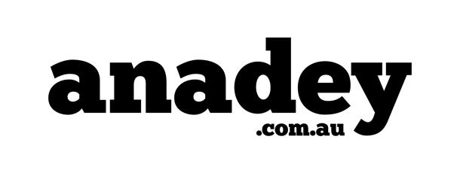

**PRESS RELEASE**

**14th July 2022**

**Anadey: Bridging the Sustainability Gap in Australian Homes**

*Reimagining How Every Australian Cleans Their Home & Takes Care of Their Family’s Health.*

**Melbourne, AUSTRALIA (July 14, 2022)** – Anadey announced today the launch of an additional ten sustainable brands to be stocked on anadey.com.au. In addition to a brand-new rewards program. Following a successful launch in April 2021, the brand has seen hyper growth, now with over 500 products available to purchase. Anadey specializes in small household goods, with a focus on the highest quality, healthiest, unique, and exquisite products.

“Anadey was built on the principle of giving back. We give back to the communities we operate in, we give back to the environment, and we give the power back to the customer to start living a more sustainable & healthy life. Our offer is simple: provide you with the best products, delivered fast at competitive prices” – Mina Tadros, CEO Anadey. Anadey’s new products can be found at anadey.com.au

An online retailer of sustainable home care and personal hygiene products. With over 20 years of combined retail experience within their leadership team, they are re-imagining the retail industry in Australia and innovating daily to bring the best sustainable brands from around the world to their customer’s doorstep in the shortest time possible. Anadey also provides carbon neutral deliveries and is committed to achieving a zero-plastic pledge, sustainable, plastic free products which the next 10 years.

"We protect our planet by selling products that don’t have damaging consequences to the environment, our homes, our families and our earth. Our brands have sustainable packaging, and materials which are thoroughly picked by our dedicated buyer’s team to match our environmental & sustainability framework." – Nancy Ayad, COO Anadey

For further information please contact:

Casey Solomon – [cs@anadey.com](mailto:cs@anadey.com)

Find the Brand Online:

<https://www.facebook.com/getanadey> | <https://www.instagram.com/getanadey/>

**About Anadey:**

Founded by Mina Tadros in 2021, quickly becoming the market leader of sustainable cleaning products in Australia. Since inception its core values include delivering sustainably made products, fast delivery, giving back to communities it operates in and promoting locally made products.