PRESS RELEASE

Kim Clark  Kimc@kimoclark.com  +61 478072670  https://www.instagram.com/kimoclark/  24 August 2022 | 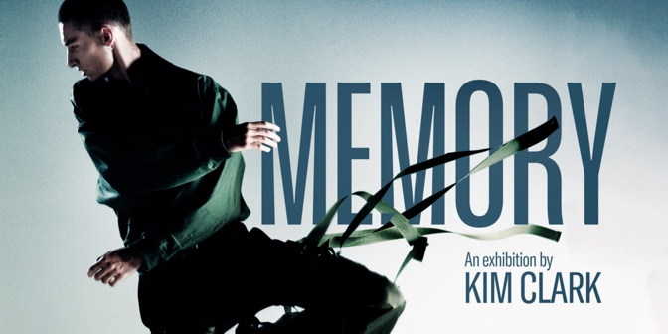

Collection Exhibition Memory by Kim Clark

Inspired from many conversations with her father about the wars their country experienced, Kim’s collection Memory 2022 celebrates peace and triumph of life. The collection features both men’s and women’s clothing, derived from research of military uniform during France’s war in Vietnam.

Skilfully using subversion method in design, Memory introduces strong colours, silhouettes with tailoring techniques to create uncomplicated designs, transforming this sombre architype to frivolity. From laser cut rose petals blazer inspired from camouflage loose leaf military uniform to parachute dress made from pure silk and delicate banded white dress inspired from a wounded soldier photo, the collection is a playground of technical skills to produce fun, cool and wearable garments.

The collection was created with an eye on sustainability. Many pieces are made from used military tents and surplus, local deadstock and silk.

Kim graduated with Master of Fashion Design from RMIT in 2019 and national winner of the prestigious Australian Fashion Foundation (AUSFF) award in the same year.

The exhibition on 16 September will showcase the collection Memory and her short fashion art movie. The audience will experience Kim’s work in different media, bringing the audience up close with many fashion pieces and art works with unique installation in a relaxing ambiance with live DJ.

Exhibition detail:
380 Smith Street, Collingwood 3066
Melbourne.
Date: 16 September 2022
Time: 6:00pm-10:00pm

