Press release: August 2022

Melbourne-based multidisciplinary engineering firm launches in Queensland

FSC has announced the launch of its Queensland office, located in Riverside Centre at 123 Eagle Street, in the heart of the Brisbane CBD.

FSC is a multi-disciplinary design, engineering, project management and environmental consultancy. FSC has a fresh approach to engineering and is proud to be a people-first company. Our team are experienced in small and large projects, and are brought together through shared passion for sustainable, safe project planning and delivery. Our team is results-driven, bringing technical excellence, practical outcomes, collaboration and innovation to projects.

In launching the Queensland office, FSC has appointed a principal, Niall Keown, as Queensland Manager. Niall is an experienced project manager and engineer with experience managing complex projects at various stages. Niall has returned to Brisbane recently after a stint in Melbourne where his experience included senior contractor and client-side roles on major infrastructure projects.

Since launch, the team has recruited two local engineers to join FSC and won work on some major local projects including Brisbane’s Cross River Rail and the Garth Prowd Bridge upgrades in Noosa.

This announcement comes as FSC has signalled its intention to diversify its geographic locations further, with Sydney also firmly in its sights. FSC has continued to grow its existing service lines with total staff numbers across FSC Group now 70.

FSC looks forward to the Queensland team’s growth and success.

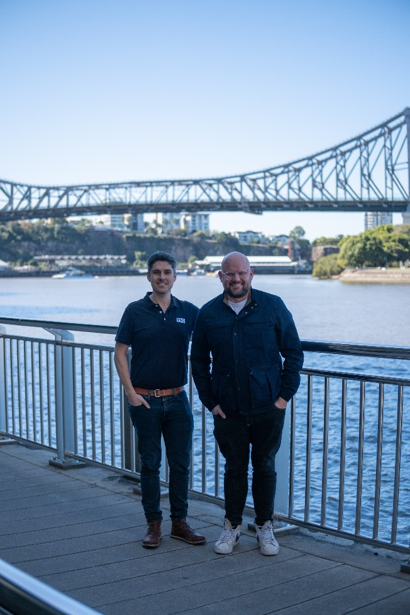

Niall Keown, FSC Queensland Manager and Travis Baker, FSC General Manager.