For Release Time

7/10/2022

Balmy nights and neon lights can only mean one thing!

Love Island Australia is back!

Custom Neon announces partnership with Love Island Australia! And says…

“This season’s neon placements are set to get pulses racing!”

**Geelong— 7/10/2022—** LOVE Island is on its way back and as temps are set to soar in Australia, it’s getting extra Scorchio in the Mallorca villa!

From what we know of the cheeky bedroom décor, things are about to get… interesting!

The Love Island Australia villa has had an extra bold makeover this season, with a few additional twists!

Of course, LED neon signs will be dazzling in the villa with puns like “Limbo lounge”, “nice buns hun” and “hot girl summer” to name but a few!

The stunning villa oozes bright vibrant colours, which evoke fun and socialisation, whilst the zesty wall décor and dripping orange neons, can’t help but make the Islanders feel, well…a little bit fruity!

The Outdoor area boasts comfy, cushion adorned day beds for cosying up, whilst the crystal pool is super inviting when things are getting a little too hot to handle!

The Outdoor exercise area, with neon emblazoned FLEX, encourages Islanders to work on their physique!

Ooooh show us your best squat! “Nice buns hun!”

Image provided by [Custom Neon](https://customneon.com.au/). Official Love Island Australia Partner

As these hottie hopefuls enter the villa, they have one thing on their mind….. Lurve! Oh and $50K….. Oh and fame!

To win over viewers and a potential match, they’ll need to pack their social A-Game!

Fortunately, the energy and ambience of the place, along with the flirty icebreaking games, islanders will soon get the conversation flowing.

Will the beanbags be back in this series? Let’s hope the cursed yellow bag got torched!

Image provided by [Custom Neon](https://customneon.com.au/). Official Love Island Australia Partner

What décor item will be the kiss of death this time?

Our monies on the Flamingo!

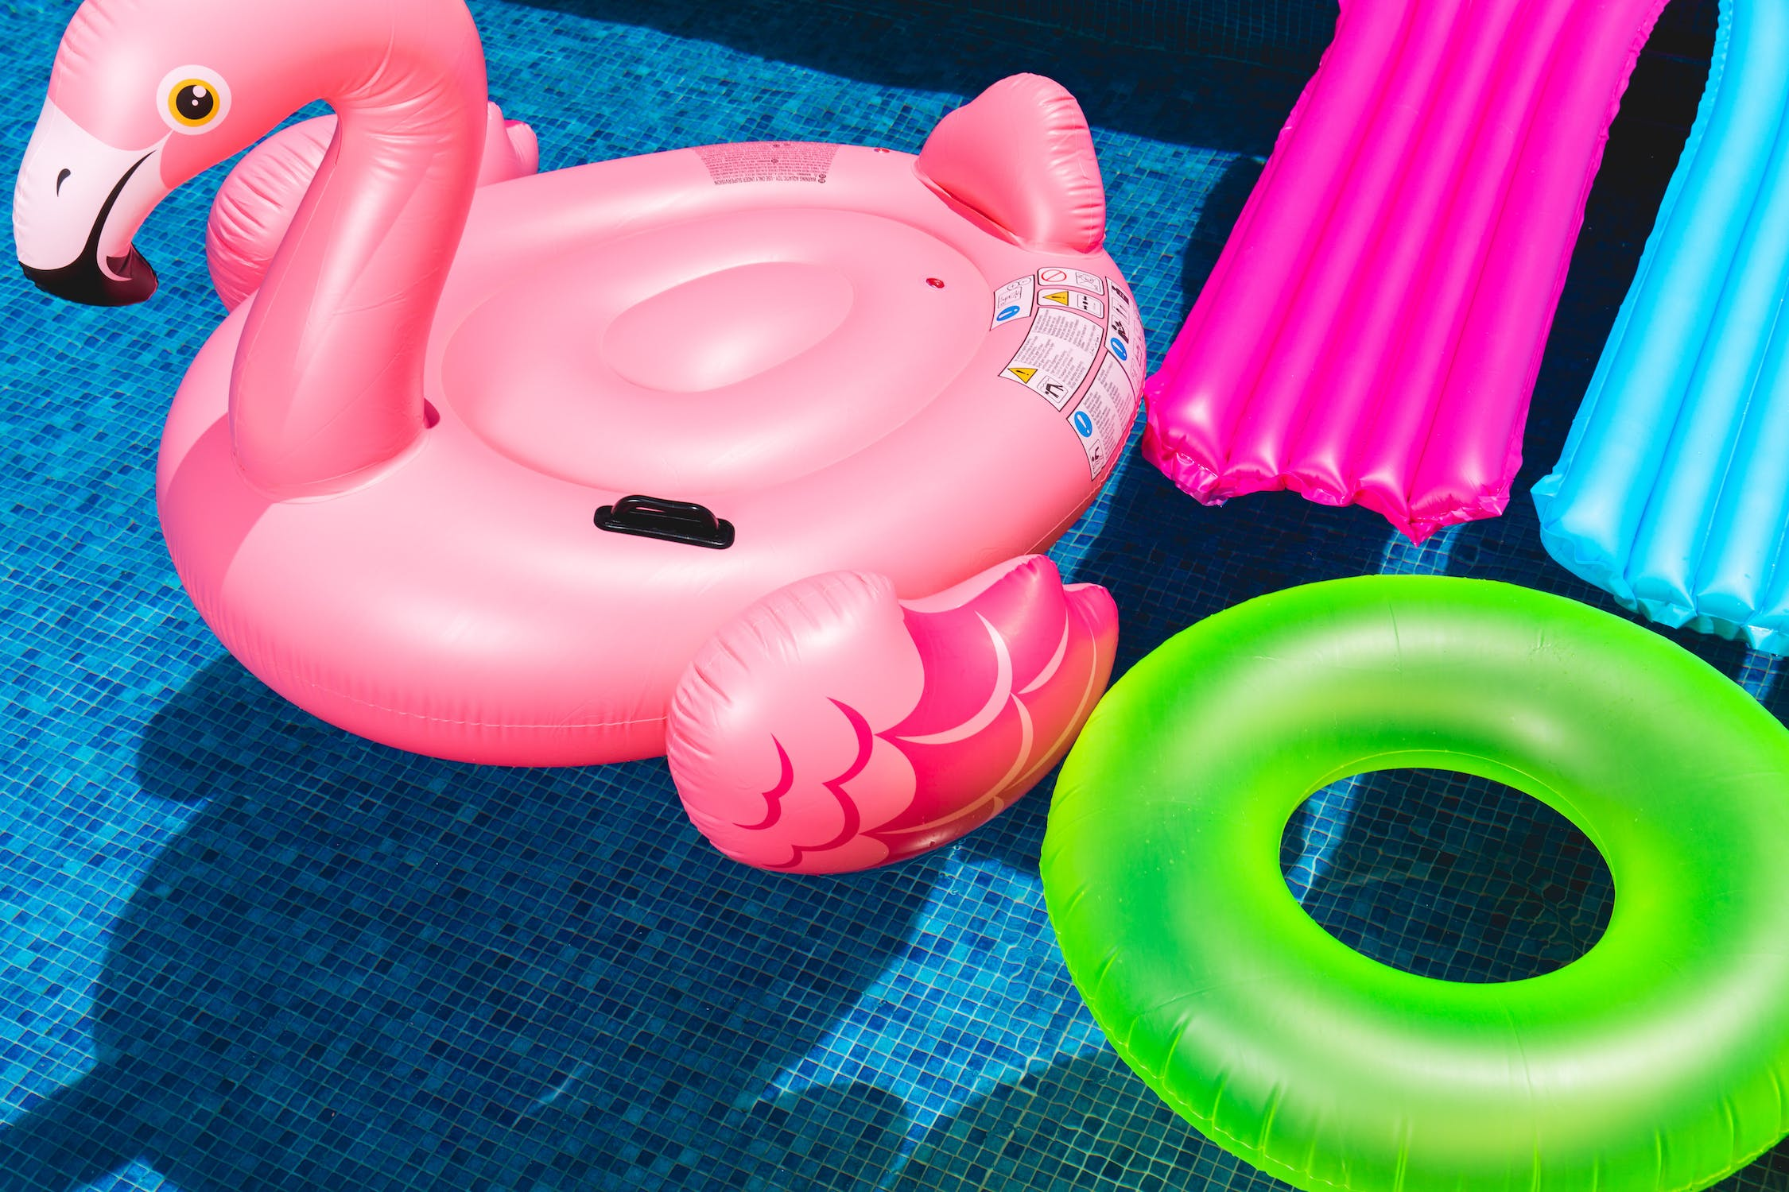

The villa has neon signs strategically positioned throughout the house, one of the largest, a striking hot pink mobile phone coupled with the words “I’ve got a text!”

These words can be heard ringing out, as a chosen contestant is sent a text with exciting news! A flirty game, a sexy new arrival, or a hot challenge!

These texts usually result in an absolute furore of screaming, laughter and bikini’d babes going bonkers!

Love Island Australia will be hitting our screens this month and the latest décor twists are sure to promote passion, energy and action!

So whether you love it or hate it, soon you’ll be captivated by the drama, dreamy bodies and décor!

Come on Sophie! Turn up the heat!

# For more information, press only:

Clare Jones

[1800 725 574](tel:1800%20725%20574)

https://customneon.com.au

# For more information on Product:

# https://customneon.com.au/