**Media Release**

|  |  |
| --- | --- |
| **16 October 2022** |  |
|  |  |

**New Covid-safe school launches as term four begins with no isolation requirements**

FOR IMMEDIATE RELEASE

**A new Covid-safe primary school alternative is being offered in Australia for the first time at Stirling in the Adelaide Hills and in Perth.**

Pod School is based on small group outdoor learning and engagement with nature. The school aims to help meet the challenges of Covid-era parenting, which have again been thrown into the spotlight in recent days as all remaining isolation requirements are dropped.

“For a lot of us parents it is daunting to send our kids to school knowing that other children and even teachers are likely to be coming in Covid positive,” Pod School founding parent Julie Marron said.

“We want better for our kids than repeated infection and until now there haven’t really been any other options.”

The Pod School movement has risen quickly, driven from the grass roots by concerned families. Pods are made up of eight to ten children of similar age. Learning takes place outdoors in nature wherever possible. Families work together to keep Covid out of the Pod, and to minimise any risk of ongoing transmission should Covid manage to get in. Indoor spaces are well ventilated, and masks are worn.

Keeping the group small further reduces Covid risk as well as enabling a level of attention from teachers that isn’t usually possible in school.

“We think this is the future of education,” said Ms Marron. “It ticks so many boxes, learning from nature, being community driven, and Covid safe.”

The idea of Pod School has been spreading quickly. Since news of the first pod in Adelaide first emerged on Twitter, pods have sprung up in Perth and as far afield as Canada, with significant interest across Australia. Pods in other parts of Adelaide are also on the cards. It seems there is an appetite among parents for a safer school alternative.

The Adelaide Hills and Perth Pod Schools are set to open for the start of the school year in 2023 and are calling for families to register interest by 7 November. For more information visit [www.podlearning.au](http://www.podlearning.au).

Ends.

**Pod School**

Pod school is a Covid-safe alternative to primary school in Australia. It is re-thinking school and offering a new model of education to help meet the challenges of Covid-era parenting. We all want to give our kids everything they deserve: a wonderful educational experience, strong social connections, and the chance to live a full and healthy life. Pod School offers a way for parents of primary school children to do all this. Pods provide a low Covid risk environment with a small group and a short week, based on outdoor learning. The goal is to keep Covid out of the Pod, and to minimise any risk of ongoing transmission should Covid manage to get in.

**Media contacts**

Julie Marron  
Pod School (Adelaide Hills Pod)  
0403991440  
[podschool2023@gmail.com](mailto:podschool2023@gmail.com)

Renee Irvine  
Pod School (Perth Pod)  
0405 534 505  
[podschool2023@gmail.com](mailto:podschool2023@gmail.com)

**Related links**

[www.podlearning.au](http://www.podlearning.au)

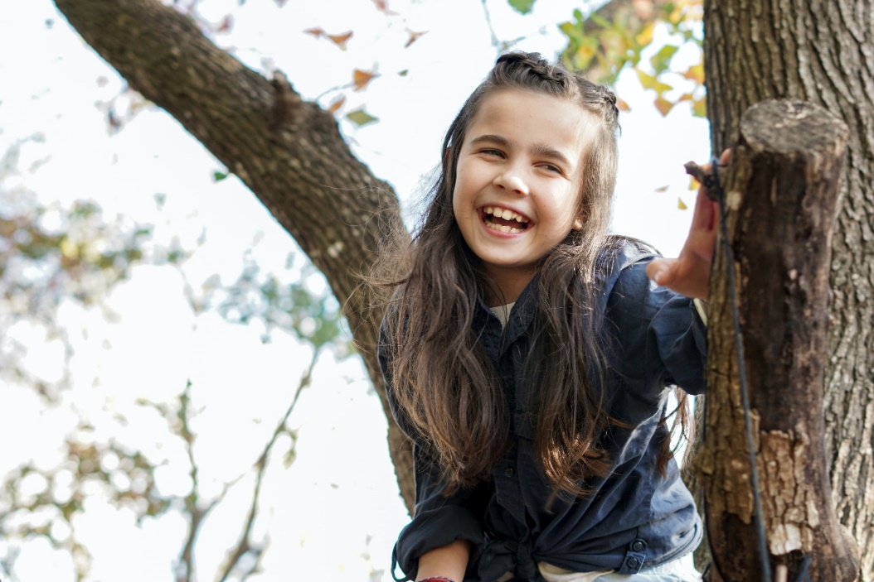

Photo credit: Izzy Park on Unsplash