The Hon Anthony Albanese MP

Prime Minister, and

The Hon Peter Dutton MP

Leader of the Opposition

Parliament House

Canberra ACT 2600

Dear Prime Minister and Leader of the Opposition

We are at a crossroads. There can be no doubt Australians overwhelmingly want to resolve the mutually felt burdens of our past and build a new settlement together, one that celebrates the rightful place of Indigenous heritage in Australia’s national identity.

The time for showing leadership is now. It is in this way the Australian people can be united rather than further divided, and as a nation we can become the very best version of ourselves, one that celebrates our many stories and layered identities, including most fundamentally:

1. The story of its foundations 65,000-year-old continuously living culture of Indigenous people.
2. The story of the British institutions built on these foundations, transported from the United Kingdom more than 230 years ago to be the democratic heritage of all Australians.
3. The story of multicultural migration which brought gifts of people and their cultures from all over the planet making us one of the most diverse and peaceful societies on earth.

It is through showing leadership and love too that we can build a new partnership between government and Indigenous Australians to close the gap on the shocking disparity that continues to afflict First Nations families and communities, despite all the substantial effort that our clever country has devoted over many years to ameliorating our disadvantage.

We all know the top-down, government-led approach to closing the gap does not work. This is precisely why you have both committed to empowering approaches and have agreed that structural reforms are necessary to achieve the changes we all want to see. The National Agreement on Closing the Gap negotiated with Aboriginal and Torres Strait Islander Peak Organisations in 2020 to improve the effectiveness of closing the gap efforts, made empowerment and structural reform a clear and shared priority.

The proposal for constitutional recognition to guarantee us a Voice in decisions made about us is the structural change needed to build a new empowering partnership between Indigenous Australians, government, and the Australian people.

We need a Voice to ensure local Indigenous communities across all of Australia’s diverse regions can be heard. To close the gap, it is local people not just politicians who need to have a say.

Politicians of all political persuasions have had their chance over a long period — yet the devastating tragedies of Indigenous child protection, incarceration and suicide continue to worsen and too many of our people simply cannot fulfil their potential. A Voice will create a shift from the current approach that is not working, to a more empowering partnership where negotiation and agreement making is commonplace between Aboriginal and Torres Strait Islander people and governments.

After more than 230 years, many hard-won lessons, and 15 years’ worth of democratic processes to deliver on the bipartisan promise of constitutional recognition of Indigenous Australians, the proposal for constitutional recognition to guarantee us a Voice in the decisions made about us is the only viable pathway forward on the table. This is Indigenous Australians saying, ‘we want in’. We want in to the Australian Constitution. We want to be part of Australia, formally and permanently.

The proposal will be put to the Australian people in 2023. Such a crucial juncture in our nation’s history, behoves you to work together.

Prime Minister, we implore you to reach out to the Opposition and establish a proper bipartisan approach to develop the detail of the Voice model. This process may well be ongoing beyond the referendum itself.

We agree that the referendum is not about the detail of the Voice but rather the principle that we should have a Voice. The operational details of the Voice will be set out in legislation in due course following a referendum. The details of the model are to be determined by the parliament and changes will be made from time to time as required.

Nonetheless, we can see further work could be done now in a bipartisan fashion to improve thinking about the Voice model even further. This would build on the work already done, including under the Morrison Government’s Co-Design process. While the Voice will continue to evolve over time, and future parliaments will continue to change and improve it in ways they see fit, we want to ensure the model at the outset is the best that we can devise, learning from lessons of the past.

Leader of the Opposition, we implore you to work constructively with the government. Like you, we do not want a Voice that does not effectively empower local Indigenous communities. We want this structural change so we can help drive the reforms needed to achieve practical outcomes — to overcome the scourge of entrenched and intergenerational addiction, poverty, violence, joblessness, and other aspects of our disadvantage that you continue to highlight.

We believe that you both want the best for Indigenous Australians and our country’s future. Surely, we are not still Australia’s most unloved people. We have complete confidence that if Australians support our constitutional recognition in 2023, we have something very positive to offer that will benefit all Australians. Through our partnership, together we can continue to grow and learn so we all share a stronger, brighter Australian future.

Yours sincerely

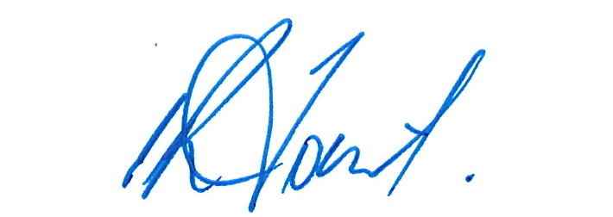

Ian Trust

Chair Empowered Communities Leaders Group

13 January 2023

*On behalf of Empowered Communities leaders:*

Fiona Jose, Cape York, Qld

Shane Phillips, Inner Sydney, NSW

Chris Ingrey, Inner Sydney, NSW

Paul Briggs, Goulburn Murray, Vic

Vickie Parry, Central Coast, NSW

Laurie Rankine Snr, Ngarrindjeri Ruwe, SA

Wayne Miller, Far West Coast, SA

Denise Bowden, North East Arnhem Land, NT

Anthony Watson, West Kimberley, WA

Tyrone Garstone, West Kimberley, WA

Des Hill, East Kimberley, WA

Mark Jackman, Ngaanyatjarra Pitjantjatjara Yankunytjatjara Lands, NT

Liza Balmer, Ngaanyatjarra Pitjantjatjara Yankunytjatjara Lands, NT