**"Inward": Lioness Film Productions Debuts Thought-Provoking Short Film Exploring Family Struggles During Pandemic**

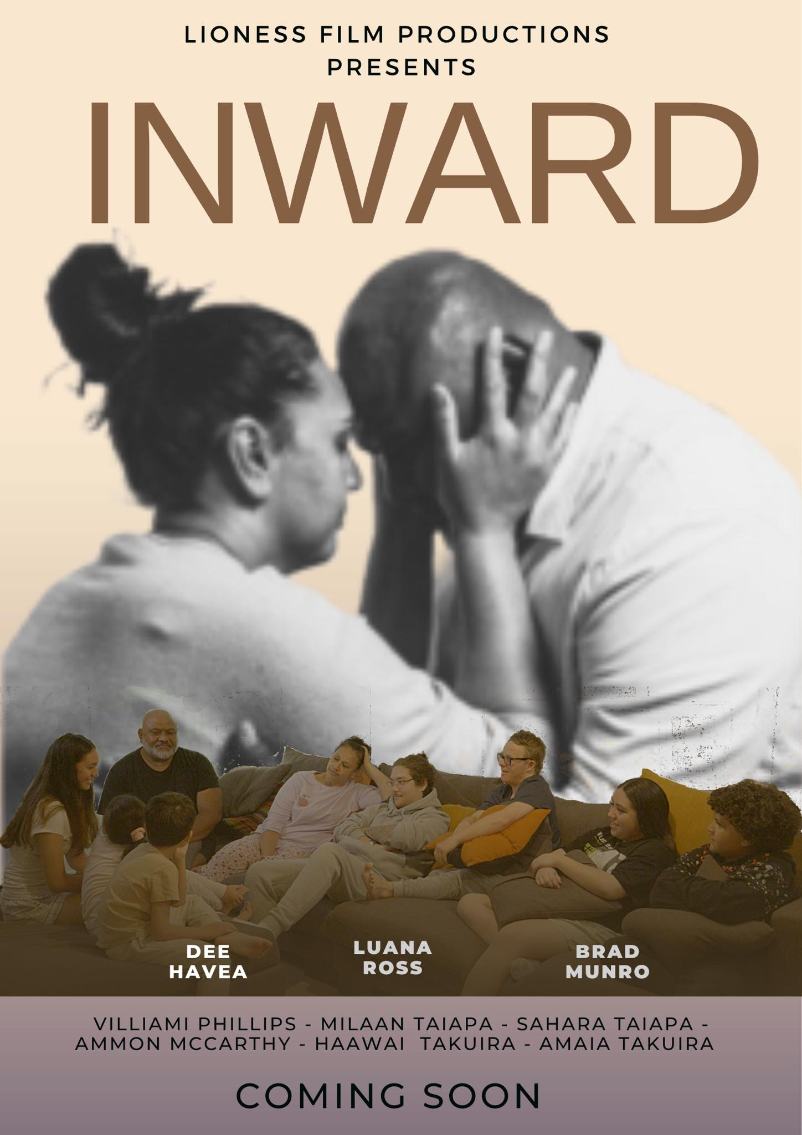

**Gold Coast, QLD, Australia** - Lioness Film Productions, an independent production house based on the Gold Coast, is excited to announce the premiere of their first film production, "Inward." Written and produced by Lepeka Lynn and directed by Liana Taiapa, the film delves into the lives of a large and disconnected family as they navigate their way through the aftermath of a pandemic.

The short film, shot on location on the Gold Coast in just two days, explores themes of suicidal ideation, body dysmorphia, online bullying, parental expectations, and the importance of families looking inward for support. With a cast that includes a Down Syndrome actor, "Inward" also breaks down stigmas surrounding people with disabilities and showcases the actor playing himself.

"Inward" follows the sudden loss of an affluent lifestyle, forcing the family to turn inward and face their own personal struggles. "With 'Inward', our goal was to create a film that would resonate with audiences of all ages and backgrounds, by exploring themes that are relatable to many families. I'm excited for the world to see this film and hope it will inspire people to be there for one another, especially during difficult times" - Lepeka Lynn, Writer/Producer of "Inward".

"We're thrilled to share this film with the world and hope it will inspire people to be there for one another, especially during difficult times," said Liana Taiapa, owner of Lioness Film Productions and the film's director and producer. "We're also excited to break down stigmas on people with disabilities and diversity of family”. Everyone has a voice and a story to tell."

The digital online launch of "Inward" will be held on February 6th, 2023 at 7 pm on the following pages:

<https://www.facebook.com/lionessfilmproductions>, <https://www.instagram.com/p/CnbovjWqflE>, <https://www.instagram.com/lionessfilmproductions>.

For more information, please visit Lioness Film Productions' website at [www.lionessfilmproductions.com.au](http://www.lionessfilmproductions.com.au).

**Media contact:**

**Company** **Name**: Lioness Film Productions

**Contact Person**: Liana Taiapa

**Phone**: 0413756054

**Email**: info@lionessfilmproductions.com.au

**City**: Gold Coast

**State**: QLD, 4214

**Country**: Australia

**Website**: [www.lionessfilmproductions.com.au](http://www.lionessfilmproductions.com.au)