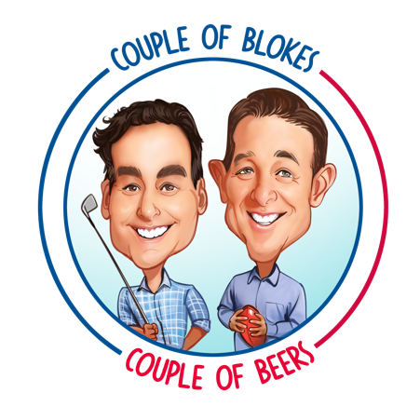

**Mark Allen & David ‘Ox’ Schwarz launch new *‘Couple of Blokes, Couple of Beers’* podcast.**

*Wednesday 8 February 2023*

*‘Couple of Blokes, Couple of Beers’* is a new weekly podcast hosted by two great mates: Mark ‘Marko’ Allen, and David ‘The Ox’ Schwarz.

Mark Allen played professional golf around the world for 15-years. He has worked at 3AW, Macquarie Sports Radio and SEN for over a decade. As a survivor of Stage 4 Bowel Cancer, Mark is now a Bowel Cancer Australia Ambassador and public speaker.

David ‘The Ox’ Schwarz is a former AFL star. Many experts regarded him at, or close to, the best forward in the game early in his career with the Melbourne Demons, however his footy career was cut short by three serious knee injuries. A reformed gambling addict, Ox has been off the punt since 2005, and has developed an impressive career in the media and public speaking.

Capturing the irreverence, fun, and rapport of their *“Ox & Marko”* partnership developed over many years on radio in multiple states, this new podcast takes their content to a new level and a new audience.

It’s a couple of blokes chewing the fat on anything and everything – but never getting too serious. The podcast runs for as long as it takes to sink a couple of quiet (occasionally noisy) beers.

Ox says:

*“Some would say a couple of beers for Marko is too many, and I agree. But after a couple he can tell a yarn like very few. So, strap yourself in as we roll the sleeves up over a couple of beers and let the truth run wild”.*

Mark added:

“*I’ve missed having fun with my mate Ox in front of a microphone. He’s a truly fun and, at times, complex fella and I fully intend to take the mickey out of all his unique complexities. Our new Podcast,* ***“Couple of Blokes, Couple of Beers”****, is perfect to fill that void”.*

The *Couple of Blokes, Couple of Beers* podcast is available now wherever you get your podcasts, or [here](https://www.coupleofblokescoupleofbeers.com/).

For further information or to speak with Ox or Marko:

Dan Bradley

*Kaizen Media*

+61 418 357 457

[dan.bradley@kaizenmedia.com.au](mailto:dan.bradley@kaizenmedia.com.au)

The *Couple of Blokes, Couple of Beers* podcast is Executive Produced by Kaizen Media, with Sound Design by Loud Zebra.