20th February 2023
FOR IMMEDIATE RELEASE

[HEADLINE:]
‘Pure’ Teleradiology Provider PRO appoints experienced Radiology CEO to lead its growth in the market.
[BODY:]
Sydney, Monday 20th February 2023:
Professional Radiology Outcomes Pty Ltd (PRO), the second largest ‘pure play’ Teleradiology provider in Australia, today announced the appointment of former CEO of Healius Imaging, Dean Lewsam, to lead its growth in the market.
Founded in 2009, PRO has largely flown under the radar and steadily accrued Imaging Center and Private Hospital clients seeking independent radiology reporting to build their businesses.
PRO’s cloud based RIS/PACS is unique in the market, enabling clients to be on-boarded more easily and quickly than any other provider in the industry.
Sean Cowan, the Company’s Co-Founder and Chairman said “It’s true that our IT set-up is impressive, what is even more impressive, and the real secret to our success, is our team. Our clients love that we have a deep focus of looking after their patients and referrers, which translates to our clients being able to focus even more on growing their imaging volumes.”
Mr Cowan said “PRO’s operating model is unique and highly supportive, integrating costly administration functions that allow our clients to focus on referral marketing.”
In-coming CEO, Dean Lewsam, has a wealth of experience in managing and growing Radiology businesses, most recently with Healius Ltd, where he spent seven years as CEO of the Imaging Division.
Mr Lewsam said “Teleradiology is absolutely the future of our industry. The incumbent corporate players recognize that and have various levels of competency in being able to adjust their IT architecture in order to execute on the opportunity.”
Mr Lewsam continued “PRO’s ‘pure’ Teleradiology model in a sense leap frogs what others are aspiring to and the opportunity to leverage PRO’s proven capabilities for exponential growth are exciting.”
Essential to the success of any Teleradiology Reporting service is the quality of Radiologists a business is able to attract and retain. PRO’s team of Reporting Radiologists have been consistent and growing, providing services through a mix of full-time, part-time and casual reporting enabling PRO to best meet the demands of their extensive client base.
“The flexibility that a private, tightly held company can provide is invigorating” enthused Mr Lewsam, going on to explain that he has many ideas on how to engage with Radiologists in ways that will be even more meaningful to them over the long term.
Mr Cowan said: “Dean’s reputation amongst the Radiologist sector in particular, is what attracted us to him; he is well-known, well-liked and well-respected and we’ll work together to build a framework that allows our high quality and loyal Radiologist partners to share in our growth”.
Mr Lewsam resides in Sydney and before taking the reins on March 6th, is getting married and will enjoy a short honeymoon, “A new life ahead” Mr Lewsam smiled.
Mr Cowan, as PRO’s Executive Chair, will support and help the transition of Mr Lewsam into the CEO role to ensure a seamless experience for the business and its clients.
The future looks bright in Radiology and PRO’s appointment of Dean Lewsam will lead strong growth in this leading Teleradiology Provider in Australia.
[ENDS:]

For further information:

Martine Hattersley,
Media Relations
Professional Radiology Outcomes
Email: Info@PROXrayManagement.com
Website: http://www.PROXrayManagement.com
Mobile: +61 0409877479

[PHOTOS:]

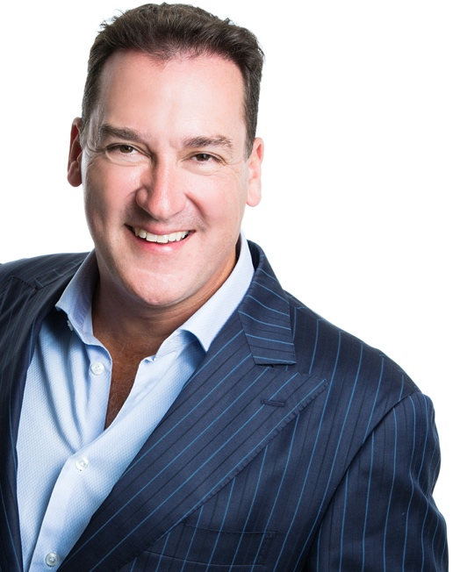
Sean Cowan
CHAIRMAN
Professional Radiology Outcomes Pty Ltd (PRO)
https://www.linkedin.com/in/seanfcowan/

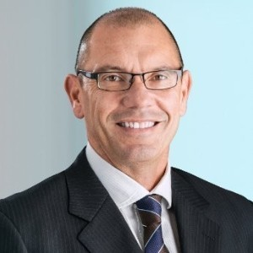
Dean Lewsam
CEO
Professional Radiology Outcomes Pty Ltd (PRO),
https://www.linkedin.com/in/dean-lewsam-ba44049a/

