17 April 2023

**Optus Announces Partnership with Leading Retailer Retravision**

Optus has announced a partnership with leading retailer Retravision to expand the telco’s distribution partner network across Western Australia, including its reach into regional WA communities.

For the first time, Optus prepaid products and offerings will be available in Retravision stores across Western Australia, giving even more local communities and businesses access to Optus telecommunications services.

Retravision Managing Director, David Dorsett-Lynn, said customers will benefit from Optus products being available to support their technology requirements in one convenient location.

“Connectivity is essential for all Western Australians. With many Retravision stores already supporting people with their technology needs, we saw a fantastic opportunity to support them further by including a range of Optus prepaid products in Retravision stores across the state,” said Retravision Managing Director, Chris Dorsett-Lynn.

Optus Territory General Manager WA, Paul O’Neill, said this is an important partnership for Optus.

“Our partnership with Retravision is an important part of our commitment to giving people across Western Australia, in particular Regional communities, a choice when it comes to deciding on a network provider. With continued investment into our network and infrastructure in Regional WA, it’s important that these communities have access to range of products and services Optus offer, now made available in select Retravision stores.

“Both Optus and Retravision shared an aligned values, passion and service to our customers. The long-term commitment from both sides is a representation of our ongoing dedication to Western Australia and we thank Retravision for their support and look forward to a successful partnership with even greater growth ahead of us,” said Mr O’Neill.

The partnership has seen Optus products and offerings available in five Retravision stores in Western Australia since late March 2023, with a further 14 sites launching across the state in the coming months.

**Media contact:**

Optus Corporate Affairs

02 9037 8179

[Media@optus.com.au](mailto:Media@optus.com.au)

Anthony Palozzolo

SOCIETY Marketing Communications

[optus@societymarcom.com](https://www.optus.com.au/about/media-centre/media-releases/2022/08/optus@societymarcom.com)

**Photo Caption:**

* Photo 1: (L-R) Jaysen Miguel – City Of Bunbury Mayor, Julie Broad – Bunbury Geographe Chambers Of Commerce, Wynn Setzinger – Retravision - Chief Information Officer, David Dorsett Lynn – Retravision - Chief Executive Officer, Paul O’Neill – Optus General Manager Regional WA, Alex Cassanet – Retravision - Category Manager Consumer Electronics

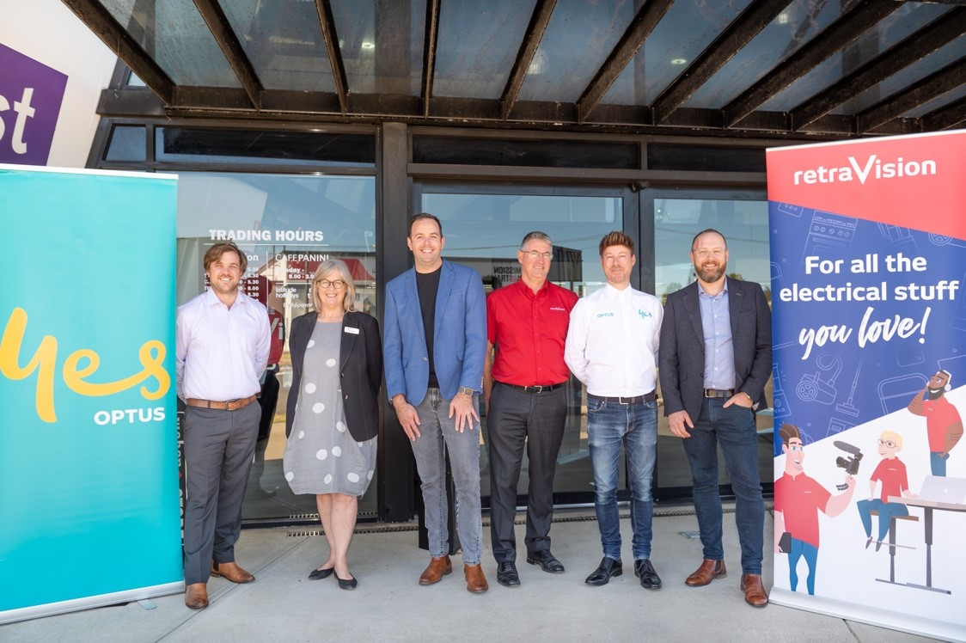

* Photo 2: (L-R) David Dorsett Lynn – Retravision - Chief Executive Officer, Paul O’Neill – Optus General Manager Regional WA



* Photo 3: (L-R) David Dorsett Lynn – Retravision - Chief Executive Officer, Paul O’Neill – Optus General Manager Regional WA

