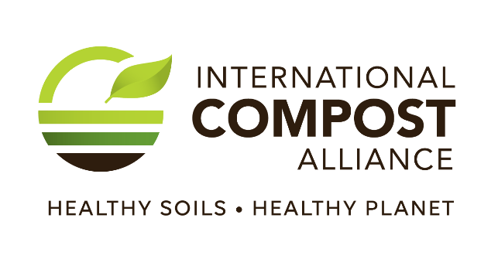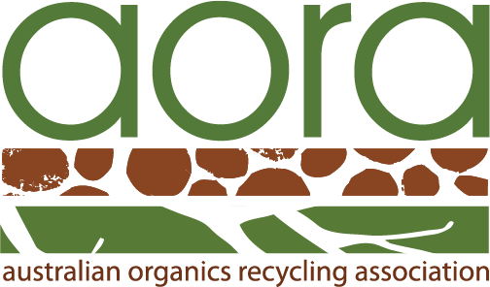
Media Release

FOR IMMEDIATE RELEASE

Contact: John McKew, National Executive Officer (Australian Organics Recycling Association)
john@aora.org.au / 0434 711 077

INTERNATIONAL COMPOST AWARENESS WEEK 2023 CELEBRATES COMPOST WITH THE THEME "FOR HEALTHIER SOIL, HEALTHIER FOOD...COMPOST"

- International Compost Awareness Week (ICAW) 2023, the largest and most comprehensive education initiative of the compost industry, takes place 7 – 13 May.
- ICAW 2023’s theme is ‘For Healthier Soil, Healthier Food….Compost’.
- Compost provides nutrients and organic matter to keep soils healthy to help enable the production of food to feed the world’s population.
International Compost Awareness Week (ICAW) is an annual international event that celebrates the benefits of composting and the role which compost plays in creating healthier soil and healthier food. This year's theme, "For Healthier Soil, Healthier Food...Compost," highlights the importance of composting as a sustainable source of fertiliser and critical addition of soil organic matter for our gardens and crops, while also significantly reducing waste, reducing greenhouse gas emissions, protecting biodiversity, and improving soil health. Without healthy soils, producing sufficient healthy food to feed our populations is at risk.

ICAW takes place from May 7-13 and is a time for governments, communities, organisations, and individuals to come together to promote composting and raise awareness about its many benefits. The International Compost Alliance (of which the Australian Organics Recycling Association is a member) is engaging with compost organisations around the world to highlight the positive climate and food nutritional benefits composting can bring. Composting is a natural process that transforms organic waste into a nutrient-rich soil amendment that can be used to improve soil health and plant growth.

Healthy soils are essential for a healthy food system. They provide the essential nutrients and minerals that plants need to grow and thrive, which in turn, supports the growth of healthy crops that are full of nutrients and flavour. Compost is an excellent source of organic matter, which provides a range of benefits to soil health. It improves soil structure, increases water-holding capacity, reduces erosion, and supports the growth of beneficial microorganisms. Compost also provides a slow-release source of nutrients to plants, which helps to reduce the need for chemical fertilizers and pesticides. As a result, composting helps to create healthier soils that support the growth of healthier food.

"International Compost Awareness Week is an important event that brings attention to the benefits of composting for our communities and our planet," said Peter Wadewitz, Chair, Australian Organics Recycling Association. "This year's theme, 'For Healthier Soil, Healthier Food...Compost,' highlights the important role that composting plays in creating healthy soils and promoting sustainable agriculture. We encourage everyone to participate in ICAW and learn more about how composting can benefit our communities and the environment."

To celebrate ICAW, communities and organizations around the world are hosting composting workshops, demonstrations, and many other types of events. Individuals can also get involved by starting their own composting system at home or in their community, getting to know the important workings at a local composting facility and by adding compost to their soil to improve their garden’s productivity and climate-resiliency.

For more information about International Compost Awareness Week and how to get involved, visit www.aora.org.au.

-ENDS-

Notes to Editors

The International Compost Alliance is comprised of:
The Association for Renewable Energy and Clean Technology (REA);
The Australian Organics Recycling Association (AORA);
Compost Council of Canada (CCC);
European Compost Network (ECN);
International Solid Waste Association (ISWA);
CRÉ - Composting and Anaerobic Digestion Association of Ireland;
WasteMINZ (Waste Management Institute of New Zealand);
The United States Composting Council (USCC); and
The Compost Research & Education Foundation (CREF)

The purpose of the alliance is for organics recycling organisations around the world to work collaboratively to maximise the recycling of organic wastes and advance the manufacturing of certified, high-quality compost to benefit the environment, society, and our members.

Currently, over 83 million tonnes of biowaste are recycled every year around the world. Not only does this recycle over 1 million tonnes of plant macro-nutrients, but, through storing carbon in soil and offsetting fertilizer use, it reduces greenhouse gas emissions by 9 million tonnes of carbon dioxide equivalents – an equivalent of driving an average car for 36 billion kilometres (23 billion miles); almost 95 thousand times the distance between the earth and the moon!
Despite our current success globally, our annual potential could be increased over 12-fold if all of the world’s unavoidable organic residuals were collected separately and composted.

