FOR IMMEDIATE RELEASE

**Twin Disc (Pacific) Pty Ltd becomes Exclusive Distributor for Seakeeper Ride in Asia Pacific**

BRISBANE, Australia - July 19, 2023 - Twin Disc (Pacific) Pty Ltd, a renowned leader in marine transmission technology and current distributor for Seakeeper gyro stabilizers, is proud to announce its exclusive distributorship of the revolutionary Seakeeper Ride, a groundbreaking Vessel Attitude Control System designed to enhance the boating experience for enthusiasts in the Australia, New Zealand and Asia regions. This partnership marks a significant milestone in Twin Disc Pacific's commitment to delivering cutting-edge solutions to the marine industry.

Seakeeper Ride is the future of stability and comfort on the water, offering unrivalled performance in controlling pitch, roll, and yaw. Unlike traditional systems, Seakeeper Ride harnesses custom proprietary inertial sensing hardware and software to actively counteract boat roll and pitch and improve onboard stability, ensuring an exceptionally smooth and enjoyable journey. This innovation enables boaters to maintain their desired course even in challenging conditions, resulting in enhanced safety and increased overall comfort.

"We are thrilled to be the exclusive distributor for Seakeeper Ride in the Asia Pacific region," said Glenn Frettingham, Managing Director of Twin Disc (Pacific) Pty Ltd. "The addition of Seakeeper Ride to our product portfolio strengthens our commitment to providing boaters with the latest advancements in marine technology. We are confident that this game-changing solution will revolutionise the boating experience and set new standards in the industry."

Seakeeper Inc.'s President & CEO, Andrew Semprevivo, also expressed excitement about the collaboration, stating, "Partnering with Twin Disc (Pacific) Pty Ltd as our exclusive distributor in Asia Pacific was a natural choice. Their extensive industry knowledge and reputation for excellence already with the Seakeeper gyro product range makes them an ideal partner for introducing Seakeeper Ride to this vibrant market. Together, we look forward to empowering boaters with unmatched stability and control, enabling them to make the most of their time on the water."

Seakeeper Ride is designed to integrate seamlessly into a wide range of boat sizes and types, making it an adaptable solution for both recreational and commercial vessels. Its compact footprint, simple installation, and low power consumption make it an ideal choice for boat owners seeking a reliable, energy-efficient stabilization system. By delivering a smoother ride and reducing fatigue, Seakeeper Ride opens up new possibilities for extended cruising, fishing, and watersports activities.

Twin Disc (Pacific) Pty Ltd will be releasing Seakeeper Ride to the Australia & New Zealand markets at the upcoming Sydney International Boat Show held in Darling Harbour, Sydney from August 3 -6, 2023 from their booth located at the Marina. To learn more about Seakeeper Ride, please visit [www.ride.seakeeper.com](http://www.ride.seakeeper.com). For more information, pricing & availability please email [ride@twindisc.com.au](mailto:ride@twindisc.com.au). For information on Twin Disc (Pacific) Pty Ltd and their comprehensive range of marine transmission solutions and stabilisation equipment, visit [www.twindisc.com.au](http://www.twindisc.com.au).

About Twin Disc (Pacific) Pty Ltd: Twin Disc (Pacific) Pty Ltd is a leading provider of power transmission technology, supplying high-performance products and solutions to the Australia and New Zealand boating & land-based product markets. With over 50 years of industry experience, Twin Disc (Pacific) Pty Ltd has earned a reputation for delivering cutting-edge technology and unparalleled customer support.

About Seakeeper Inc.: Seakeeper Inc. is the global leader in active gyro stabilization technology for the maritime industry. With a relentless commitment to innovation, Seakeeper continues to revolutionise the boating experience by virtually eliminating boat roll, enhancing stability, and improving comfort on the water.

Media Contact:

Chris Thompson – Seakeeper Product Manager - Twin Disc (Pacific) Pty Ltd

Phone: +61 7 3265 1200

Email: [chris.thompson@twindisc.com.au](mailto:chris.thompson@twindisc.com.au)

Video Link: <https://www.youtube.com/watch?v=N9_LH7I_-d4>

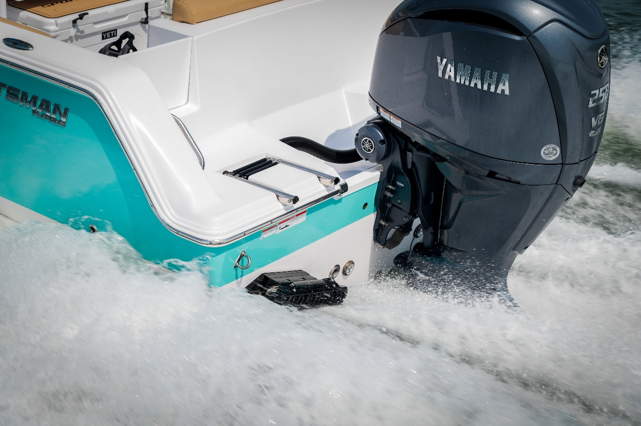Image Links:

