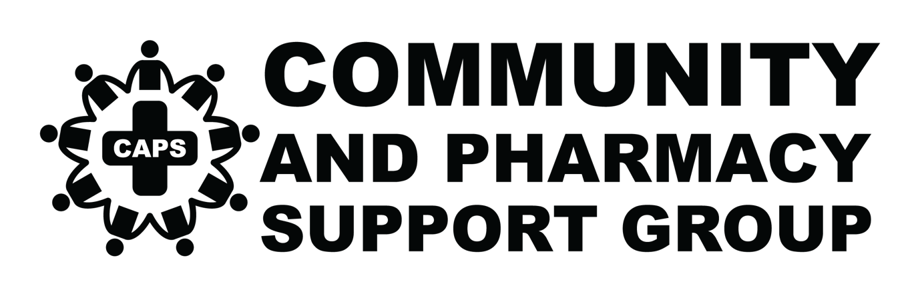

Media release
Pharmacy rally against 60-Day dispensing
Thursday, 17th August 2023
10 am St Andrews Square
(near Town Hall)
Immediate release: 11th August 2023

SYDNEY: On 17th August 2023, Community And Pharmacy Support Group (CAPS) - a group of approximately 150 individual pharmacies, pharmacists, interns and pharmacy students will "walk for awareness" to bring attention to the impact that the 60 Day Dispensing legislation will have on local pharmacies and most importantly, their patients.

The Federal Labor Government's 60-Day dispensing legislation will have a deep and negative impact on thousands of local pharmacies. It was designed and delivered without consultation with the pharmacy sector.

It is estimated that the new policy will result in over 20,000 jobs lost, cause over 600 pharmacies to close with another thousand struggling to survive. The biggest impact will be felt in regional and rural areas where the pharmacy is often the frontline of healthcare. These cuts are predicted to disproportionately impact the most vulnerable people in our communities.

Representative for the CAPS group Emil Demyane has said that pharmacists want to be able to deliver cheaper medicine for all Australians but without closing down pharmacies and robbing people of essential services.

"We ask that the government pause the 60-day dispensing until a new Community Pharmacy Agreement can be implemented.

"A better solution would be for the government to halve the co-payment cost so every citizen of the country has a fair go. A policy that helps a few Australians, is funded by their fellow citizens, and destroys a respected profession is definitely not a fair policy."

"As it stands, the only way for pharmacies to survive the cuts will be to charge for currently free services, reduce staff levels and open fewer hours. This will hurt patients and communities."

The rally will occur in Sydney on 17th August, beginning at Town Hall station and concluding at Martin Place.

Representatives from CAPS and the NSW State opposition will address the media at St
Andrews Square (Sydney Square) at 10:30 am.

CAPS is an independent group of NSW pharmacists.

For more information, please contact:

Pharmacist
Emil Demyane
0431 311 413
ecdemyane@gmail.com

PR
Amanda Lacey
0418 448 570
amanda@popcom.com.au

