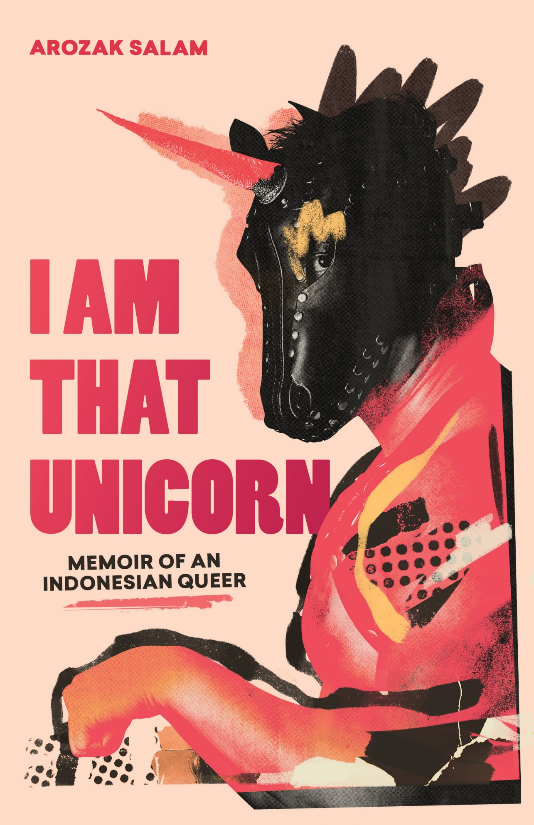

**FOR IMMEDIATE RELEASE**

**ON SALE: 31 August 2023**

**For more information contact:**

**Arozak Salam**

**+61 423 109 159**

**arozaksalam@gmail.com**

**www.thatunicorn.com**

Arozak Salam’s book ‘I Am That Unicorn: Memoir of an Indonesian Queer’ is now available for order, as an e-book or in paperback.

Sydney, NSW, Australia, [31st August 2023] — Arozak Salam’s memoir tells of his personal sacrifice and sheer will to stay true to himself, no matter what. Hailing from Indonesia, Arozak’s dream was to find a place where he could be free to live authentically and fearlessly as a gay man. Fate and relentless grinding brought him to Australia, a seemingly magical place with endless opportunity. But Arozak quickly learns that every rose has its thorns, and the price for pursuing his dreams is far greater than he imagined. This is the story of a celebration of contrasts and life’s full of spectrum from an immigrant’s perspective, a proud gay man from a conservative Muslim family, a subsea engineer by day and a unicorn burlesque performer by night.

‘At the beginning of the Sydney Mardi Gras march, I started healing from the oppression of being gay I had experienced back in Indonesia. I walked proudly, remembering how far I had come. I marched to remember the moment I chose to be a Pink Power Ranger…[and] how I got my first girlfriend in junior school so my friends would not call me a faggot…[and how I joined] an Islamic youth organisation at high school, hoping I would be cured. I marched to remember that after graduating, I had to find my own path instead of marrying a woman like my peers.’

Arozak Salam is an engineer by trade, as well as a former Australian navy officer, burlesque performer and singer. He immigrated to Australia in 2011 and lived briefly in Melbourne before relocating to Perth. After becoming an Australian citizen, Arozak moved to Europe but eventually returned to Australia, this time New South Wales. Arozak has performed as his unicorn alter-ego at Australian and international shows and events, and was a competitor in the Mr Gay World 2014 pageant. He continues to push boundaries as a performer, singer and queer POC.

I Am That Unicorn: Memoir of an Indonesian Queer

Arozak Salam

On sale: 31 August 2023

Price: $29.99

Pages: 234 pages

ISBN: 9780645843606

Visit www.thatunicorn.com for more information or to order a copy of the memoir.