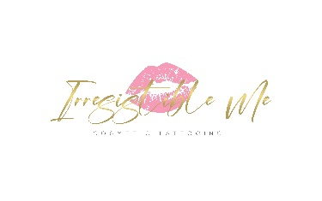**MEDIA RELEASE**

**Irresistible Me Cosmetic Tattooing**

Tuesday 22 August 2023

*For immediate release*

**New mentoring program to avoid botched brow tattoos**

Irresistible Me has just launched a mentoring program aimed at helping newly trained technicians avoid botched work.

A Cosmetic Tattoo qualification in Australia currently only takes 3-5 days.

“What you don’t get with that qualification is experience” says Tracey Langdon, CEO of Irresistible Me Cosmetic Tattooing in Springwood, Brisbane.

“3-5 days is just not enough time. Things can go terribly wrong when students leave the security of the classroom.”

“There’s just too much to learn and too much to remember, she says”

Tracey who has been a cosmetic tattooist for 6 years believes newly qualified technicians need time on skin alongside an experienced technician over a longer period of time.

“There are hundreds of people out there who have paid thousands of dollars for basic training yet have no confidence or experience to proceed.”

In response Tracey has launched a 12 week mentoring program she feels is long overdue for technicians who feel they need more time to practice, strengthen and reinforce what they’ve learn’t after basic training.

I’ve seen alot of botched work, it’s frustrating and expensive for clients who have already spent hundreds of dollars elsewhere.

“I’d like to see it stop.”

“I’ll be there helping them every step of the way to ensure their training locks in and they are fully competent and confident in the work they’re producing”

The mentoring program is open to anyone who has completed basic training in Australia or hasn’t been in the industry for a while and wants to refresh their skills.

“So much is changing all the time. Anyone who hasn’t invested in upskilling will be getting left behind.”

**More information here**: https://irresistibleme.com.au/brow-tattoo/mentoring-program/

**Media Contact:** Tracey Langdon

**Mobile:** 0402 250 192

Shop 5/29 Cinderella Drive, Springwood, QLD