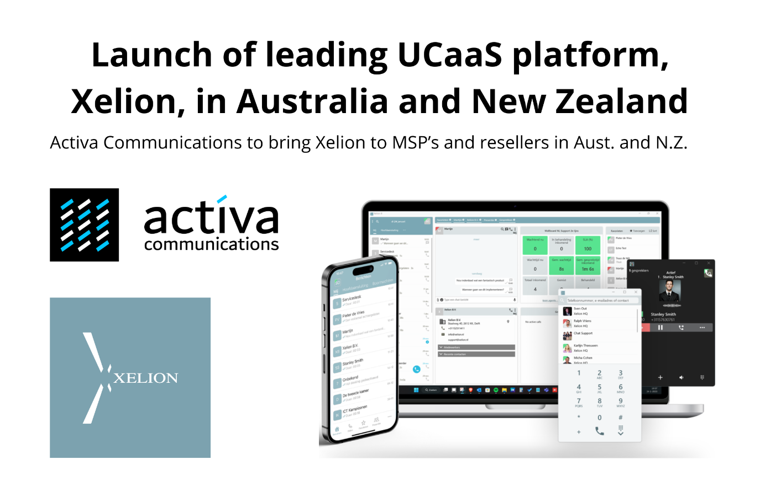

# Xelion Phone System now available in Australia and New Zealand

Sydney, Australia – 25th September 2023 - Xelion, a leading Unified Communications platform widely used in Europe and in the UK, is now available in Australia and New Zealand after the appointment of [Activa Communications](https://www.activacomms.au) as the exclusive distributor of [Xelion](https://www.xelion.com) in both countries.

Only available through approved partners, Xelion provides a true Unified Communications platform with powerful software applications for many platforms including Windows, iOS and Android.

*"After successfully launching and growing the Xelion presence in the UK I'm excited that Xelion will now be available in Australia and New Zealand. Xelion is growing rapidly because our partners and their customers see the value and power of the platform, and we look forward to helping Activa Communications to repeat our success in Australia and New Zealand"* said Dave Reynolds, Managing Director of Xelion UK.

The Xelion platform is now in use by over 200,000 people daily and represents a challenge to the established UCaaS players in the Australian and New Zealand markets. By including all features under a single license per user structure, regardless of the number of devices used, Xelion offers a fresh approach suited to small to medium sized businesses.

*"We evaluated a wide range of Unified Communications platforms and were truly amazed at how far ahead the Xelion platform is compared to other widely used alternatives. After the very public cybersecurity incidents involving other communications platforms recently, we feel that Managed Services Providers in Australia and New Zealand are ready for a fresh, powerful alternative they can offer to their customers"* said Jason Bock, Director of Activa Communications.

## About Xelion

With offices in the Netherlands, Germany, and the UK, Xelion is a growing UCaaS vendor. The Xelion platform is developed in-house and sold in the UK via a strict channel-only sales policy.

www.xelion.com

## About Activa Communications

Activa Communications is a leading distributor of connectivity and collaboration services in Australia. With services spanning from secure connectivity to unified communications, Activa empowers its partners and resellers to deliver performance and value to their customers.

www.activacomms.au

###