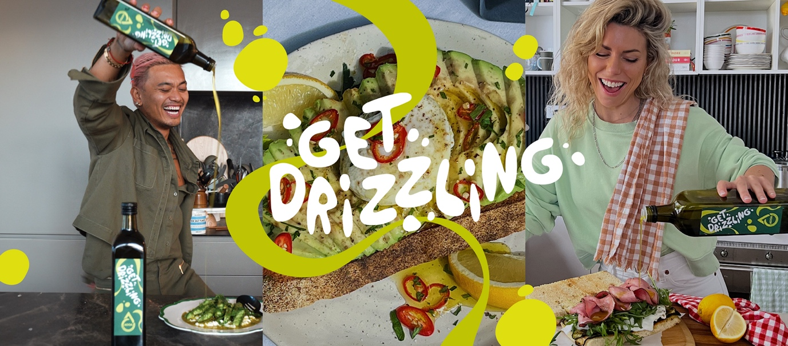

GET DRIZZLING AUSTRALIA!

The Australian Olive Oil Association (AOOA), in partnership with JOY, has launched their ground-breaking ‘Get Drizzling’ campaign, featuring Australia’s biggest tastemakers, drizzling olive oil to an energetic, tailor-made beat, inspired by the sounds of the kitchen.

Olive oil is one of the world’s best flavour enhancers, yet many Australians only use it for dressing salads or bread dipping. Most Aussies are unaware of its broad-ranging flavour potential - so, we set out to change that.

“Successful campaigns start with a highly focused opportunity, and we pinpointed a specific moment in our ambition - to get Australians to lift every dish by finishing it with a generous drizzle of olive oil before serving.” - David Valmorbida, President of the Australian Olive Oil Association

Behaviour change is no mean feat, especially on a budget, so we pushed aside the typical, over used views of olive groves and Mediterranean vistas, and the usual recipes calling for ‘1 tablespoon of olive oil’ - and replaced these with an integrated idea with edge and cut-through.

The ‘Get Drizzling’ campaign boldly asks and inspires Australians to take up the precise behaviour we desire and finish each dish with a drizzle of olive oil to make every dish delish.

At the core of the campaign, is a suite of videos featuring Australia’s biggest tastemakers – led by Khanh Ong, Leah Itsines and Lucy Rosenberg. Encouraging Australians ‘It’s time to drizzle, drizzle’ to add flavour, aroma and texture to their dishes, our tastemaker team drizzle olive oil with fun and flair over a range of unexpected and delicious dishes, while moving to a custom beat inspired by the sounds of the kitchen.

“We knew we had to feel big, so we strategically enlisted three of Australia’s most influential foodies, who not only lent their vibrancy and credibility in bolstering olive oil as a dish finisher but also delivered a drool-worthy content to spread the ‘Get Drizzling’ call to action across the brand’s digital footprint” – Josh Tan, Head of Social

To support the launch, a fresh new visual identity for the brand was developed, with a unique colour palette to reflect the joy and energy people get from great food. Brand devices were purpose-built to work in the social space to ensure we had the power to stop the scroll, and importantly, secure a memorable brand takeout.

“Collaborating with a client bold enough to create a new VI and campaign as vibrant and delicious as the dishes themselves was an absolute delight."– Libby Young, Creative Director

Credits
Australian Olive Oil Association
- David Valmorbida – President, Australian Olive Oil Association
- Jan Jacklin – General Manager, Australian Olive Oil Association
- Kristen Moxey – AOOA Campaign Committee Member

JOY Agency
- Luisa Paton - Head of Strategy & Insight
- Libby Young – Creative Director
- Josh Tan – Head of Social
- Sean Vrabel – Senior Copywriter
- Kate O'Donnell - Art Director
- Jacqui Ollevou – Group Media Account Director
- Stephen McNamara – Senior Account Director
- Kath Hunter, Multimedia Studio Manager
- Courtney Meyer – Influencer Talent Manager
- Amar Narula - Production Integration Director
- Joseph De La Hoyde - Music Composer

For more information:
Jan Jacklin
General Manager, Australian Olive Oil Association
gm@aooa.com.au
https://getdrizzling.au/
041753281

