| **Content-Type** | PR |
| --- | --- |
| **Suggested Topic** | **Aussies Opting for Natural Swimming Pools Over Traditional Pool*s*** |

**Must be reviewed and approved as these will appear in news media**

# Headline: Aussies Opting for Natural Swimming Pools Over Traditional Pools

Dateline: Perth, Australia], 20 Nov 2023

Australians are increasingly choosing natural swimming pools over conventional pools, embracing a more eco-friendly and visually stunning backyard experience.

[Natural swimming pools,](https://www.pasesaqua.com.au/natural-swimming-pools-dams/natural-swimming-pools/) a concept that originated in Europe, are now trending in Australia. These pools use freshwater and native vegetation for filtration, eliminating the need for harsh chemicals.   
  
Dr. Dulana Herath, a leading biologist and Managing Director of PASES Aqua, comments, "Natural swimming pools are not just about swimming; they are about creating a sustainable and harmonious ecosystem in your backyard. They offer a unique blend of organisms, functionality and natural beauty, making them an attractive choice for environmentally conscious Australians."

Herath further emphasises the health and environmental benefits of these pools. The absence of chlorine and salt in the water prevents skin and eye irritation, while the presence of native plants and wildlife enhances biodiversity. Moreover, these pools are cost-effective in the long run due to lower maintenance and electricity expenses.

The shift towards natural swimming pools reflects a growing awareness and preference for eco-friendly lifestyles among Australians. Snorkelling with fish, turtles, plants and macroinvertebrates is just what we do when we go camping and travelling,, so why not create these ecosystems at home at a similar price to traditional pools. These pools offer a sustainable alternative to traditional swimming pools, combining aesthetics, environmental responsibility, and wellness.

Contact Information: For more information, contact Pases Aqua, 08 9414 8040, 02 8379 2086 [admin@pases.com.au](mailto:admin@pases.com.au). Website : <https://www.pasesaqua.com.au/>

[PASES Aqua](https://www.pasesaqua.com.au/), led by Dr. Dulana Herath, specialises in creating natural swimming pools and ponds, focusing on ecological sustainability and innovative design.

Images:

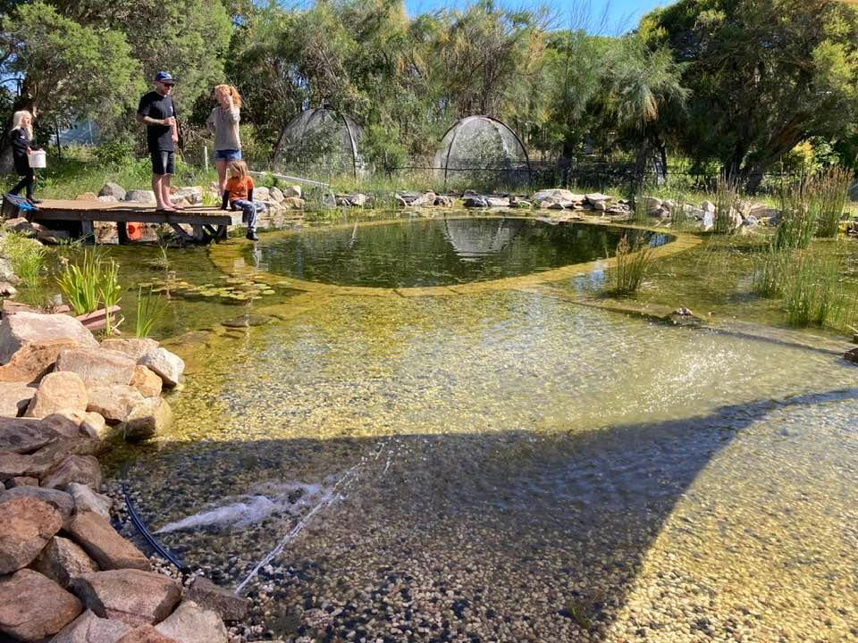

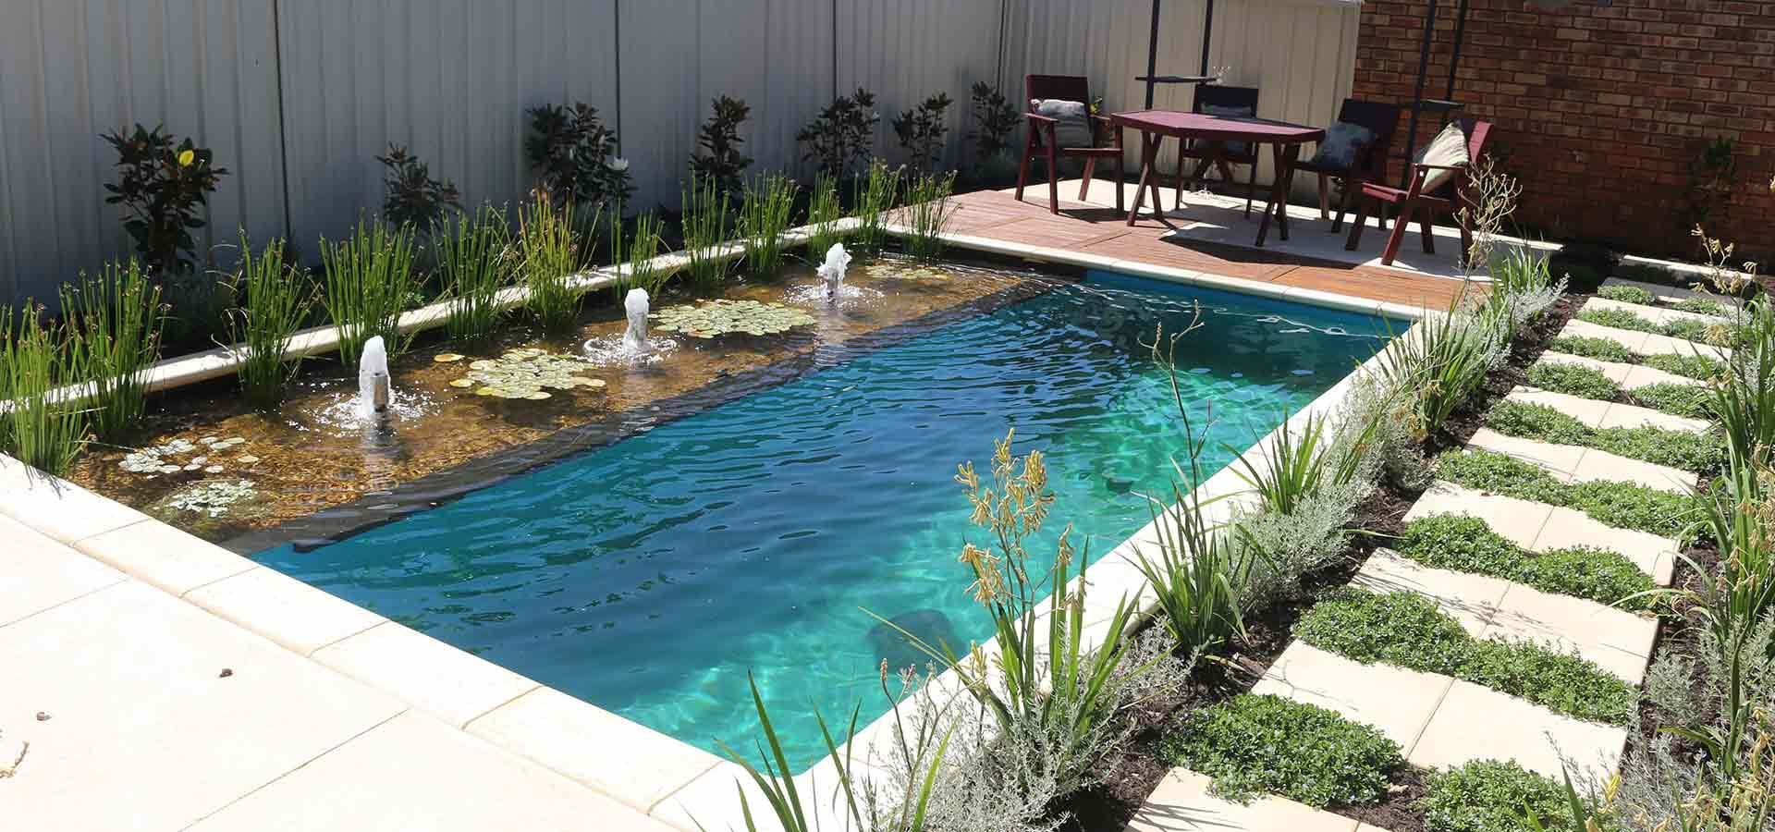

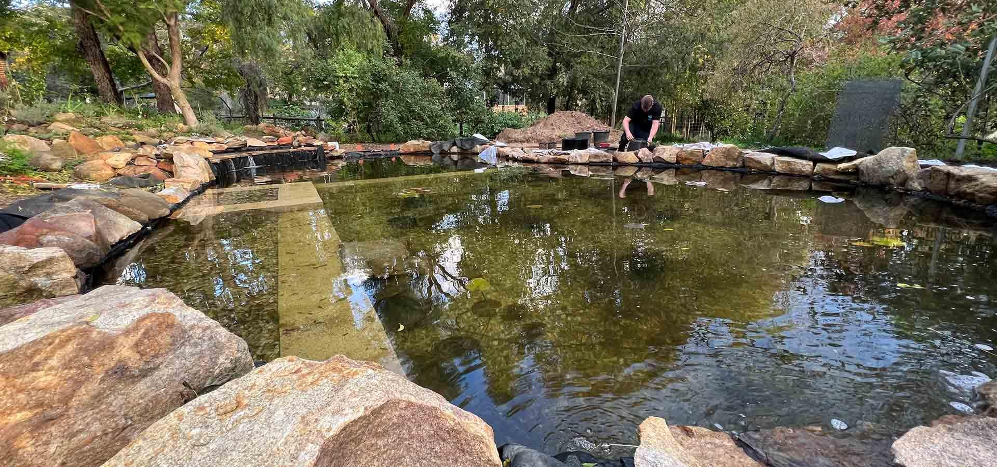

Links - <https://www.pasesaqua.com.au/>

<https://www.pasesaqua.com.au/natural-swimming-pools-dams/natural-swimming-pools/>