IS THIS WHAT YOU NEED FOR BODYBUILDING/FITNESS SUCCESS IN 2024?

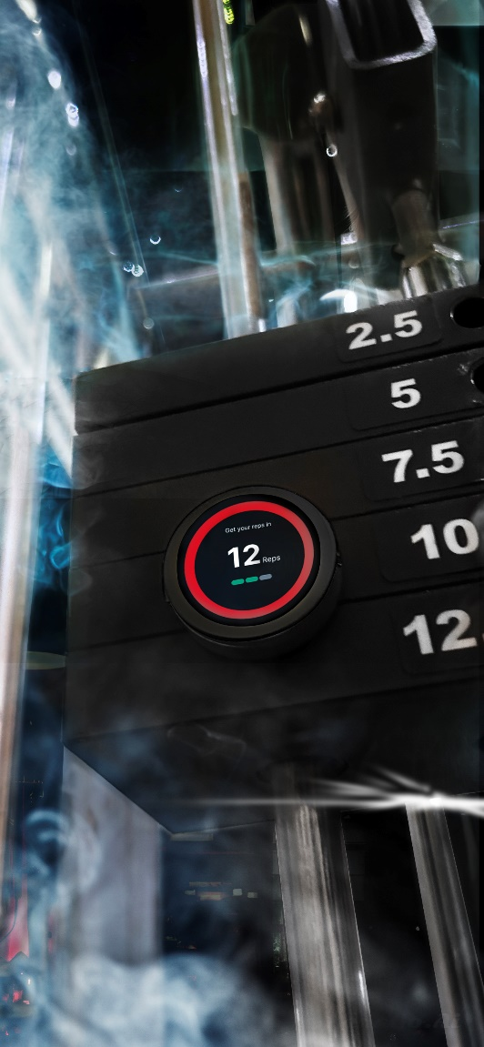

RepIImaX Pty. Ltd.'s upcoming rep counting gadget will soon enter the crowd funding market aiming to improve, yet disrupt, the body-building and fitness world. This rep counting device promises to revolutionize the gym experience in the ever fast-paced world of fitness, by offering incentives to those who commit to their fitness goals. This one of a kind attachable gadget makes every repetition count, while making users accountable and committed to their goals. Rep2maX's software creates a community-driven platform for inspiration and connection, while leading a social effort in improving the bodybuilding and fitness world.

Purpose and Vision of Rep2maX
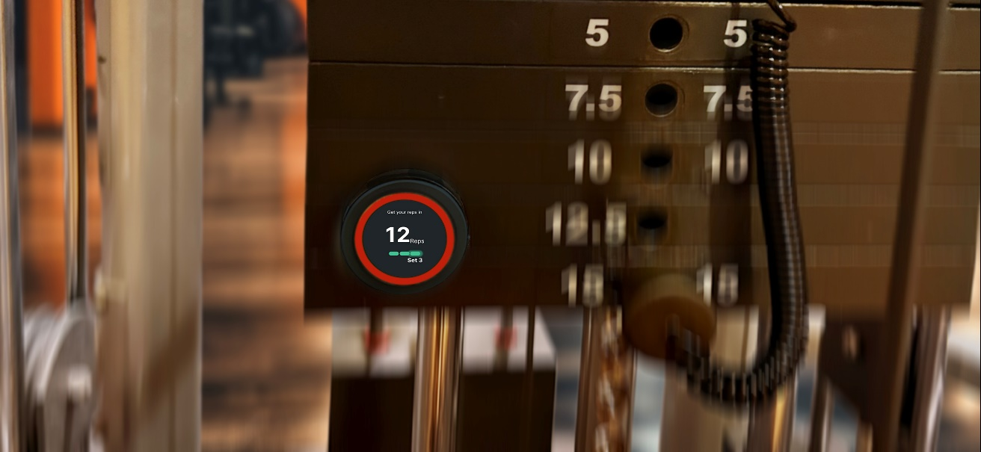Performing the correct number of repetitions, with the correct form while progressively overloading and delivering the right amount of stress to the muscle without over-resting, is the only formula for effective bodybuilding and fitness success.

With the Rep2maX rep counting device, you can now dedicate your absolute attention to every single rep. No more stopping in the middle of a set to remind yourself that you have 2 lots of 3 reps because you know that you have already performed 6 reps, or now that you hit the 6th rep of the second set, you are now half way there. All this, will soon now be visualised on an attachable device that will keep record of all your progress, and will also allow you to begin an entire workout plan, with the press of a button

A Connected Community
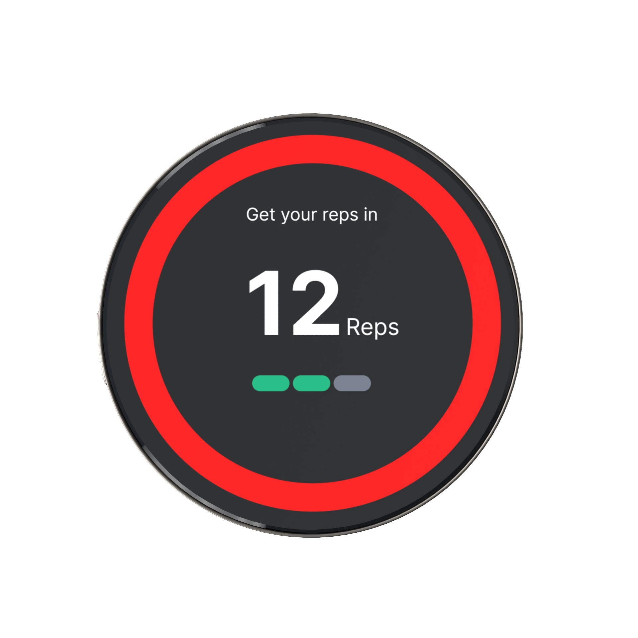
Rep2maX provides unique challenges and competitions in addition to fitness tracking. Create a dynamic and interesting training environment by setting personal goals, joining group challenges, or competing with friends.

A simple app interface lets users with similar goals to virtually meet through a group voice chat during your daily walk, or during a workout at the gym. By doing so, whether you go for a quick walk or a quick workout, the added motivation offered through the Rep2maX app will ensure that it is anything but a quick walk or a quick workout.

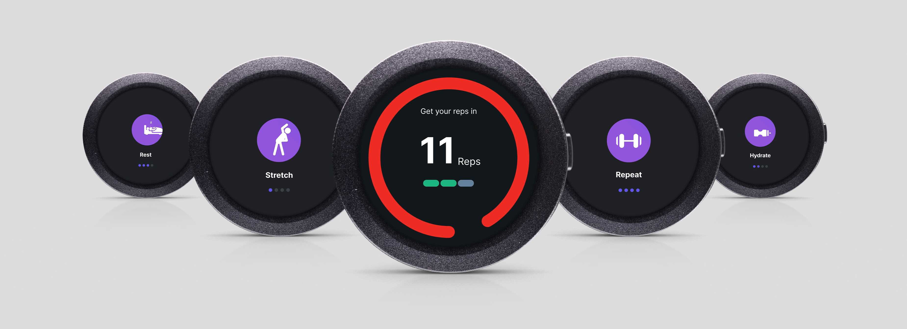

R2X: The Social Media
The Rep2maX experience is enhanced by its companion app that expands the gadget's capabilities. With access to the unique R2X social media, the app helps users feel inspired and supported. Users, on the R2X social media, will be segregated based on gender and goals. By doing so, users will be motivated by the sense of community who share similar stories, goals and objectives.

More individualized community interactions and guidance are made possible by this segmentation. The software offers a platform where users may discover inspiration and friendship, reflecting a thorough grasp of the social components of the fitness journey in its design.

“You are no longer alone in your fitness journey” Rep2maX CEO, 2023.
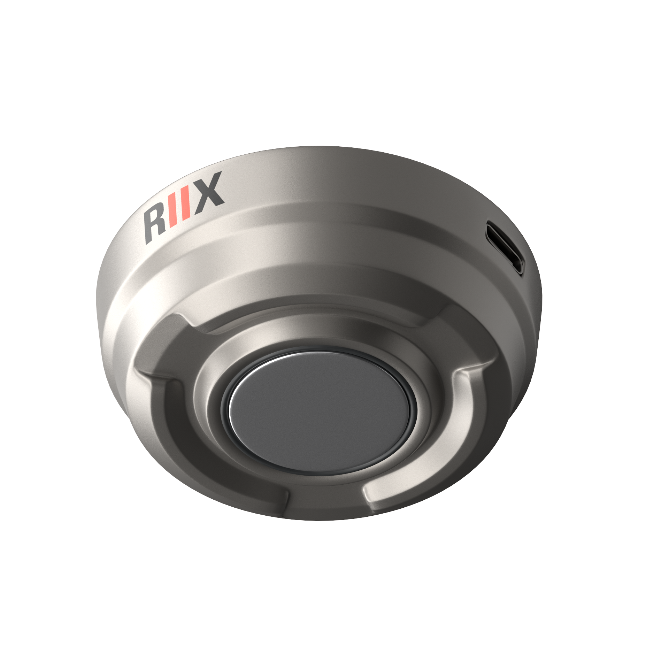

Social Contribution: Supporting Personal Trainers
The Rep2maX ecosystem's capacity to help users and personal trainers is one of its most notable features. Fitness influencers, personal trainers and enthusiasts now have more opportunities to monetize their routines and support their fitness journeys thanks to the option to sell exercise programs, meal plans and workouts that are synchronize-able to the RIIX.

Upon purchasing full workout programs from reputable influencers, a unique workout plan will be synchronized to the phone app where users will perform a full workout plan with a specified number of exercises, sets, reps and even the length of each resting period.

Conclusion
Rep2maX is a soon-to-be fitness industry leader that redefines how people approach their health and wellbeing objectives by seamlessly fusing exercise with state-of-the-art technology. This cutting-edge device and its companion software go beyond the traditional function of rep counting to create a worldwide network of fitness lovers, trainers, and influencers that encourage information sharing, motivation, and financial empowerment. Rep2maX takes a holistic approach to fitness; in addition to monitoring and evaluating exercise data, it promotes social media integration, friendly competition, and teamwork for a unique and interesting experience. A long-lasting and mutually beneficial atmosphere is further established by the platform's dedication to assisting personal trainers. Rep2maX is committed to making training approachable, pleasurable, and results-driven. This is shown by its breakthrough one-touch workout experience, which represents a paradigm change in how we see and accomplish our wellness and health goals.

