**COMMUNITY - CHAMPION AWARDED ON AUSTRALIA DAY**  
  
Renowned community leader and founder of My Guardian, Jad Haber, has been honoured with the prestigious Australia Day Award for his exceptional contribution to community service. Known for his transformative journey from the advertising and marketing industry to a leader of hope and support for individuals that are affected by a disability, and the elderly, Jad's commitment to fostering a positive change in the vulnerable community is an inspiration to all.  
  
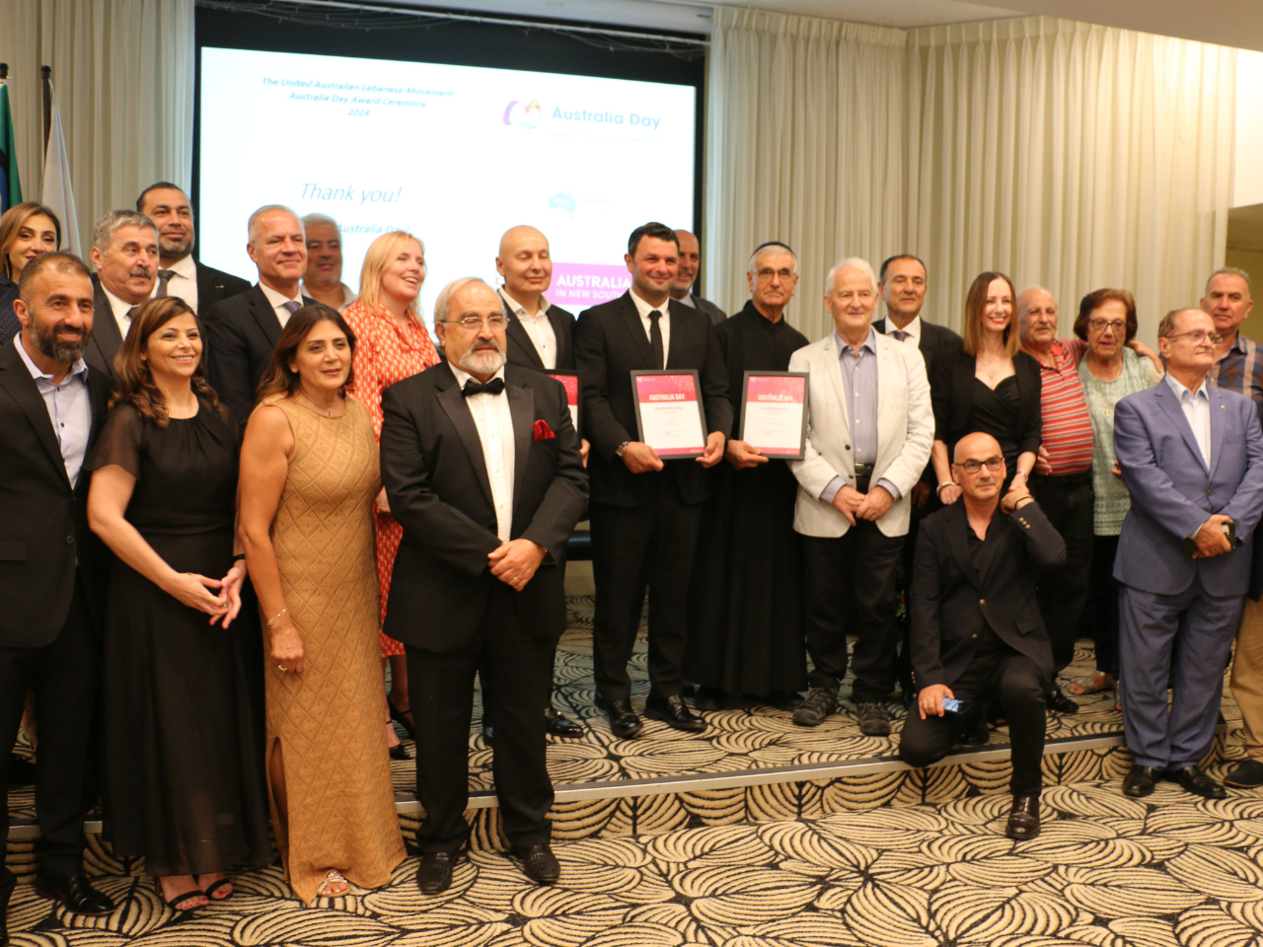  
*Jad Haber (Middle) with the organisers, nominees and other awardees.*  
  
  
Jad Haber's influential story is not just one of personal triumphs but of a relentless pursuit to improve the lives of those around him. Starting from his days in the film and advertising industry, Jad has always been a storyteller at heart. However, his true calling was realised when he shifted his focus from the silver screen to serving the community. A calling and passion for Making Lives Better through acts of service. A complete 180 transformation in his career. This transition marked the beginning of My Guardian and the My Guardian foundation, epitomising the values of care, support, and dedication to the vulnerable.

Jad’s new calling enabled him to embrace the roles of a parent for children with disabilities and a voice for the voiceless, seeking to make a positive difference in the lives of the vulnerable.

One moving story stands out—a girl with severe cognitive impairment abandoned at a hospital by parents unable to provide adequate care. Jad stepped in as her guardian, offering a loving home, organising support, and ensuring her access to education. This act of kindness epitomises Jad's unwavering dedication to improving the lives of those in need.

The Australia Day Award recognises Jad's unwavering commitment to community service, highlighting his role not just as a founder but as a guardian to many.

Jad's philosophy of service is deeply rooted in his belief that every act of kindness, no matter the size, has the potential to create a ripple effect of positive change. His speech at the award ceremony echoed this sentiment, "It is not how much we give, but the love and selflessness in the act of giving that truly matters."

Jad's initiatives extend beyond traditional community service. His efforts in supporting education, covering medication and tuition fees for underprivileged students, and providing high-complex care support, demonstrate his holistic approach to community welfare.  
  
 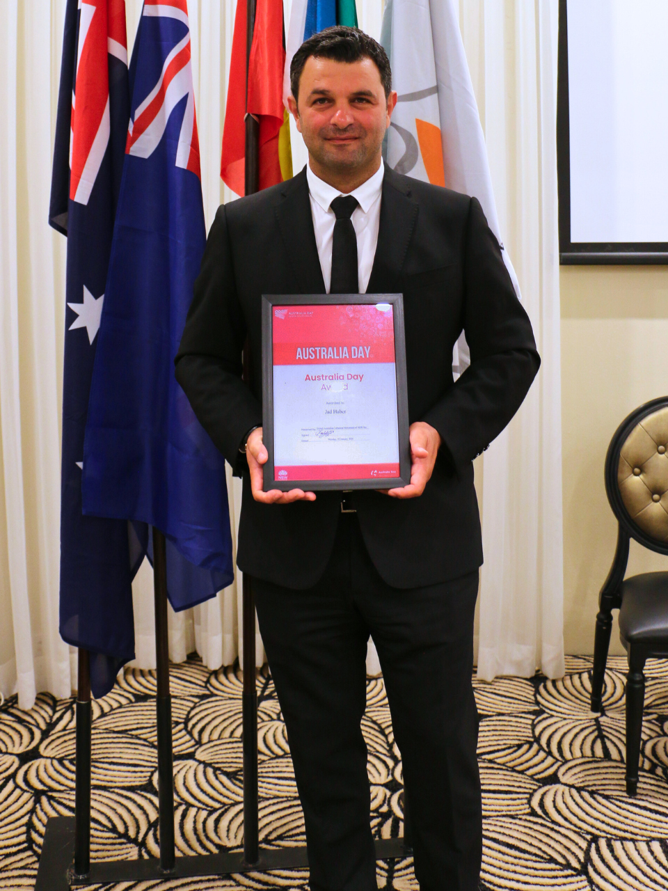  
*Jad Haber was awarded Australia Day Award for his contribution to community service*  
  
As we celebrate Jad Haber's achievement, it is essential to remember that this award is not just a recognition of one individual's efforts but a celebration of the collective spirit of the community. Jad often says, "We are not superheroes that can do big things, but we all can do small things with big love." This Australia Day, let us draw inspiration from Jad's journey and commit ourselves to small acts of kindness that collectively make a significant impact.

My Guardian and the community it serves are proud to share this moment with Jad Haber, a true champion of Aged and Disability care and community service.