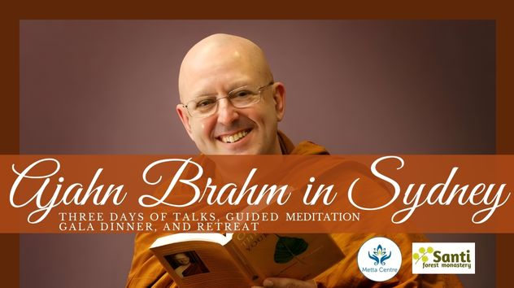

Ajahn Brahm —World renowned meditation master is in Sydney to support Buddhist nuns.

*Internationally and locally respected senior Buddhist monk, Ajahn Brahm, is visiting Sydney in February* ***to teach meditation and to entertain everyone with his renowned sense of humour. He is also in Sydney to fun(d)raise to establish a nuns’ residence in Leumeah, NSW to care for sick and elderly nuns – this initiative, from Santi Forest Monastery, is a first of its kind in Australia***

Ajahn Brahm is a revered spiritual guide regularly drawing multinational audiences of thousands. After attending Cambridge University to study theoretical physics, he became a Buddhist monk in rural Thailand in the 70’s under the famous meditation master Ajahn Chah. He is now the Abbot of Bodhinyana Monastery in Perth and the spiritual director of the Buddhist Society of WA. In 2019 he was made a Member of the Order of Australia (AM) in recognition of his contribution to the Buddhist community and especially for his promotion of women’s rights in Buddhism.

**Like many spiritual and religious traditions plagued by patriarchal inequality, women in Buddhism have experienced significant gender-based discrimination and marginalisation. Ajahn Brahm has played a pivotal role in changing this picture by helping to revive the order of nuns that was originally established by the Buddha. The higher ordination of Buddhist nuns in 2009 at Ajahn Brahm’s Monastery caused an upheaval in the Theravada Buddhist world, and he was** censured and ostracized by a section of the monastic order in Thailand.

In spite of its troubled birth, the order of Theravada Buddhist nuns is thriving in Australia. **The number of nuns has grown steadily over the last fifteen years. Nuns’ advocacy along with the increasing presence of female spiritual leadership in Buddhism has transformed perceptions and improved gender equity within Buddhist organizations and communities.**

Santi Forest Monastery is one of two large forest monasteries in Australia dedicated exclusively to nuns of the Theravada Buddhist tradition. Santi is situated on 150 acres of rugged eucalyptus forest, on the edge of Morton National Park, in the NSW Southern Highlands. It is a place of unique beauty with cliffs, caves and wildlife, well suited to quiet contemplation. It is a rare place where nuns can live in forest huts and practice the teachings of the Buddha just like the monks.

With the increase of women interested in taking up monastic life in Australia, it is essential to establish facilities to offer support for everyone, including those who require special needs. Ajahn Brahm continues to have a critical role in raising funds for building and establishing places for nuns. In July 2023 the nuns’ community at Santi purchased a property to offer care for nuns who are sick, elderly or with special needs. Ajahn Brahm’s teaching tour in February is to raise awareness of the Buddhist nuns in NSW, to offer valuable teachings, and to raise funds for establishing facilities for nuns.

**For more information about Ajahn Brahm’s Sydney Tour:** <https://www.mettacentre.com/ajahn-brahm-sydney2024/>

**For more information about Santi Forest Monastery suburban residency project and donations:** <https://santifm.org/santi/donations/suburban-nuns-vihara/>

**Promotional video:** <https://youtu.be/sTliu7UQ39g?feature=shared>