Media Release – 26 February 2024 –  For Immediate Release

**digiDirect Golf Day Hosts Industry to Raise $120,000 for Make-A-Wish Australia**

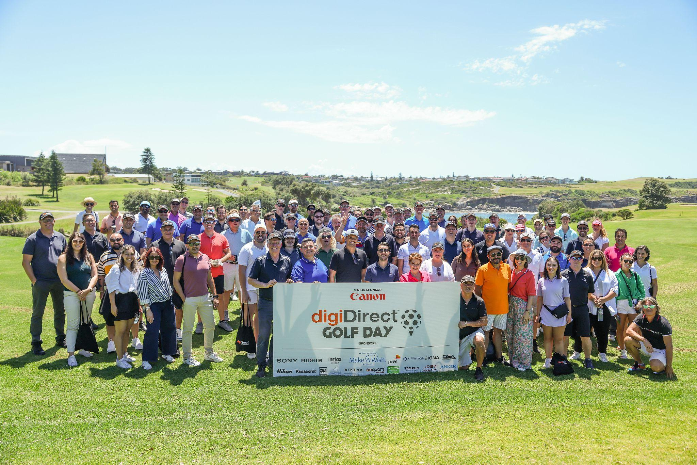

[**[FOR MORE PICS, CLICK HERE]**](https://drive.google.com/drive/folders/1ePD7mdJPEJ0LK1GWyIyj59YVl7GMnIeF?usp=sharing)

SYDNEY: Australian consumer electronics retailer, digiDirect held its second annual Golf Day on 13th February 2024 at The Coast in Sydney, bringing together leaders of industry and business, who together raised $120,000 for charity.

Over 100 partners and friends of digiDirect spent a perfect summer’s day on one of Sydney’s most picturesque golf courses, before participating in a charity dinner in the clubhouse to support Make-A-Wish® Australia in their endeavour to grant life-changing wishes for children with critical illness.

“We were delighted to once again bring together digiDirect’s partners of industry and business, for what was a fun day of immense networking value, made into an even greater occasion because of the commitment by participants to deliver for our moral purpose,” said Haig Kayserian, General Manager of digiDirect.

Canon was the major sponsor of the 2024 digiDirect Golf Day, joined by Sony, Fujifilm, PWC, Nikon, Anker, Panasonic, OM System, CR Kennedy, Lifestyle Brands, Videndum, Outdoor Sports Agencies (OSA), Blonde Robot and Pierge. Hamptons Sydney provided the drinks carts and Onsport.com.au sponsored the golf buggies.

Representatives of the sponsors participated on the golf course and during the dinner, along with fellow suppliers and partners of digiDirect, including Synnex, Ingram Micro, Seagate, Dell, Leica, Westpac, Google, Salesforce, RQ Media, Feedops, Amazon and Ebay, among others.

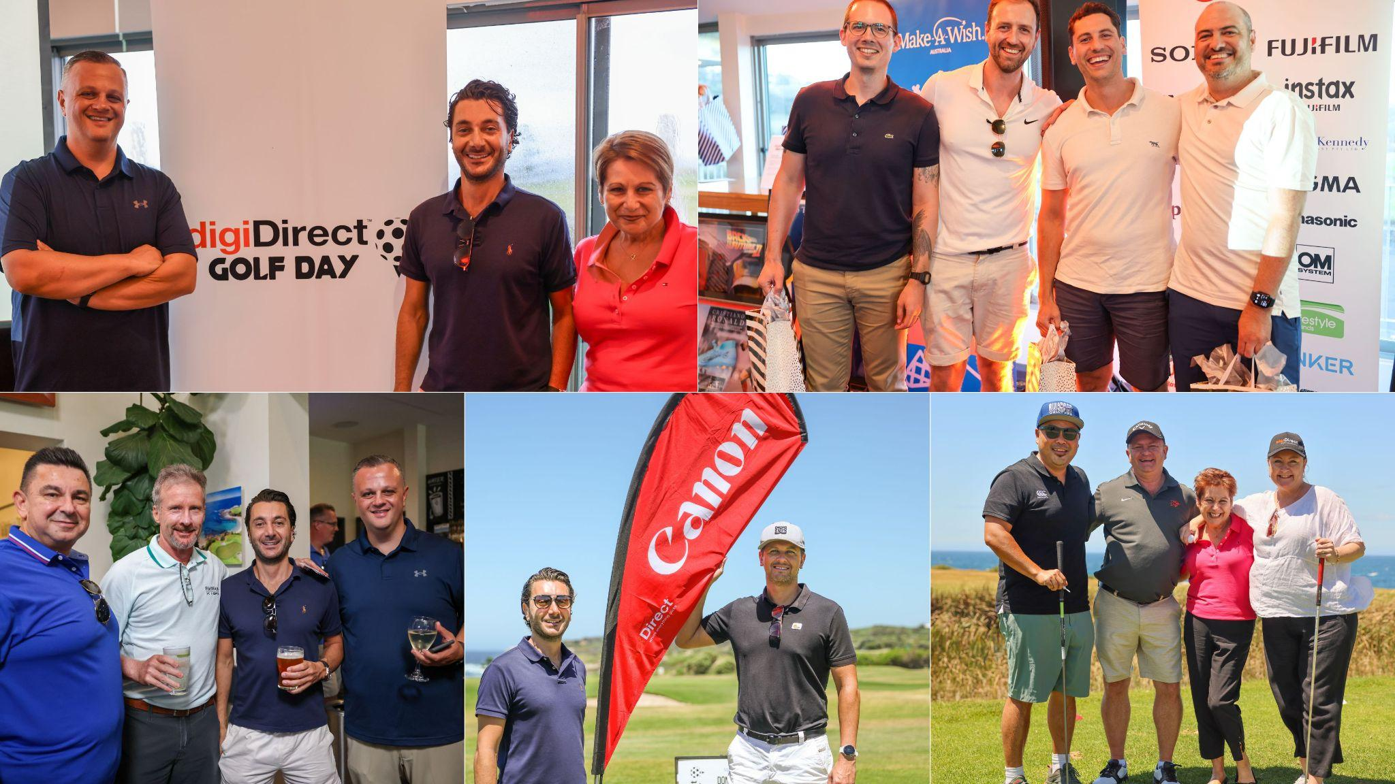

The dinner to close the evening was presided over by MC, Vache Kahramanian, who announced the winning team and runners-up, as well as the victors of the “Nearest to Pin” and “Longest Drive” novelty holes, which also contributed to raising important funds for Make-A-Wish Australia.

“Putting on this event is about all of us at digiDirect mirroring the generosity and commitment to philanthropy of our founder and leader, Shant Kradjian, whose reflex is to share in any of his successes to support those in need,” commented digiDirect General Manager, Haig Kayserian.

“This would not have been possible without our partners and friends accepting to join their peers to support digiDirect’s goal of raising critical funds for Make-A-Wish Australia, and it would not have been possible without our staff toiling away for months to ensure such a major endeavour delivered genuine outcomes,” he added.

In his remarks, Canon Australia’s General Manager, Aaron Berthelot explained why his company backed the event as its major sponsor for the second time running.

“digiDirect is a valued retail partner of Canon Australia, and supporting Shant Kradjian and his team to deliver for such a noble cause was a privilege for our company,” said Berthelot. “We were delighted to participate and help deliver $120,000 for Make-A-Wish Australia.”

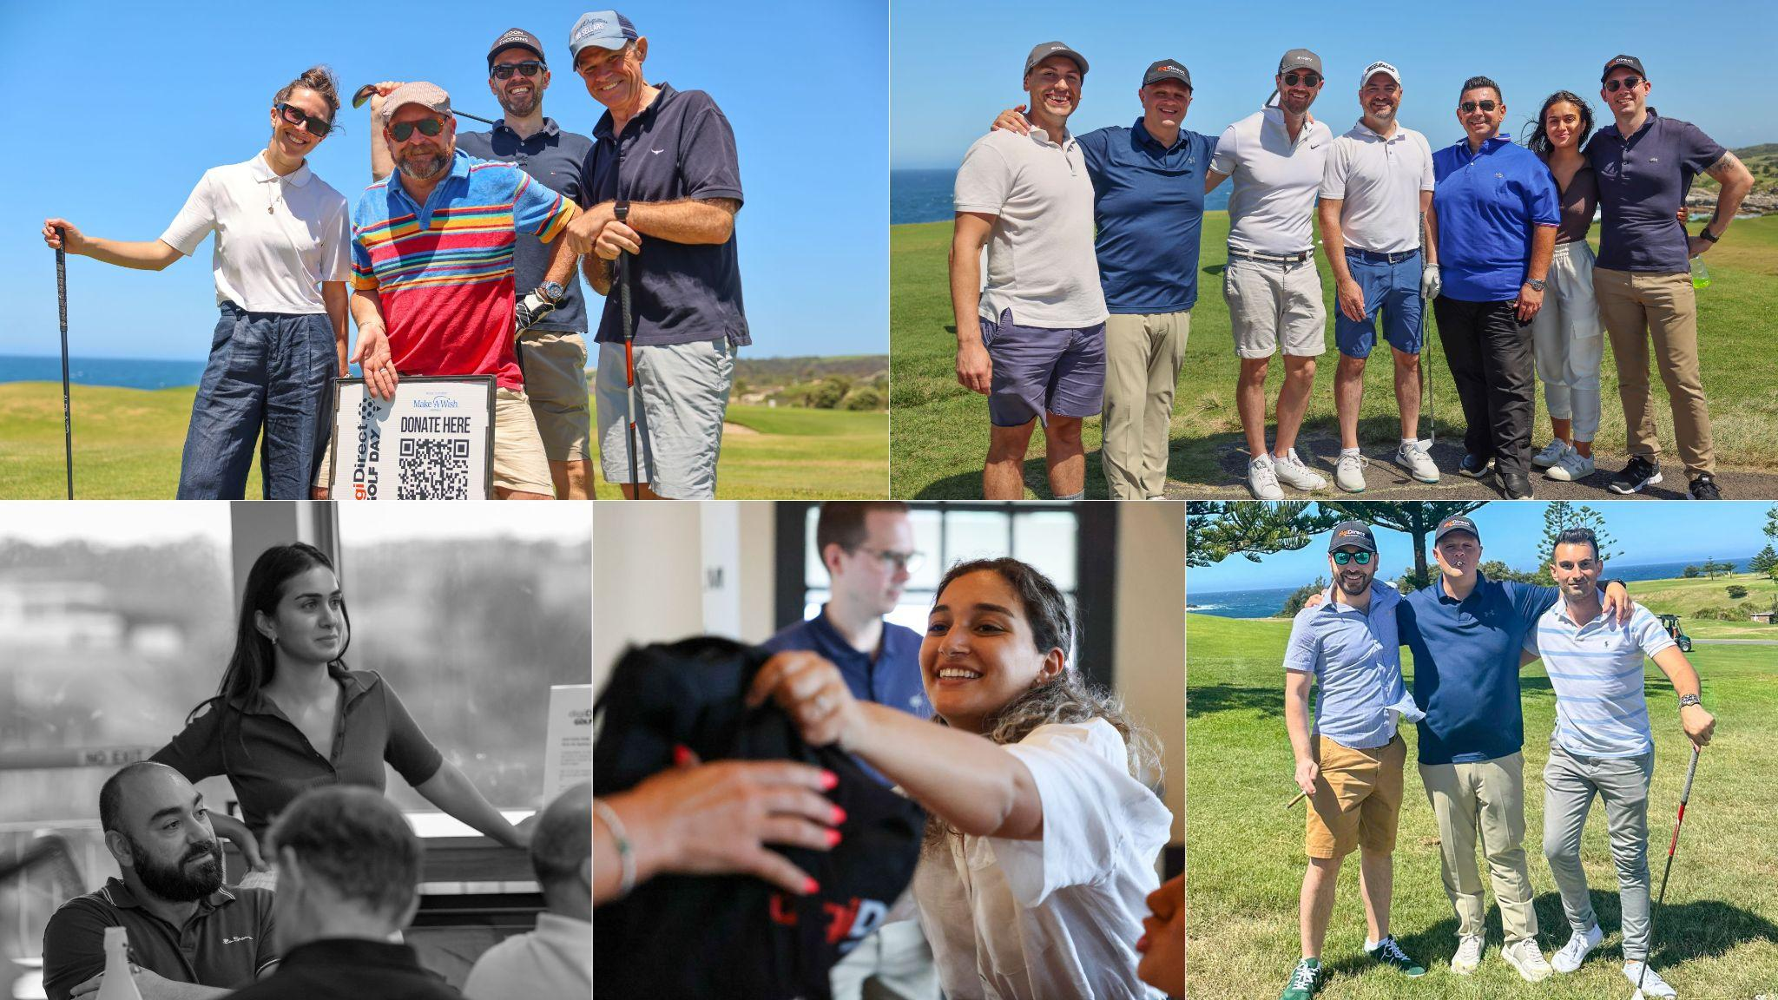

In their address, Make-A-Wish Australia expressed their warm appreciation of the philanthropic commitments of digiDirect founder and Group Managing Director, Shant Kradjian, who funded the entire event to bring together digiDirect industry and partners to raise funds for the critically ill cared for by the charity.

Make-A-Wish Australia’s CEO, Sally Bateman, said that digiDirect’s Golf Day is a wonderful example of the community coming together to help create life-changing wishes for critically ill kids across the country.

“As a registered Australian children’s charity, we reply on our incredible community of supporters to come together to make wishes happen. We all have the power to create inspirational wishes for sick kids and the donations from digiDirect’s event will help support some of the 900+ children currently on their Wish Journey,” Bateman said.

Videos were played showing how digiDirect’s inaugural Golf Day had helped Make-A-Wish Australia support the wish program in 2023, bringing much needed hope and joy to critically ill children.

With the charity auction bringing up the raised funds from the 2024 digiDirect Golf Day to around $113,000, Kradjian rounded it up to $120,000 with a further donation.

General Manager of the digiDirect Group of Companies, Sina Clayton, closed proceedings with a vote of thanks, highlighting the important contributions of Shant Kradjian and the sponsors to delivering such an outstanding outcome for Make-A-Wish Australia.

[END]

—

**ABOUT DIGIDIRECT GOLF DAY**

digiDirect is one of Australia's largest retailers of consumer electronics. Having started as a retailer specialising in photo & video, digiDirect's seven brick-and-mortar stores across the country maintain that speciality with expert staff and the widest range of products. Online, digidirect.com.au is one of the most popular online retail destinations in Australia, offering tens of thousands of products shipped to thousands of loyal customers from the company's state-of-the-art Sydney headquarters.

Founded by Managing Director Shant Kradjian in 2005, digiDirect employs over 150 staff across multiple states and enjoys important relationships with multinational supplier partners, payment, loyalty rewards, logistics and other agencies.

The digiDirect Golf Day is about bringing the industry together, along with the company's professional service partners, to enjoy a great day out while raising money for a worthy cause.

**ABOUT MAKE-A-WISH AUSTRALIA**

Each and every day, Make-A-Wish® Australia brings amazing people together to grant life-changing wishes for children with critical illness.

Each year, thousands of Australian children are diagnosed with a life-threatening illness. From the simple to the seemingly impossible, their wishes complement medical treatment - working on calming, distracting and empowering sick kids at the time they need it most. When a wish is realised, a child discovers that despite their situation, anything is possible.