RCF Invests in BRC-339 Project to Foster Innovation in Blockchain Digital Assets

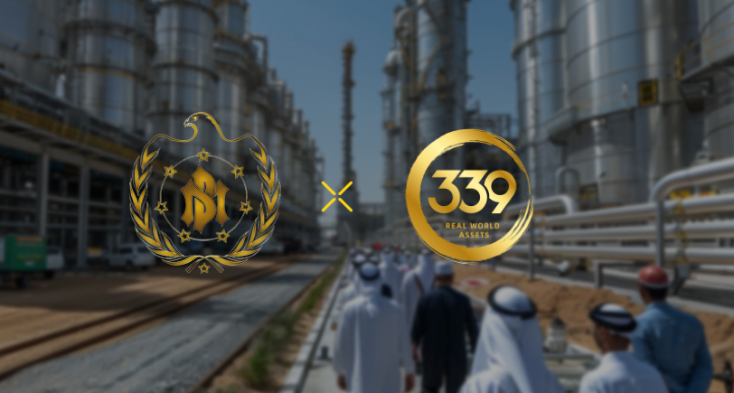

The Royal Committee Fund (RCF) of Dubai has announced a successful investment in the BRC-339 project, aimed at jointly establishing an on-chain platform for real-world commodity trading covering gold and crude oil. RCF will collaborate with the RWA protocol newcomer, BRC-339, to research BTC Layer2 solutions suitable for on-chain transactions of real-world assets and to issue its Gold-backed Stable-coin. The current mainstream BTC Layer2 solutions, which combine the stability of the BTC network with the convenience of the EVM, offer a promising direction for the market. They are using this as a basis to investigate solutions for the traceability of real-world assets and the legality issues that have long been criticized. Through the project's protocol, offline physical assets are mapped onto the blockchain, driving innovation in the digital economy.

A fund manager representative from RCF stated: "We are confident in the prospects of the BRC-339 project and believe it has significant potential in the digital economy sector." "By investing in the BRC-339 project, we aim to jointly promote the application of blockchain technology in the commodity trading field, providing investors with a safer and more efficient trading environment.”

Furthermore, with the successful launch of the BRC-339 project, RCF extends its warm congratulations to the BRC-339 team! This marks an important step for the project, which will undoubtedly bring new opportunities and development to the commodity trading market.

As reported, the BRC-339 project is dedicated to mapping offline physical assets onto the blockchain. Besides establishing a trading platform, it also provides liquidity for other Real-World assets, such as real estate, luxury watches, and artwork, which typically have poor liquidity, offering investors a more convenient and reliable investment platform. As an innovative project in the digital economy field of RCF, it will first revolutionize the trading of gold and crude oil.

As the collaboration between the two parties deepens, the BRC-339 project will bring new opportunities and challenges to commodity trading methods, driving innovation in the digital economy sector, and creating more value for investors.

BRC-339 official website: <https://www.brc-339.com/>

Official media: <https://twitter.com/BRC339RWA>