**Multi-award winning UK brand Sweet Freedom lands in Aldi Australia in February 2024**

The multi-award winning UK-based brand, Sweet Freedom, is introducing a tempting assortment of versatile and natural syrups sweetened only with fruit (carob and apple) to the Australian market next month.

The flavours landing on Aldi shelves are: **HONEYCOMB SYRUP**, **RASPBERRY SYRUP**, and **PANCAKE SYRUP**. These products are perfect for drizzling over pancakes, oats, yoghurt, stirring into coffee and drinks, and serve as a must-have for home bakers too.

Sweet Freedom’s co-founder Deborah says:

*“We are super excited to be working with Aldi Australia to share the joy of our delicious award-winning syrups with Australian customers. It’s a significant milestone for Sweet Freedom... we’re dedicated to bringing our natural, high-quality, vegan alternatives to fans worldwide.”*

**Reasons to choose Sweet Freedom:**

* NO refined sugar, NO artificial sweeteners, NO nasties
* All natural sweetness from fruit – apples & carob
* Made without allergens
* No palm oil
* Source of fibre
* Vegan friendly
* Low calorie indulgence – only 54kJ per teaspoon

**PANCAKE SYRUP:** A scrumptious, Great Taste award-winning syrup, perfect for drizzling over pancakes, waffles, and other breakfast delights.

**RASPBERRY SYRUP:** Bursting with the vibrant taste of raspberries, this syrup adds a delightful twist to desserts and treats. Surprisingly good stirred into coffee too!

**HONEYCOMB SYRUP:** A rich and golden syrup with the distinctive flavour of honeycomb… no bees involved! Ideal for drizzling over ice cream, porridge, or using as a sweetener in baking.

**Some recipe inspiration…**

**Easy vegan honeycomb oat cookies**

Time: 10 minutes. Serves: 6

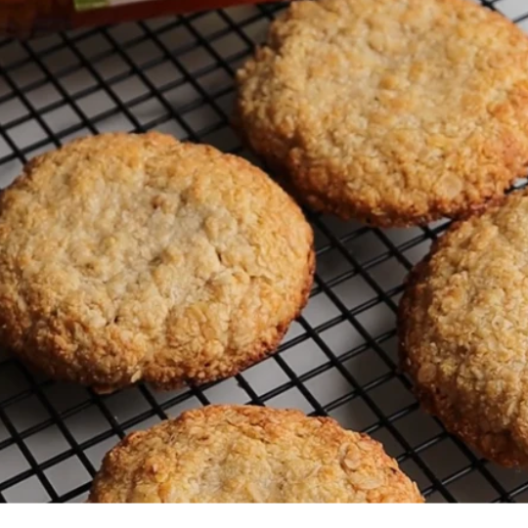

**ingredients**

100g oats

100g oat flour (whizz up oats in a blender to create this)

30g ground almonds

80g coconut oil melted

80g Sweet Freedom HONEYCOMB FLAVOURED SYRUP

**make**

1. Pre heat your oven to 180°C.
2. In a bowl, mix together the dry ingredients and then add in the wet.
3. Scoop the mixture into balls and then flatten slightly onto a lined baking tray.
4. Bake for 10-12 minutes.
5. Once out the oven, leave to cool completely and then enjoy!

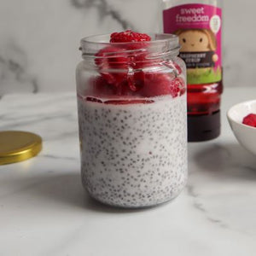**Raspberry chia pudding**

Time: 5 minutes (plus time overnight in the fridge). Serves: 1

**ingredients**

200g coconut milk

3 tbsp chia seeds

3 tbsp Sweet Freedom RASPBERRY FLAVOURED SYRUP

**make**

1. Chill the coconut milk and then mix it to combine the cream part and the water part.
2. Pour the coconut milk into a bowl and then mix in the chia seeds and SYRUP.
3. Pour into a jar/container and put into the fridge overnight to set.
4. Top with raspberries and RASPBERRY FLAVOURED SYRUP the next morning. Delicious!

**Mini mighty pancakes**

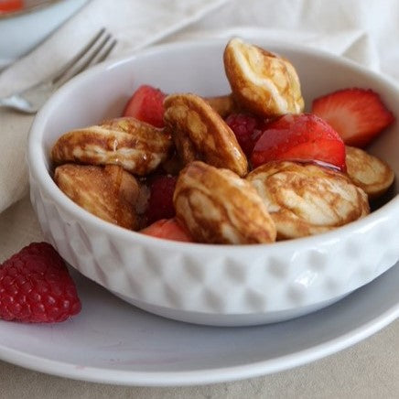

Time: 20 minutes. Serves: 1-2

**ingredients**

180g flour (wholewheat, plain or gluten free)

1/2 tsp bicarbonate soda⁠

2 tbsp Sweet Freedom FLAVOURED PANCAKE SYRUP

240ml plant-based milk

2 tsp apple cider vinegar or lemon juice⁠

FLAVOURED PANCAKE SYRUP plus berries for topping⁠

**make**

1. Start by combining the milk and vinegar. Set aside for 10 mins.
2. Mix together the dry ingredients and then stir in the milk mixture and FLAVOURED PANCAKE SYRUP.
3. Heat a non-stick pan and lightly grease.
4. Pour the pancake mixture into a piping bag and pipe small pancakes onto the pan.
5. Cook for about 30 seconds on one side, or until bubbles start to form, and then flip and cook the other side.
6. Serve with berries and a generous drizzle of FLAVOURED PANCAKE SYRUP.

**-ENDS-**

**NOTES TO EDITORS**

Behind the Sweet Freedom brand is a small, dedicated team, including original co-founder Deborah. They carefully craft all their products from scratch and have proudly earned many Great Taste Awards along the way. They are committed to producing ethical, sustainable, vegan products, all made with love in the UK. They have an engaged online audience of over 121k, and can be found on the following social channels: [Instagram](https://www.instagram.com/sweetfreedomuk/), [Facebook](https://www.facebook.com/sweetfreedomuk), [TikTok](https://www.tiktok.com/@sweetfreedomofficial), [YouTube](https://www.youtube.com/@sweetfreedomofficial), [LinkedIn](https://www.linkedin.com/company/sweet-freedom-ltd/) and [Pinterest](https://www.pinterest.co.uk/sweetfreedomuk/).

**For more information or high-resolution images please reach out to Natasha (Marketing Executive) at** [**natasha@sweetfreedom.co.uk**](mailto:natasha@sweetfreedom.co.uk)**.**