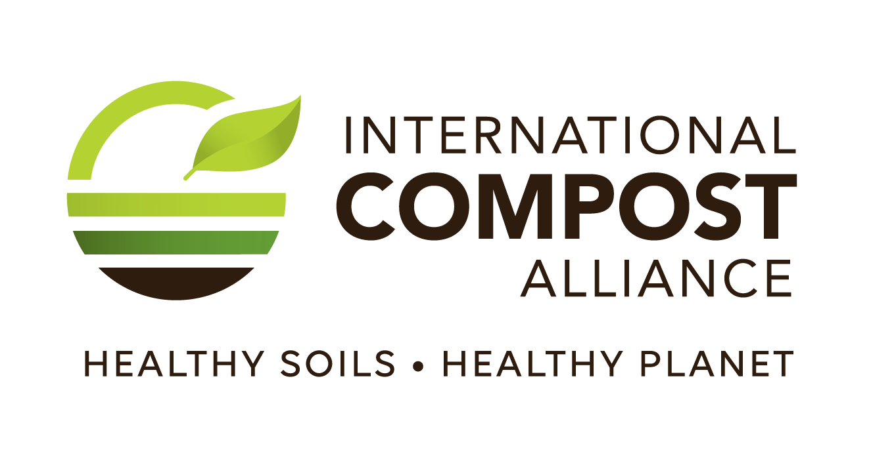
FOR IMMEDIATE RELEASE 3 May 2024

Contact: John McKew, National Executive Officer, Australian Organics Recycling Association
0434 711 077 / john@aora.org.au

INTERNATIONAL COMPOST AWARENESS WEEK 2024 CELEBRATES
NATURE’S CLIMATE CHAMPION

- International Compost Awareness Week (ICAW) 2024, the largest and most comprehensive education initiative of the compost industry, takes place 5 – 11 May.
- ICAW 2024’s theme is COMPOST…Nature’s Climate Champion.
- Composting organic residuals and creating compost is a proven winning combination to tackle climate change, while also helping to keep soils healthy. It also helps to make soil more resilient to drought, reduce the need for mineral fertilisers, support biodiversity and grow more nutrient-rich foods.
As the world grapples with the urgent need to combat climate change, International Compost Awareness Week (ICAW) stands as a beacon of hope, celebrating compost and the importance of organics recycling. From 5th to 11th May, individuals, communities, and organisations worldwide will unite to raise awareness about the transformative power of compost and composting in mitigating climate change.

This year’s theme, COMPOST... Nature’s Climate Champion, highlights the very real fact that we can still fight climate change instead of accepting it as a given. Through organics recycling and the return of compost back to our soils, greenhouse gas emissions can be reduced with additional benefits being delivered including improved soil health and biodiversity, increased agricultural productivity, enhanced food security and water quality.

"Compost is a powerful champion in our fight against climate change," remarked John McKew, National Executive Officer, Australian Organics Recycling Association. "It not only reduces methane emissions from landfills but also enriches soil, sequesters carbon and promotes greater biodiversity. Through International Compost Awareness Week, we aim to highlight the immense potential of composting and compost as nature-based solutions to combat climate change."

The organic matter in compost helps our soils absorb carbon dioxide from the atmosphere and store it in the soil, where it can remain stored for years, decades, or even centuries. At the same time, compost helps create healthier soils that are more resilient to changing weather conditions, improving soil structure and water-holding capacity while also reducing erosion. Providing a slow-release source of nutrients to plants, with healthier soil, compost also helps reduce the need for chemical fertilizers and pesticides.

"As we confront the challenges of a rapidly changing climate, composting emerges as a tangible and accessible solution that empowers individuals and communities to take meaningful action," said Mr McKew. "International Compost Awareness Week serves as a catalyst for change, inspiring collective action towards a more sustainable future.". We encourage everyone to participate in ICAW and learn more about how composting can benefit our communities and the environment."

To celebrate ICAW, communities and organizations around the world are hosting composting workshops, demonstrations, and many other types of events. Individuals can also get involved by starting their own composting system at home or in their community, getting to know the important workings at a local composting facility and by adding compost to their soil to improve their garden’s productivity and climate-resiliency.

For more information about compost and the Australian organics recycling industry, visit www.aorg.org.au.

-ENDS-

Notes to Editors

The International Compost Alliance is comprised of:
The Association for Renewable Energy and Clean Technology (REA);
The Australian Organics Recycling Association (AORA);
Compost Council of Canada (CCC);
European Compost Network (ECN);
International Solid Waste Association (ISWA);
CRÉ - Composting and Anaerobic Digestion Association of Ireland;
WasteMINZ (Waste Management Institute of New Zealand);
The United States Composting Council (USCC); and
The Compost Research & Education Foundation (CREF)

The purpose of the alliance is for organics recycling organizations around the world to work collaboratively to maximise the recycling of organic wastes and advance the manufacturing of certified, high-quality compost to benefit the environment, society, and our members.

Currently, over 83 million tonnes of biowaste are recycled every year around the world. Not only does this recycle over 1 million tonnes of plant macro-nutrients, but, through storing carbon in soil and offsetting fertilizer use, it reduces greenhouse gas emissions by 9 million tonnes of carbon dioxide equivalents – an equivalent of driving an average car for 36 billion kilometres (23 billion miles); almost 95 thousand times the distance between the earth and the moon!
Despite our current success globally, our annual potential could be increased over 12-fold if all the world’s unavoidable organic residuals were collected separately and composted.

