**National Pickleball League Season 1 Champions – The Jalapenos, Win $50,000 As Australia’s Inaugural Professional Pickleball League Winners**

**MEDIA RELEASE**

**5th June 2024**The inaugural season of Professional Pickleball in Australia - National Pickleball League Season 1, completed on Sunday 2nd June, with The Jalapenos from Victoria being crowned champions and earning the largest ever prize money seen in Pickleball in the southern hemisphere.   
  
The first season of professional Teams Pickleball in Australia consisted of 108 players, across 18 teams in Victoria, New South Wales and Queensland. Each team played 5 rounds of regular season games (10 matches) in their state conference, before the Top 8 teams battled it out in the finals series held at NPL’s venue – The Jar in South Melbourne, over June 1st and June 2nd.   
  
The #1 Seed – Jalapenos, who went undefeated in the Victoria conference faced off against the #2 Seed – Aliens, who went undefeated in the New South Wales conference in the Grand Final. On the show court at Australia’s only dedicated indoor venue , the Jalapenos ultimately prevailed 3-1 after winning the final Gender Doubles set – 21 to 17. The Jalapenos took home the grand prize of $50,000 with the Aliens taking home $20,000 in 2nd place.  
  
In the 3rd place match, the Turtles from NSW defeated the Iguanas from QLD, taking home $10,000. All 8 NPL Season 1 finalists received a prize pool of at least $3,000.   
  
Steve Wood, former Tennis Australia CEO and current NPL Board Member provided his highlights on the first ever season of Professional Pickleball in Australia:

* The live streamed broadcast of the NPL competition and on-site events created an amazing “sporting community” that leverages the most accessible participation sport we have ever seen
* NPL’s vision and team allowed it to launch a national competition concurrently across three states despite Pickleball being such a new sport (with an estimated 50,000 participants in Australia right now)
* NPL provided incredible opportunities for semi-professional and professional athletes to earn significant prize money in the early stages of their career
* NPL delivered a unique player friendly Pickleball league that showcased the best of both disciplines of the sport (Singles & Doubles) not seen by other racquet sports
* NPL have already begun to attract a huge wave of current tennis & racquet sport professionals who recognise the potential of a career in Pickleball
* NPL delivered unique league content and highlights that attracted a premium, young audience to the sport, culminating in hundreds of fans spectating over the weekend finals

Fresh off the back of the great success of NPL Season 1, NPL announced Season 2, starting on August 17th, 2024 with another $100,000 Prize Pool and 18 teams returning across the three states. The NPL Season 2 Draft will be held on July 14th, where 144 players will be selected to compete in the 2nd official season of Professional Pickleball in Australia. More information can be found online at: <https://www.nplpickleball.com.au/npl-season-two>

Six Zero Pickleball & Squealing Pig Wines were proud major sponsors of the NPL and will continue to be a driving force behind NPL Season 2. Pictured below is NPL S1 winners – The Jalapenos with their cheque & Squealing Pig winning prizes.   
  
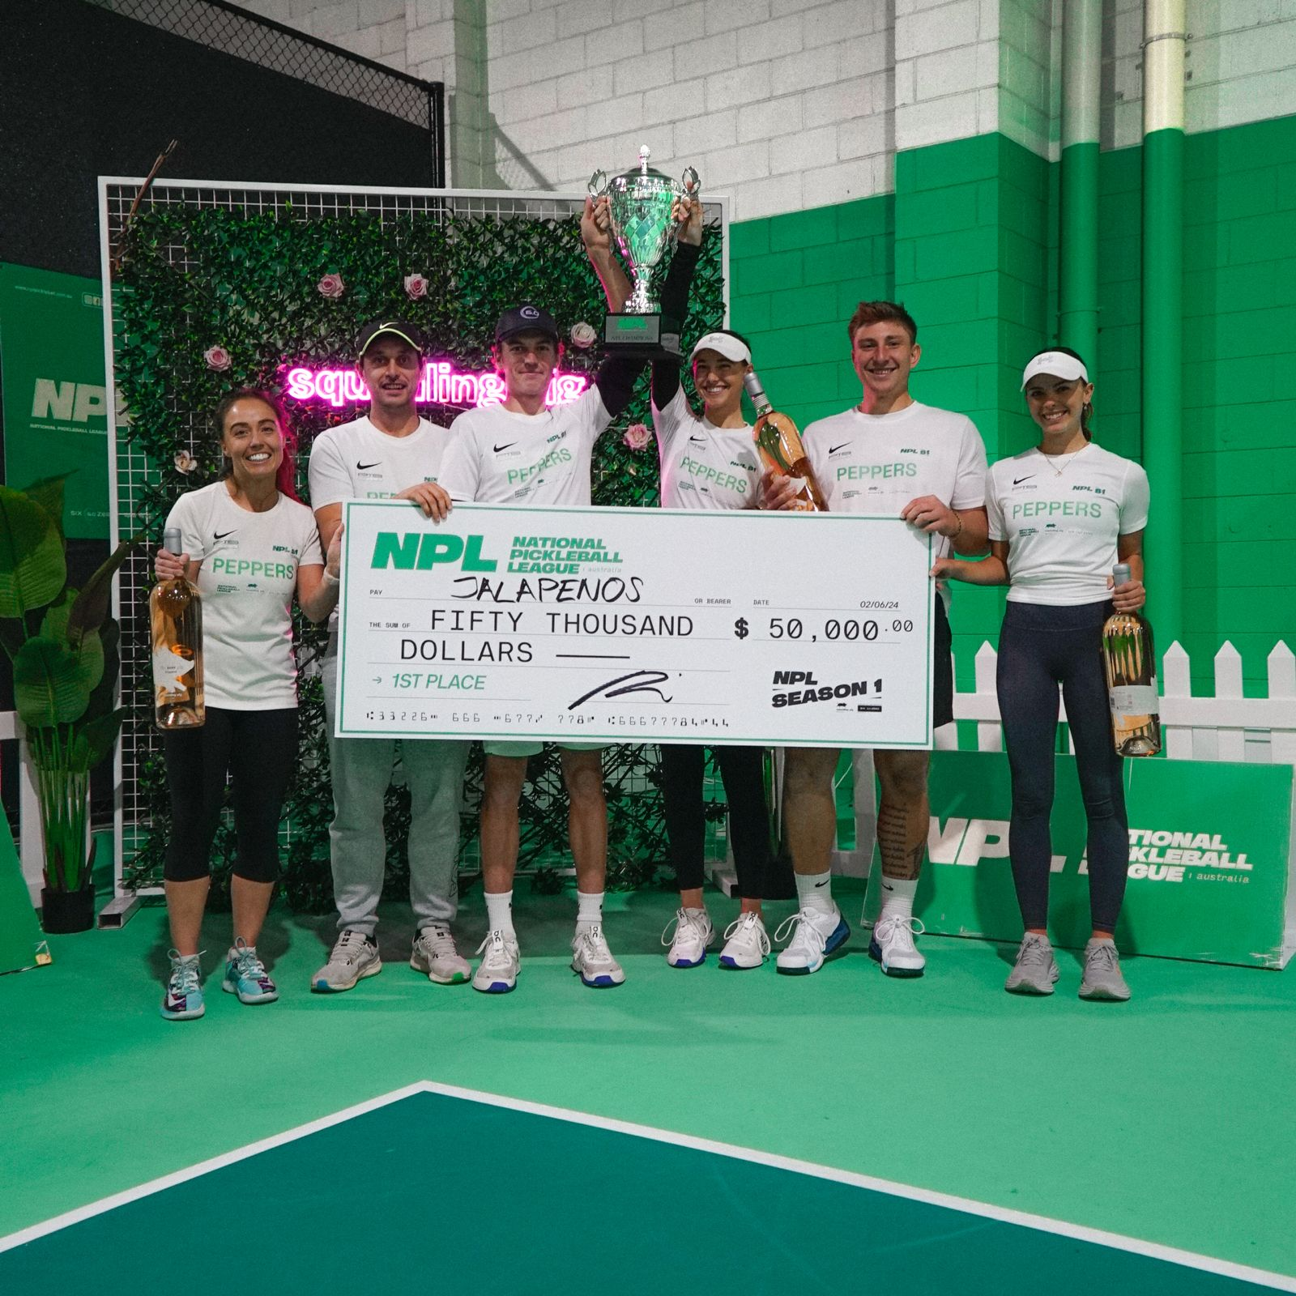

**-ENDS-**

**About National Pickleball League (NPL)**

NPL is the premium pickleball organisation of Australia. The NPL brand offers Australia’s professional national league, tournaments, corporate days, school/university programs, social leagues, events & introductory Pickleball days. NPL aims to build the total number of Pickleball players in Australia via professional league pathways, marketing, content & venue investment. NPL aims to expand its product internationally in 2024.

Website: [www.nplpickleball.com.au](http://www.nplpickleball.com.au)  
Instagram: [@nplpickleball](https://www.instagram.com/nplpickleball/)  
Facebook: [@nplpickleball](https://www.facebook.com/nplpickleball/)  
Twitter: [@nplpickleball](https://twitter.com/nplpickleball)  
  
**For further information please contact:**

**Ron Shell**

CEO   
[ron@nplpickleball.com.au](mailto:ron@nplpickleball.com.au)   
  
**Steve Wood**

NPL Board Member

[steve@nplpickleball.com.au](mailto:steve@nplpickleball.com.au)