Nomad The Label Announces New Line With LENZING™

**FOR IMMEDIATE RELEASE**

Australia – Nomad The Label is thrilled to announce our official partnership with LENZING™.

This collaboration, beginning in June 2024, aims to reduce our environmental impact and promote slow, sustainable fashion by using luxury fabrics made from certified renewable and sustainable wood sources.

By turning today's waste into tomorrow's raw materials, we avoid landfills. Materials are recovered and converted with low emissions into high-quality, soft, breathable, and durable materials.

Founder and fashion designer for Nomad The Label, Louisa Warman said:

“Our latest collection, 'FREYJA,' is a testament to sustainable luxury. Each piece is meticulously crafted using LENZING™ Ecovero™ viscose fibres, sourced from responsibly managed forests. This material not only boasts natural and renewable properties but also offers a silky, luxurious feel that sets our collection apart.”

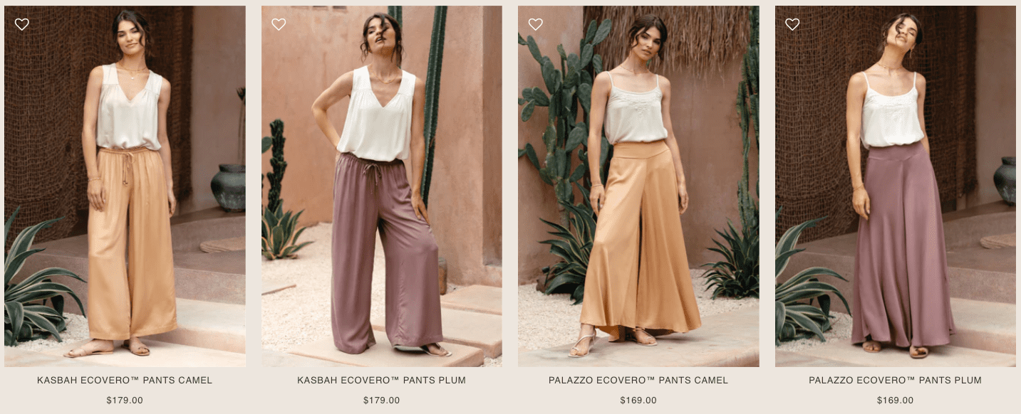

New collection available at:

<https://www.nomadthelabel.com.au/collections/freyja-collection>

**About Nomad The Label:**

Nomad The Label is an online women's clothing brand founded to create garments that understand a woman’s need for freedom, longevity, and practicality in her wardrobe. We create stylish everyday essentials that are figure-flattering, comfortable, and functional at the same time.

Nomad The Label answers to a personal endeavour to find garments that stand the test of time and are a genuine joy to wear, where practicality, style, and sustainability co-exist.

After huge success in Australia, Nomad The Label has recently launched a dedicated store in the US to better serve its US customers.

**Contact Information:**

Donal Breslin

Managing Director of Nomad The Label

[donal@nomadthelabel.com.au](mailto:donal@nomadthelabel.com.au)

Unit 1/7 Bonnal Rd, Erina NSW 2250  
+61480413376

**Websites (only place to purchase):**  
  
For Customers in Australia, New Zealand and Worldwide

<https://www.nomadthelabel.com.au/>

For Customers in the US and Canada

<https://nomadthelabel.com/>