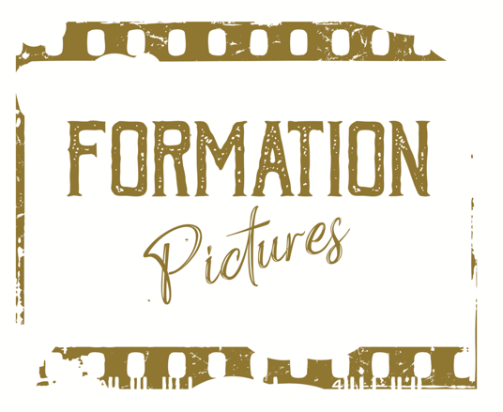

MELBOURNE INTERNATIONAL FILM FESTIVAL (MIFF) SHOWCASES AUSTRALIAN DEMONIC FAMILY DRAMA
THE DEMON DISORDER

WATCH TRAILER

EMBARGO: TO BE RELEASED AFTER 8PM JULY 11TH 2024

Starring John Noble, The Demon Disorder is the Feature Directorial Debut
of Special Effects Designer Steve Boyle

Melbourne, Australia - July 11th 2024 - Prepare to be unsettled as THE DEMON DISORDER, the latest Australian independent horror film will be showcased at the Melbourne International Film Festival (MIFF) this year. Written and directed by award-winning special effects master Steve Boyle (THE MATRIX Trilogy, THE HOBBIT Trilogy, KING KONG), THE DEMON DISORDER promises to be a gripping and spine-chilling experience that body horror enthusiasts won't want to miss.

The Australian demonic family drama centres on Graham, a man haunted by his past since the death of his father and the estrangement from his two brothers. Jake, the eldest brother, visits Graham claiming that something is horribly wrong: their youngest brother Phillip is possessed by their deceased father. Graham reluctantly agrees to go and see for himself. With the three brothers back together, they soon realize they are unprepared for the forces against them and learn that the sins of their past will not stay hidden. But how do you defeat a presence that knows you inside and out? An anger so powerful it refuses to stay dead?

Directors Vision: Quirky Characters, Isolated Settings and Practical Creature Effects

“My first film was always going to be a combination of all my loves in cinema - writing, directing, special effects and creatures. I also have a dark sense of humour and wanted that peppered throughout this film as well. The Demon Disorder is a love letter to the films that I grew up admiring”, said Steve Boyle

Boyle says “The film has such an over-the-top premise; I didn’t want to take it too seriously. How do you show a demon tongue running down a hallway without laughing about it? Or a man giving birth to his father via his armpit? I felt that, if I didn’t have fun with it and make it light, it would have just turned people away.”

The film will be released globally through Shudder on 6th September 2024.

Samuel Zimmerman, Head of Programming for Shudder, said THE DEMON DISORDER is “Full of impressive body horror that fans have come to expect from this master of effects. Boyle’s film is an engrossing story about breaking generational curses that viewers will find both unsettling and amusing.”

Written and directed by Boyle, THE DEMON DISORDER is produced by Boyle and Ally Muller and executive produced by Michael Spierig and Peter Spierig.

Festival Screening:
"THE DEMON DISORDER" will be showcased at MIFF on throughout the festival from 8-25th August 2024. This prestigious festival, renowned for celebrating both established and emerging talents in the film industry, provides the perfect platform for "THE DEMON DISORDER" to captivate and thrill audiences.

About the Melbourne International Film Festival:
The Melbourne International Film Festival is one of the most significant and long-running film festivals in Australia, showcasing a diverse range of films from around the world. MIFF provides a platform for filmmakers to present their work to a global audience, fostering creativity and innovation in the film industry.

Press Contact:
For further information, interviews, or press inquiries, please contact:

Ally Muller
Formation Pictures
Email: ally@formationpictures.com
Phone: +61 405 509 645

Follow us on social media:
Instagram: @formation.effects

