Media Release

**Father’s Day ‘Leaving a Legacy’ TV CSAs - Feature Two Indigenous Fathers**

**“The Legacy You Leave for Your Children Will Help Shape Your Children’s Destiny”**

The team at Dads4Kids is pleased to announce the release of their Dads4Kids 2024 TV CSAs. We congratulate Channel Seven and Channel Nine across Australia, all regional free to air TV, all community channels and SBS TV for playing the CSAs. The ad series called “Leaving a Legacy” features Australians from many different backgrounds.

What is special is we have two indigenous fathers James Dargin from Wollongong & John Kennedy from Sydney sharing the legacy of love their own respective fathers left for them with a few dad jokes besides.

Dads4Kids “Leaving a Legacy” 60 second TV CSA ad: <https://youtu.be/MH6938HMCdI?si=MgshzzF6YCkOd19H>

Dads4Kids “Leaving a Legacy” 30 second TV CSA ad: <https://youtu.be/PmqrfhBmsZY?si=-SaSCsAQyeSgtFs0>

In the lead up to Father’s Day, Dads4Kids congratulates Australian fathers on their amazing level of commitment to their children. Dads these days are more involved with their kids than ever before. Dads4Kids would also like to congratulate the Australian TV, Radio and Print media who are working hard to promote fathers in a positive way.

Dads4Kids CEO, Warwick Marsh said, *“The process of getting people to share on the TV CSA ad was self-selecting. The people who chose to give their time for free to talk about their Dad on screen had pretty good memories of their father.*

*The questions were simple, like, “Tell us something your dad used to tell you. What was your favourite memory of your father, and what was your dad like?” Needless to say, the response from this broad demographic of men and women was very heartfelt and moving.*

*Many people broke down in tears of appreciation and joy when they talked about their father. One woman talked about how her father walked her down the aisle almost 50 years ago. Her tears of joy told the story.*

*Another man broke down sobbing, overcome with emotion such was the positive power of recalling his experience with his father’s love and care for him. Watch him here:* [*https://youtu.be/OOqQcPMBz9E?si=6LiAHfxOBeKFSxhx*](https://youtu.be/OOqQcPMBz9E?si=6LiAHfxOBeKFSxhx)

*Yet, some people wrongly say that Dads don’t matter.*

*Dads set the course of their children’s futures. All the stats show this to be the case. Dad’s love and nurture can create a great future for his children. Sadly, fatherlessness creates chaos for our children. See the newly updated Facts on Fatherlessness* [*research document here.*](https://dads4kids.org.au/wp-content/uploads/2024/08/THE-FACTS-ON-FATHERLESSNESS-2024.pdf) *All fathers leave a legacy for their children. The question is whether it is a good one or a bad one!*

*Our mission at Dads4Kids is to help men become great fathers so they can leave a good legacy and see their children thrive. The message of hope for this Father’s Day and all year round is found in the words of indigenous father James Dargin who says in the last few frames of the TV CSA that, ‘My father taught him about forgiveness, unity and love’.”*

To interview Warwick Marsh from <https://dads4kids.org.au> please call: 0418225212

James Dargin- Indigenous Father & Grandfather

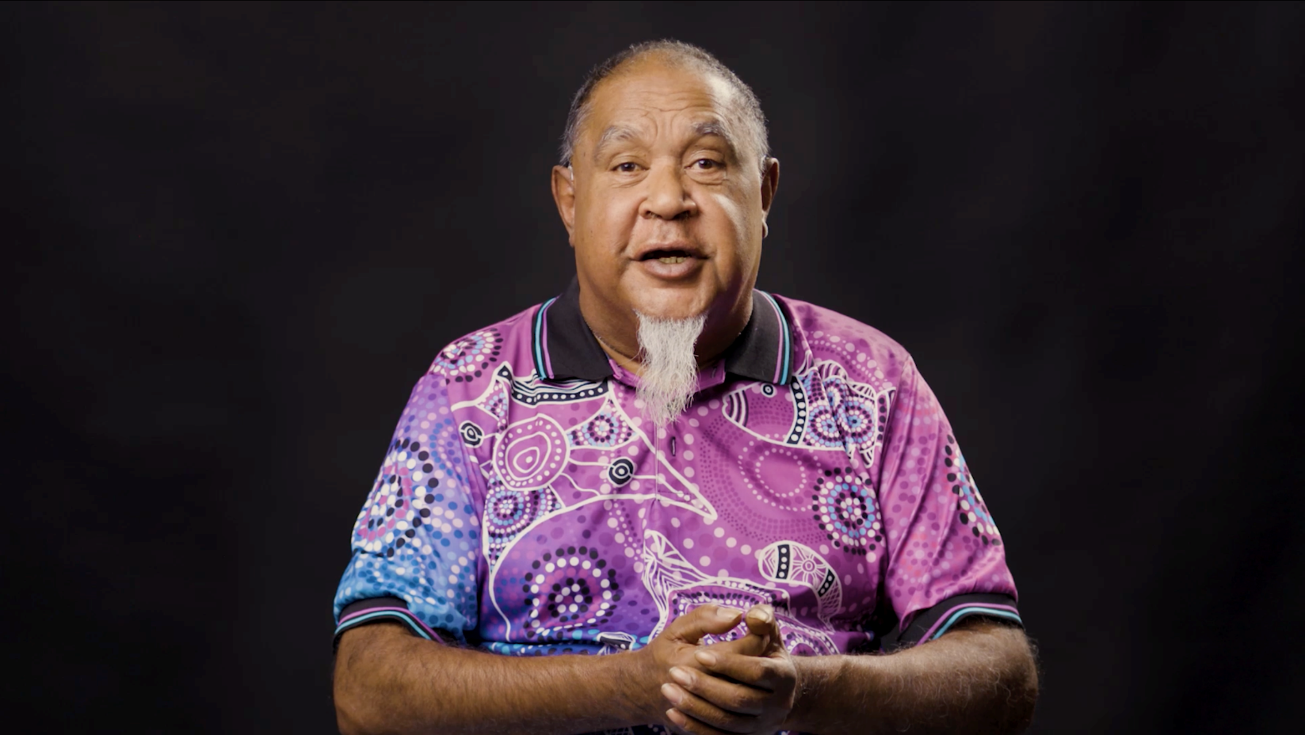

John Kennedy – Indigenous Father

