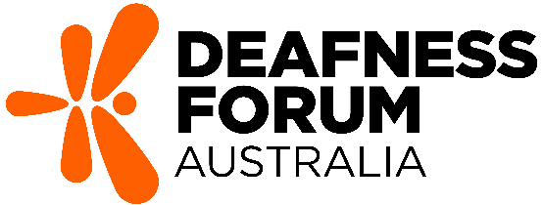
Media Release
For Immediate Release
Safe Listening Week 2024: Addressing the Rising Trend of Hearing Loss with Proactive Education
[Canberra, ACT] - Safe Listening Week 2024 is set to run from August 26 to September 1, as a unique online initiative hosted on Deafness Forum Australia’s Facebook page that spotlights urgent need for more hearing health awareness. This vibrant and inclusive event aims to promote safe listening habits. It will also debut a new resource for secondary students in agricultural communities developed in collaboration with the National Centre for Farmer Health.
Rising Hearing Loss Trend
With hearing loss affecting 1 in 6 Australians and projected to impact 1 in 4 by 2050, Safe Listening Week 2024 addresses a growing public health trend. The campaign's focus on preventive education aims to counteract this trend, with additional emphasis for rural youth who face increased risks.
Unique Virtual Experience
Safe Listening Week 2024 is a week-long, interactive event featuring daily educational content and activities on Deafness Forum’s Facebook page. From August 26 to September 1, participants can access practical tips, engage with diverse content, and take part in community-driven initiatives to promote safe listening habits.
"Safe Listening Week 2024 is a response to the increasing trend of hearing loss in Australia; it creates awareness and empowers individuals to take charge of their hearing health,” said Steve Williamson, CEO, Deafness Forum Australia, “Through education and community engagement, we can create a culture where safe listening practices are the norm, ensuring that everyone can enjoy sound safely for years to come.”
Benefits of Participating in Safe Listening Week
- Trend Awareness: Understand the rising trend of hearing loss and its implications for daily life.
- Practical Advice: Access straightforward advice to integrate safe listening into everyday activities.
- Engaging Content: Enjoy a range of daily content, including educational posts, testimonials, guides, and quizzes.
- Community Participation: Join challenges, win prizes and share personal safe listening stories.
- Accessibility: Enjoy a user-friendly online format designed to be inclusive for all participants.
New Educational FACT Sheets
This year, Safe Listening Week will launch new FACT sheets designed for secondary students in agricultural communities created with the National Centre for Farmer Health. These resources aim to promote a culture of safe listening among young people in high-risk areas.
Get Involved
Participate in Safe Listening Week 2024 by following us on Facebook @deafnessforum, liking, commenting, and sharing our posts. Your involvement helps spread crucial awareness and supports a healthier community for everyone.
Supporting Preventative Health
Aligned with the National Preventative Health Strategy and the WHO’s ‘Make Listening Safe’ initiative, this campaign emphasises proactive health measures and education.
For more information about the Student Hearing FACT Sheets visit: https://www.deafnessforum.org.au/resources/student-hearing-fact-sheets/. Available from 26 August.
Follow us on Facebook @deafnessforum from August 26 to September 1 to participate in Safe Listening Week 2024. Join us in this groundbreaking initiative to enjoy sound safely and sustainably. Together, we can make a real impact on hearing health.
-end-
Media Contact
Steve Williamson
Chief Executive Officer
Steve.williamson@deafnessforum.org.au

About Deafness Forum Australia
Deafness Forum Australia is the national independent body representing Australians with hearing challenges. We strive to make hearing health a national priority, supporting Australians to live well in their communities.
About National Centre for Farmer Health
The National Centre for Farmer Health, a partnership between Western District Health Service and Deakin University, is based in Hamilton, Victoria. It is a leading organisation in agricultural health and wellbeing.

