# A new trend has taken centre stage on The Block. Moditerranean.

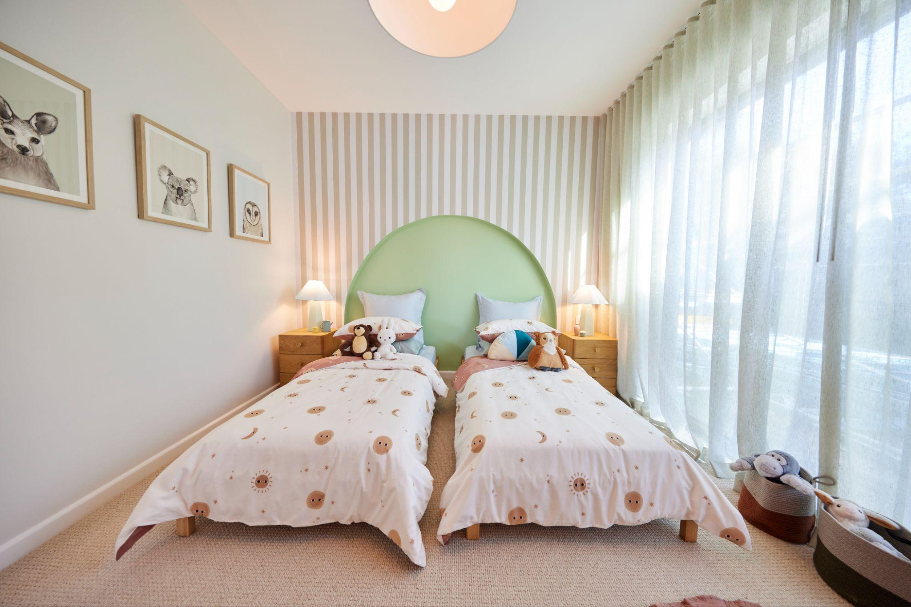

A new trend in interior design is emerging on The Block 2024: “[Moditerranean](https://www.diyblinds.com.au/inspiration/moditerranean-on-the-block-discover-the-trend)”. This innovative style, recently showcased on The Block, blends modern chic with earthy elegance, creating a unique and timeless aesthetic set to become a favourite among design enthusiasts.

[Courtney and Grant](https://www.diyblinds.com.au/the-block/house-2) Freeman showcased the style in House Two of The Block 2024.**What is Moditerranean?**

[Moditerranean](https://www.diyblinds.com.au/inspiration/moditerranean-on-the-block-discover-the-trend) combines the raw beauty of natural landscapes with the sleek sophistication of contemporary design, combining old-world charm with modernism. It merges natural materials, curves, and organic shapes with polished finishes, creating warm, inviting, and timeless spaces.  
  
The essence of Moditerranean lies in its celebration of indoor-outdoor living, where handcrafted details meet soft edges and a nature-inspired palette.

Courtney Freeman said, ***"Moditerranean is about bringing the tranquility and beauty of the outdoors into your home while maintaining a modern and stylish look. It's versatile, inviting, and perfect for creating a cosy yet elegant living space."***

## Key design elements of Moditerranean

**Window furnishings**

A key element in achieving the Moditerranean look is thoughtfully selected window furnishings. They enhance natural light, provide privacy, and add texture and warmth, contributing to the layered decor.

“Window furnishings play a key role in creating a Moditerranean home. Natural fibers in soft, neutral tones perfectly complement raw and refined elements in this trend, helping to create a cohesive and harmonious space," said Courtney.

[**HomePro by DIYblinds**](https://www.diyblinds.com.au/homepro), window furnishings partner on [The Block](https://www.diyblinds.com.au/the-block/shop), helped realise Courtney's vision with a curated range of curtains and blinds that align with the Moditerranean trend, featuring:

* **Eco-friendly materials** like recycled fabrics that resonate with nature.
* **Warm, earthy tones** like green and beige blend seamlessly with rugged and polished surfaces.
* **Textural variety** through a mix of sheer and heavier fabrics to create depth and interest.

**Natural materials**

Incorporate natural materials like stone, wood, and clay to create a rugged yet refined aesthetic. Stone countertops, wooden beams, and clay pots add texture and warmth, contributing to the cultural fusion central to Moditerranean design.

**Indoor plants**

Indoor plants enhance the connection with nature, purify the air, and add vibrancy to your decor. Large potted plants, hanging planters, and succulents help blur the lines between indoor and outdoor living.

**Statement lighting**

Choose statement lighting fixtures made from natural materials like rattan, bamboo, or metal with a rustic finish. These fixtures serve as focal points, adding elegance and sophistication*.*

Moditerranean’s timeless, contemporary design, with its warm and inviting ambiance, resonates with style-conscious homeowners and fans of The Block. Blending outdoor tranquility with modern style, the trend creates spaces that are both inviting and sophisticated. The seamless integration of old-world charm with modernism, detailed craftsmanship, and natural elements makes Moditerranean a trend that looks beautiful and feels like home.  
***About***[**HomePro by DIYblinds**](https://www.diyblinds.com.au/homepro)

We provide top-quality products with access to premium suppliers, combined with professional installation for seamless project delivery. With decades of design expertise and connections to the industry’s best suppliers, we create stunning, tailored spaces.

***Resources***

[***https://www.diyblinds.com.au/inspiration/moditerranean-on-the-block-discover-the-trend***](https://www.diyblinds.com.au/inspiration/moditerranean-on-the-block-discover-the-trend)

[***https://www.diyblinds.com.au/the-block/house-2***](https://www.diyblinds.com.au/the-block/house-2) ***Product: Sheer Curtain: Allusion colour Fern***

***Images***

[***H2 RM2 Bedroom Courtney & Grant-013.jpg***](https://drive.google.com/file/d/1uoGZahuAYAI6GGg6wCGQRBJc9GlSzYI_/view?usp=sharing)

[***https://drive.google.com/file/d/1V5mLPGndiqAqZ2j12QKFnAAXeFKFRFJC/view?usp=sharing***](https://drive.google.com/file/d/1V5mLPGndiqAqZ2j12QKFnAAXeFKFRFJC/view?usp=sharing)

[***https://drive.google.com/file/d/1QgMJQ2ATF-8lQ4C7XjwrVxh43kvd88NY/view?usp=sharing***](https://drive.google.com/file/d/1QgMJQ2ATF-8lQ4C7XjwrVxh43kvd88NY/view?usp=sharing)

***For media inquiries, please contact***

***Liv Tully***

Head of Brand

liv@diyblinds.com.au

0497853132