Media Release  Melbourne, 5th September 2024 | 

PieProof Unveils Innovative Cycle Helmets to Defend Against Magpie Attacks
Melbourne, Australia – September 5, 2024 – PieProof, an innovative Australian company, is thrilled to meet the 2024 magpie swooping season head on with world-first helmets designed to keep Aussie cyclists safer.

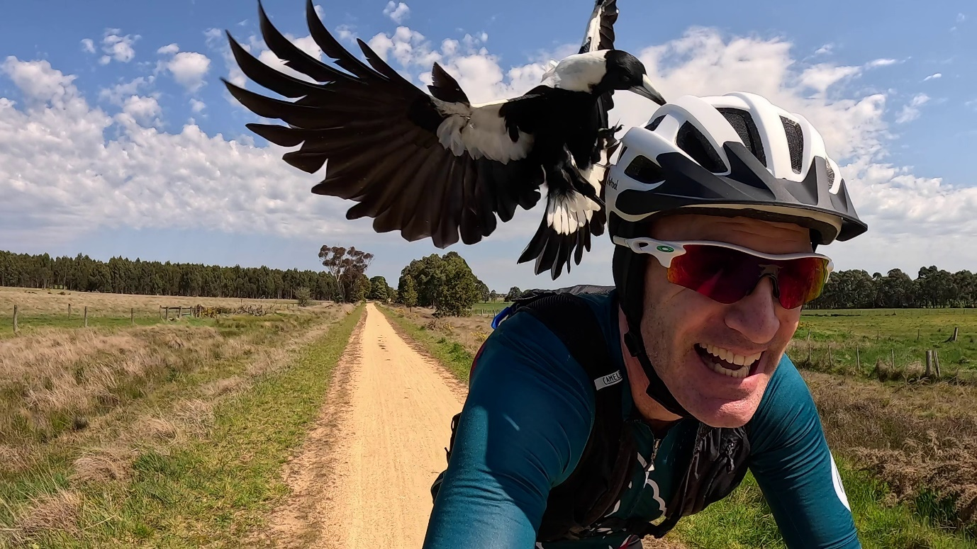
GPLama (YouTube) testing PieProof cycle helmets near Ballarat in late October 2023.

Designed in Australia for Australian Cyclists
When Dutch-Australian Engineer Leo Boesten was left sore and bleeding after being attacked by aggressive Magpies on one of his rides, he asked, ‘Why hasn’t someone done something about this?’ What followed was a quest to keep cyclists safe during the annual menace of the Magpie breeding season which stretches from late July through to early November.
Leo recognised early in the process that an angry magpie won’t be deterred from attacking a cyclist by some wobbly cable ties and googly eyes attached to a helmet. While these home-made solutions are great at giving the surrounding traffic something to laugh at, their performance has been repeatedly debunked.
An Engineered Solution
The focus instead moved to providing an engineered solution to the problem. PieProof helmets protect the rider from direct injury enabling them to stay calm, focus on the road ahead and avoid the urge to fight off the bird and potentially crash in the process. Each year thousands of injuries occur in this way and sadly even some fatalities. (Check MagpieAlert.com for a running tally of logged National attacks)
The PieProof patent-pending design stops sharp beaks and claws from contacting the rider using a strong, integrated pet-proof mesh that covers the helmet vents, sturdy ear protectors and a visor which protects the eyes and face when coupled with glasses. Both the ear protectors and the visor are detachable making the helmets suitable for use outside of the swooping season. The helmets also have a rechargeable, integrated LED tail lamp for extra nighttime safety.
See PieProof helmets in action here:- Springtime in Australia means Magpie attacks! (youtube.com)
Magpies are Just Protecting Their Young
These beautiful birds perceive humans as a threat to their offspring and around 10% of males display aggressive behaviour to scare off the intruder. Once you’ve travelled through the bird’s territory, the attack stops. It is not practical to avoid the area because birds often nest on busy cycling routes and magpies tend to nest at different times throughout the season.
Lightweight and Comfortable
Weighing just 270 grams (medium size), PieProof helmets are incredibly lightweight, well-ventilated and comfortable. In keeping with the Magpie theme, only Black and White colours are available!
Join the PieProof Revolution
Many cyclists simply avoid riding during the Spring months which just happen to be the best riding weather. With PieProof helmets, cyclists can ride with confidence all year knowing that they are protected from these unexpected challenges.
Availability
PieProof helmets are available for just $109.95 from select stockists or online at PieProof.com.au and Amazon. Check the website for stockist details.

Contact Information
For media inquiries, please contact:
Leo Boesten
Director
PieProof Pty.Ltd.
Email: leoboesten@pieproof,com
Phone: +61 435 455 308

