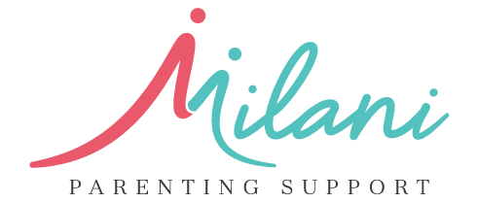**Press Release**

**Contact:** Rose Milani  
Director, Milani Parenting Support  
Phone: +61370429151  
Email: info@milaniparentingsupport.com.au  
Website: <https://milaniparentingsupport.com.au/>

**FOR IMMEDIATE RELEASE**

**Milani Parenting Support Takes Action Amid Rising Youth Crime Rates in Queensland and Victoria**

**Melbourne 26.09.2024** – The recent surge in youth crime rates across Queensland and Victoria has sparked substantial government intervention, leading to significant funding for parenting support programs aimed at addressing the underlying causes of these pressing issues. In this context, Milani Parenting Support is poised to make a meaningful contribution by providing targeted resources and programs designed to empower families and foster safer communities.

In Queensland, the government has allocated $446.4 million over five years to enhance community safety, specifically targeting the complex factors contributing to youth crime. This funding supports early intervention programs aimed at diverting at-risk youth from the criminal justice system, including initiatives like the Youth Co-responder Teams and Intensive Case Management, which focus on engaging with young people in need of tailored support​【Ministerial Media Statements】.

Similarly, the Victorian government has launched various grants to promote youth engagement and community connection through sports and cultural activities. These initiatives not only build essential life skills but also foster inclusion among young people from diverse backgrounds. This funding underscores the importance of community-led solutions to youth crime, emphasizing the critical role of family and social structures in preventing delinquency【Community Crime Prevention Victoria】.

In response to these urgent calls for support, Milani Parenting Support is aligning its efforts with government intervention strategies to address the root causes of youth crime. “We understand the complexities that families face and the vital role that supportive parenting plays in shaping the lives of young people,” said Rose Milani, Director of Milani Parenting Support. “Our goal is to empower families, enhance communication, and create nurturing environments that discourage negative behaviors.”

Milani Parenting Support offers an array of programs designed to support parents, including one-on-one coaching, educational courses, and community seminars focusing on effective parenting strategies. By equipping families with the necessary tools and knowledge, Milani Parenting Support aims to be an integral part of the solution, contributing to a significant reduction in youth crime and a positive impact on community safety.

For more information about Milani Parenting Support and to explore how we can collaborate to support families, please visit https://milaniparentingsupport.com.au/

**### END ###**

For media inquiries or to schedule interviews, please contact Rose Milani at 0420407240 or rose@milaniparentingsupport.com.au.