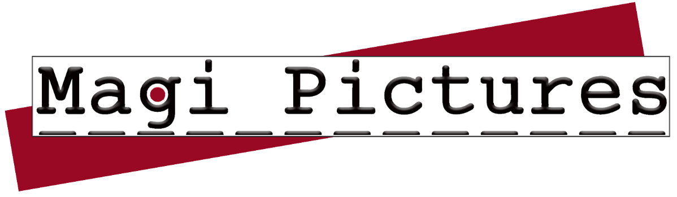
For Immediate Release
GOLD COAST, QLD 30th September 2024

Hollywood Veterans Launch Magi Pictures on Gold Coast
Magi Pictures, a new film production company founded by internationally acclaimed filmmaker Michael Rymer and renowned writer Shirley Pierce, is set to make waves in the Australian film industry. Based on the Gold Coast, Magi Pictures aims to create world-class films and television series that showcase Australian talent and locations to global audiences.
Michael Rymer, known for producing and directing the hit series "Battlestar Galactica" brings a volume of history to Magi. As an Emmy Nominee and Directors Guild of America nominee, he has directed US series "Hannibal", "American Horror Story", Man In The High Castle” and many more. His Australian film "Angel Baby" swept the AFI Awards and was a hit at the Sundance Film Festival. Rymer's recent Australian projects include "Deadline Gallipoli", "Picnic at Hanging Rock", and the ABC's bushfire drama "Fires", demonstrating his commitment to telling important Australian stories.
Shirley Pierce, originally from Ohio but now a Gold Coast local, has written for major Hollywood studios on films that have collectively grossed over half a billion dollars at the box office. Her credits include Disney animated features like "Dinosaur" and "Meet the Robinsons", as well as numerous action and drama TV movies and series.
Magi Pictures will specialize in developing and producing film and television projects that combine authentic Australian storytelling with global appeal. The company is committed to creating content that entertains, inspires, and drives positive change while boosting the local film industry.
"We're thrilled to be setting up shop on the Gold Coast," says Rymer. "This region has always been a hub of creativity, and we're excited to tap into the local talent pool and showcase the stunning locations Queensland has to offer."
Pierce adds, "Our goal is to tell uniquely Australian stories that can travel the world.”
The establishment of Magi Pictures is expected to provide a significant boost to the local economy, as film and TV productions can bring millions of dollars into a region. With their combined experience in Hollywood and the Australian film industry, Rymer and Pierce are well-positioned to bridge the gap between local content and international audiences.
The company's development process integrates market research and industry engagement, ensuring both artistic integrity and commercial viability. Magi Pictures is committed to authenticity and specificity in storytelling, focusing on elevated stories with strong messages.
As Magi Pictures begins operations, the Gold Coast can look forward to seeing more of their stunning landscapes and talented performers on screens around the world, enhancing the local film industry ecosystem and providing new opportunities for aspiring filmmakers and established professionals alike.
For more information, contact:
Contact: Barry Pierce
admin@magipictures.com
Ph +61 468 427 341

https:/www.magipictures.com

