Hi Andrii,

I hope you’re doing well.

We would like to push out the press release to the media site in an attempt to gain placements on Australian and New Zealand media sites.

Would you be happy for us to distribute the following article?

**3HLINEN Launches Innovative Thermal and Soundproof Curtains for Modern Homes**

**Enhancing Comfort and Style: 3HLINEN's New Range of Curtains and Blinds Offers Thermoregulation, Noise Reduction, and Elegance**

[Sydney, Australia, 30th September 2024]: 3HLINEN, a leading provider of high-quality linen products, is excited to announce the launch of its latest collection of thermal curtains, soundproof curtains, outdoor curtains, and versatile linen [roman blinds](https://3hlinen.com.au/collections/roman-shades). This new line is designed to deliver both functionality and aesthetic appeal to modern homes, offering superior noise reduction, privacy, and style.

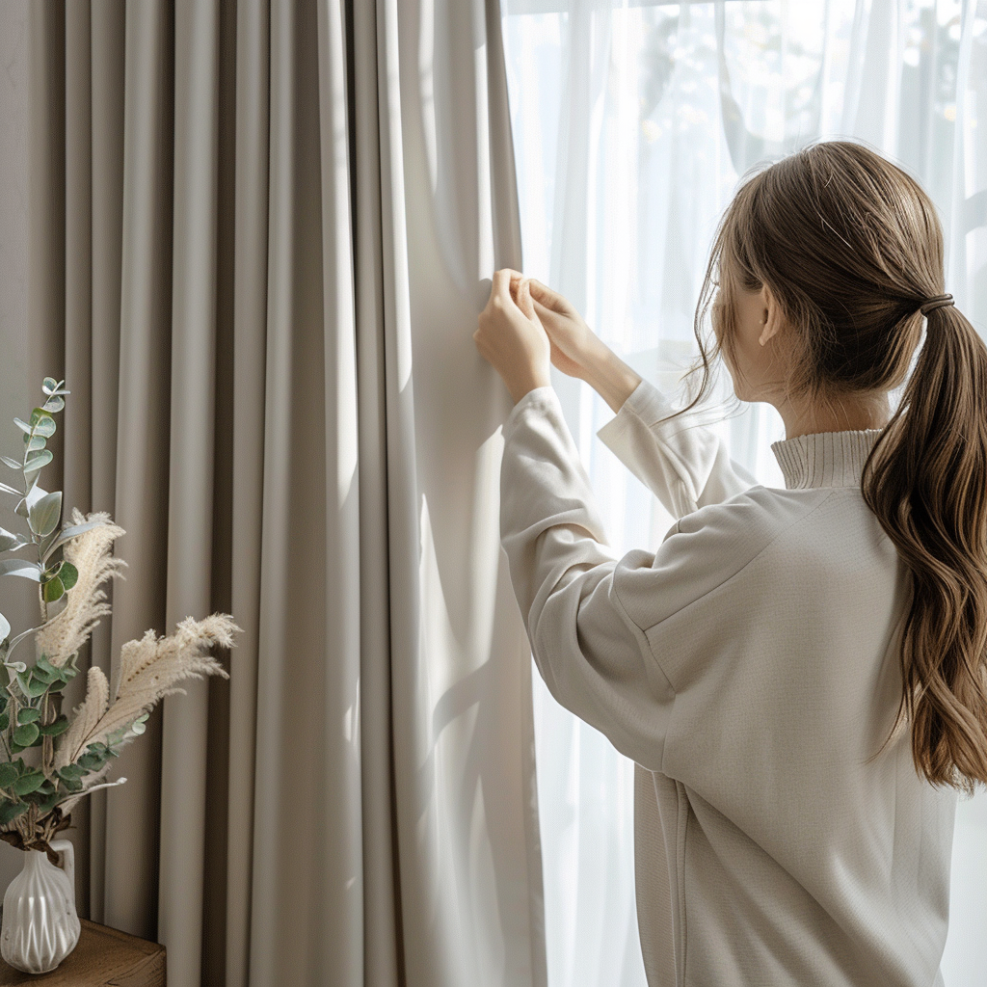

The [thermal curtains](https://3hlinen.com.au/collections/thermal-curtains) feature 100% flax linen on the front layer with a neutral back layer, combining luxury and practicality. Available in various widths (125 cm to 250 cm, with custom sizing), these curtains come in a wide range of colours and offer hanging options such as back tabs, eyelets, pole pockets, and ceiling tracks.

“The launch of this new collection marks a significant step forward in home comfort and design,” said Sergii, Founder of [3HLINEN](https://3hlinen.com.au/). “Our thermal curtains are engineered to regulate temperature effectively, reducing heat in the summer and maintaining warmth in the winter. At the same time, the soundproof curtains help minimise outside noise, creating a serene atmosphere indoors, perfect for modern living spaces.”

In addition to offering thermoregulation and soundproofing, 3HLINEN’s curtains also provide total blackout functionality, ensuring complete privacy and optimal sleeping conditions. The outdoor curtains and linen roman blinds combine timeless style with practicality, making them a versatile addition to any home. All products are certified by OEKO-TEX® and are free from over 400 harmful substances, reflecting 3HLINEN's commitment to safety and sustainability.

This innovative collection is designed for customers who value both style and performance in their home decor, offering a sleek modern vibe with high functionality.

**About 3HLINEN**

3HLINEN is a premium linen products company based in 602-612 Botany Road Alexandria NSW 2015. Specialising in high-quality linen curtains and home textiles, 3HLINEN combines craftsmanship, sustainability, and modern design to create products that enhance everyday living. With a focus on environmental responsibility, all materials are ethically sourced and certified to meet the highest safety standards.

**Get in touch**

PH: [(02) 7908 2533](https://3hlinen.com.au/collections/thermal-curtains/products/thermal-linen-curtains-with-back-tabs-heading)

Address: 602-612 Botany Road Alexandria NSW 2015

Website: <https://3hlinen.com.au/>